Car OBD2 Gauge + Inclinometer

Model: S6

Catalog:

1. To Users

2. Product Introduction

3. Product Characteristics

4. Product Function

5. Alarm function

6. Product parameters

7.Introduction of Host

8.Introduction of Display Interface and Function

9. Introduction of Key Function

10. Car speed error fine adjustment

11. Installation steps

12. Warranty Regulations

13．Precautions

1.To Users
Welcome
Dear customer,
Thanks for buying our product. It is our great honor to provide our best service to you. Your satisfaction is our goal and your support will be highly appreciated and it is the driving force of our progress!
We’re specialized in TPMS products and won good reputations from our customers because of our good quality and service. Since our company established, we’re subjected to the " Credit comes first.and the client is the God. " business philosophy, to fulfill the "Grasp the opportunity to blaze new trails, developed strong competitive products" as the principle of service. Regard “People-oriented, Reputation fist" as our corporate culture.
Please read this manual carefully before using our product. With full pictures and their accompanying essay in detailed we introduce you the operation of our product Intuitively. By the way, due to product production date, different batches, indicating that the actual use of the product may be different, specifications are subject to the phisycal product.
Thank you again for your choose and support. Meanwhile we hope that you guys may send us feedback during the course of you use it. Your suggestion and support are the driving force of our progress! "Happy to go out, peacefully come back" is our hope, and finally we sincerely wish you family all happy, everything goes well.

2. Product Profile:
OBD Intelligent Escort extends the concept of combining HUD automobile head-up display function with on-board gradient meter, which greatly improves the product's safety escort level for users, and is favored by a large number of off-road enthusiasts.
OBD Intelligent Escort reads data through OBD interface of automobile connected by data line. It supports nine major protocols. It is widely used in more than 95% of the models on the market, and can also support the use of some small trucks. It is the first in the industry.
With OBD intelligent escort, you can not only drive without bowing your head and pay attention to the vehicle dynamics at any time, but also see the roll angle and elevation angle of the vehicle. The OBD intelligent escort uses LCD color screen display. The effect is dazzling and clear, so that the vision can be seen at a glance. The functions of OBD intelligent escort include (OBD speed, speed, clearing fault codes, water temperature, voltage, roll angle of the vehicle, elevation angle of the vehicle, etc.). Functions)
3. Product characteristics:
■ Suitable for domestic car system, Asian car system, American car system, European car system, and some minivans.
■ It has the function of clearing the fault code of automobile.
■ Free switching between degrees Fahrenheit and degrees Celsius (tank temperature display)
■ Free switching between British and metric units (speed display) Gui Temple site
■ Support for the nine major OBD agreements。
■ Automatically monitor the driving condition of the vehicle.
■ The light intensity induced by the light source sensor is used to adjust the brightness of the screen.
■ The free rotation is used, and its sensitivity is high.
■ Using color high definition liquid crystal screen display, high resolution
■ Carbon fiber appearance fuselage design.
■ Start with the car, stop automatic dormancy function

4, product function:
■ Vehicle roll angle display
■ Vehicle elevation display
■ OBD Speed Display
■ OBD Speed Meter Display
■ OBD Speed Digital Display
■ Temperature Display of Water Tank
■ Clearing Fault Code
■ Battery Voltage Display

5. Alarm function:

■ Roll angle danger alarm

■ Elevation angle hazard alarm
■ Overspeed alarm
■ Fatigue driving alarm (alarm will be given if driving for 4 hours continuously)
■ Battery Abnormal Alarm
■ Alarm for high water temperature
■ Vehicle Fault Code Alarm

6. Output parameters：

Power | DC 10V ~ 30V | Working Temperature | -40℃ ~ +80℃
Depression& Elevation angle | -40°~ +40° | Roll Angle | -40°~ +40°
OBD Speed | Synchronous automobile data | OBD revolution | Synchronized Vehicle Data
Voltage measurement accuracy | + - 0.5V | Speed Accuracy | ＜ 0.05Km/h
Water tank temperature accuracy | + - 0.5° | Fault code | Synchronized Vehicle Data
Support agreements | Support for 9 major protocols | Shell Material | ABS+PC High Temperature Resistant Materials
Product Size | 70*59*59  （mm） | Weight | 203g

7、Introduction of Host
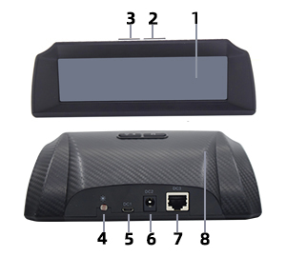
1-Display Interface

2-" M "function key.

3-Switch key.。

4- Photoelectric sensor (automatic adjustment of display brightness).

5- Upgrade dedicated USB interface

6-DC12V Power Supply Interface (version OBD is not available).

7-RG45 power supply and OBD signal receiving port.

8- Carbon fiber process shell.

8、.Introduction of Display Interface and Function

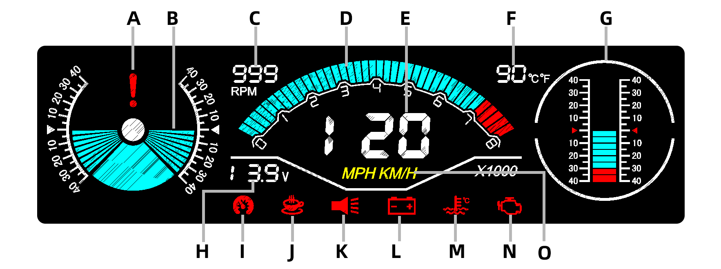

A-roll angle alarm icon, when the roll angle of the car reaches 30 degrees, this icon will light up and give an alarm sound.

B-roll angle indication area, real-time measurement of vehicle roll angle, using free rotation, left and right angles of 40 degrees.

C - Digital speed display area, showing the current speed (motion speed).

D-engine speed dashboard display, indicating the current speed of the engine (dashboard speed).

E-Satellite Vehicle Speed Display Area, which shows the current speed of the vehicle as it travels.

F-tank temperature display area, real-time display of water temperature.

G-elevation indicator area, real-time measurement of vehicle elevation angle, using free rotation, front and rear angles of 40 degrees.

H-automobile battery voltage monitoring display area, showing the current battery voltage value.
I - Overspeed alarm. When the car arrives at 120KM/H, this icon will light up and make an alarm sound. (You can also turn off the alarm sound)

J - Fatigue driving alarm. When the car runs continuously for 4 hours, this icon will light up and give an alarm sound.

K-Sound Close/Open icon. When the sound is turned on, the icon is lit, but not when it is turned off. (You can open/close by pressing the right button for a long time.)

L-battery voltage abnormal alarm icon, when the battery voltage abnormal, this icon will light up and give an alarm sound.

M-water temperature alarm, when the water temperature of the tank is higher than the set value, this icon will light up and give an alarm sound.

N-automobile fault code alarm, when the car breaks down, this icon will light up and alarm prompt (long press left key to clear the fault code)

O-MPH/KMH is the unit of speed icon, MPH is the unit of English, KM/H is the unit of English (you can switch the two unit modes by right-clicking for 3 seconds)

9. Introduction of Key Function
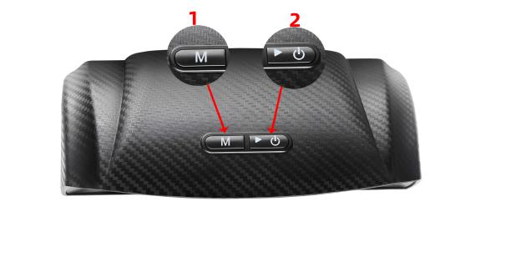
1. Right click
* Short press 2 "right key" to switch the temperature unit °C/°F, speed unit KM/H and MPH (°C and KM/H synchronous switching, °F and MPH synchronous switching)
* Long press 2 "right key" function button 5S, turn on/off sound

2."M" function key
* Press the 1 "M" function key briefly to reset the balance between the roll angle and the attachment angle.
* Press and hold the 1 "M" key for 5 seconds to clear the car fault code (the device will restart after the operation is completed) (special note: the speed must be less than 10KM/H when clearing the fault code).

10、Car speed error fine adjustment

Hold down the left button for a long time, then turn on the power and turn it on. After the device is turned on, the device will enter the speed fine-tuning setting interface (as shown below), set the desired value by the left and right buttons, and then restart the computer to complete speed fine-tuning settings.

11、Installation steps

1. Park the car on the horizontal road, paste the back glue on the product, fix it anywhere convenient to observe inside the car, and adjust it manually to the level.

2. Connect the OBD data line to the OBD interface of the automobile (as shown in the figure below). The OBD intelligent convoy will start until the data are displayed properly.

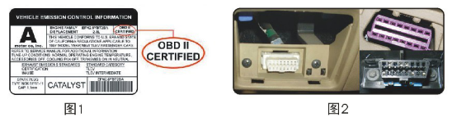

12、Warranty Regulations:

The whole machine and accessories of GPS intelligent navigator enjoy 1 year warranty period from the date of customer signing and receiving.
Warranty mode:
1. Repair or replace the equipment according to the specific failure situation.
2. We guarantee that all replacement parts, accessories or equipment are brand new.
3. When the customer receives the product within 90 days of failure and provides video and picture at the same time, we bear the freight and provide the corresponding accessories to the customer for replacement free of charge. After receiving the product for more than 90 days, the customer will bear the corresponding cost, and we will provide the spare parts to the customer for replacement free of charge.

The following conditions are no longer covered by free warranty：

1. Purchase of GPS intelligent escort products through informal channels;

2. Damage caused by failure to use and maintain as required by the product specification.

13、Precautions
■ This specification is an essential part of this product. Please read it carefully.
■ Keep this specification properly for use during maintenance.
■ Follow this specification and use only the accessories recommended by the manufacture.
■ This machine is only used for clear purposes in the design and must not be moved for other purposes.

■ Non-technical personnel shall not privately modify, disassemble or maintain this product, and all losses arising therefrom shall be borne by the users of this guide.
■ Do not prick, bend, twist, stretch the wire, and do not place the wire at high temperature, do not press, decompose the on-board charging adapter.
■ Do not place nails, needles and other small sundries at the charging port so as not to damage the charging joint
■ Do not use the product in unstable places such as high altitude, oblique plane, shelf, etc.
■ This product is electrified and used, do not let children as toys.
■ Do not immerse this product in water or other liquid may send Th short circuit.

■ Please try your best to use this product standard power supply and power cord.
■ When not in use, please do not bake in strong light or high temperature

The manufacturer shall not be responsible for damage caused by improper use or diversion.

Statement: The Company reserves the right to change the product design and specifications without prior notice at that time. The physical appearance and color may be different from that shown in the specification, please take the physical object as the standard. We have tried our best to make all the descriptions in the book accurate, but there is still something wrong in it, if in doubt, please contact the dealer or after-sales service center, our company does not bear any consequences caused by misunderstanding.

目 录

一、致 用 户

二、产 品 简 介

三、产 品 特 点

四、产 品 功 能

五、报 警 功 能

六、产 品 参 数

七、主 机 介 绍

八、显 示 界 面 及 功 能 介 绍

九、按 键 功 能 介 绍

十、车速误差微调

十一、安 装 步 骤

十二、保 修 条 例

十三、注 意 事 项

一、致 用 户

尊敬的用户:
您好!首先非常感谢您使用我们公司的系列产品,能够为您服务是我们最大的荣幸,您的认可与支持是我们前进的动力!
我们公司的系列产品拥有完善的保固及过硬的服务品质，因此受到广大顾客的支持与好评。公司自创建以来，一直秉承着“客户至上，质量第一”的经营理念；履行着“把握时机，开拓创新，研发出具有强大竞争力的产品”的服务宗旨；贯穿着“以人为本，信誉第一”的企业文化。
在使用本产品前，请仔细阅读本手册。手册采用图文并茂的方式，配合文字的插图详细直观地阐述产品的操作。另外，由于产品生产日期、批次不同，说明可能会与实际使用的产品有差异，请以实物为准。
再次感谢您的支持与惠顾，同时也诚挚希望您在使用过程中给我们反馈您的宝贵意见。您的辅正与支持是我们前进的动力！“快快乐乐地出门，平平安安地回家”是我们最大的心愿，最后我们诚挚地祝福您：合家幸福，事事顺心!

二、产 品 简 介：
OBD智能护航仪延用ＨＵＤ汽车抬头显示功能与车载坡度仪两大功能相结合的理念，大大提高产品对用户的安全护航等级，更是受到了大批越野爱好者的青睐。
OBD智能护航仪通过数据线连接汽车OBD接口读取数据，支持9大协议，通用于市面上95%以上的车型，还可以支持部分小货车使用，是业内首创。
拥有OBD智能护航仪既可以开车不低头，随时关注到车辆动态，同时也可以看到车辆横滚角和附仰角状态，OBD智能护航仪采用LCD彩屏显示.效果炫丽清晰，让视觉一目了然.OBD智能护航仪功能包括（OBD车速，转速，清除故障码，水温，电压，车辆横滚角，车辆附仰角 等功能）

三、产 品 特 点：
■ 适用于国产车系、亚洲车系、美洲车系、欧洲车系、和部分小货车。
■ 具备清除汽车故障码功能
■ 华氏度和摄氏度自由切换（水箱温度显示）
■ 英制和公制单位自由切换  （车速显示）  圭  寺 地 
■ 支持OBD九大协议。
■ 全自动监测车辆行驶状况。
■ 采用光源感应器感应的感光强度来调整屏幕亮度。
■ 采用游离式转动，其灵敏程度较高。
■ 采用彩色高清液晶屏显示，分辨率较高。
■ 采用炭纤维外观机身设计。
■ 随车启动，停车自动休眠功能。

四、产 品 功 能：
■ 车辆横滚角显示
■ 车辆附仰角显示
■ OBD车速显示
■ OBD转速仪表显示
■ OBD转速数字显示
■ 水箱温度显示
■ 电瓶电压显示
■ 清除故障码

五、报 警 功 能：

■ 横滚角危险报警
■ 附仰角危险报警
■ 超速报警
■ 疲劳驾驶报警（连续行驶4小时会报警）
■ 电瓶异常报警
■ 水温高报警
■ 车辆故障码报警

六、产 品 参 数 ：

电源 | DC 10V ~ 30V | 工作温度 | -40℃ ~ +80℃
俯仰角 | -40°~ +40° | 横滚角 | -40°~ +40°
OBD车速 | 同步汽车数据 | OBD转数 | 同步汽车数据
电压测量精度 | + - 0.5V | 速度精度 | ＜ 0.05Km/h
水箱温度精度 | + - 0.5°度 | 故障码 | 同步汽车数据
支持协议 | 支持9大协议 | 外壳材质 | ABS+PC耐高温材料
产品尺寸 | 70*59*59（mm） | 重量 | 203g

七、主 机 介 绍
1-显示屏界面。

2-“M”功能键。

3-开关键。

4-光电传感器（自动调节显示亮度）。

5-升级专用USB接口。

6-DC 12V供电接口（OBD版本不可用）。

7-RG45供电和OBD信号接收端口。

8-炭纤维工艺外壳。

八、显 示 界 面 及 功 能 介 绍

A-横滚角报警提示图标，当汽车横滚角度达到30°度，此图标会点亮并发出报警声音。

B-横滚角指示区域，实时测量车辆横滚角度，采用游离式转动，左右角度为40°度。

C-数字转速显示区域，显示当前转速值（运动转速）。

D-发动机转速仪表盘显示，指示发动机的当前转速（仪表盘转速）。

E-卫星车速显示区域，车辆行驶时显示车辆当前车速。

F-水箱温度显示区域，实时显示水温度值。

G-附仰角指示区域，实时测量车辆附仰角度，采用游离式转动，前后角度为40°度。

H-汽车电瓶电压监测显示区域，显示当前电瓶电压值。

I-超速报警，当汽车行驶到达120KM/H时，此图标会点亮并发出报警声音。（也可以关闭报警声音）

J- 疲劳驾驶报警，当汽车连续运行4小时，此图标会点亮并发出报警声音。

K-声音关闭/开启图标，当开启声音时此图标点亮，关闭时不点亮（可以长按右键操作打开/关）

L-电瓶电压异常报警图标，当电瓶电压出现故障异常时，此图标会点亮并发出报警声音。

M-水温报警，当水箱水温高于设定值时，此图标会点亮并发出报警声音。

N-汽车故障码报警，当汽车出现故障时，此图标会点亮并报警提示（可以长按左键清除故障码）

O-MPH/KMH为车速单位图标，MPH是英制单位，KM/H为公制单位（可以长右键3秒切换这两个单位模式）

九、按 键 功 能 介 绍
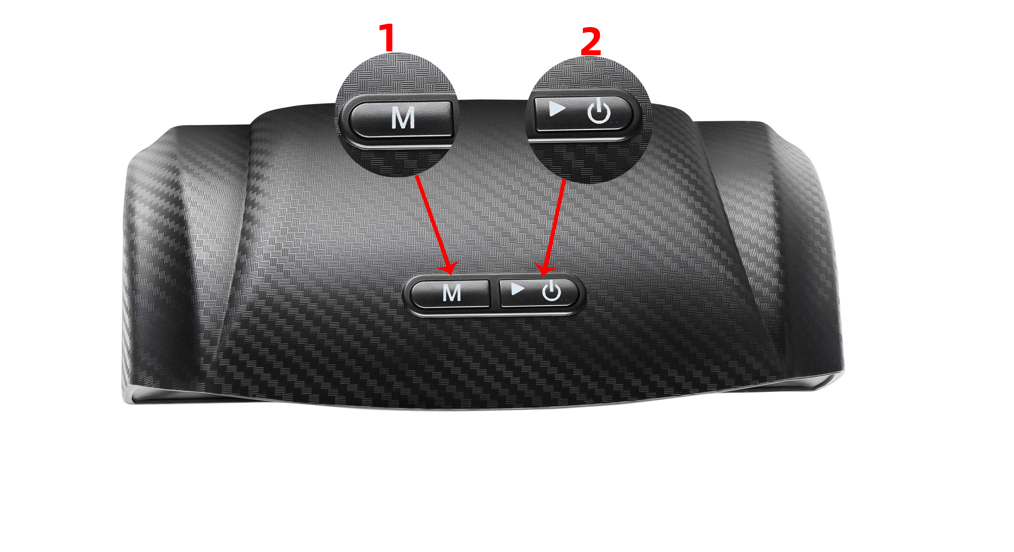
1、右键
* 短按2“右键”键，切换温度单位℃/℉，速度单位KM/H和MPH（℃和KM/H同步切换，℉和MPH同步切换）
* 长按2“右键”功能键5S,开/关声音

2、“M”功能键
* 短按1“M”功能键，横滚角和附仰角复位平衡 。
* 长按1“M”键5秒，清除汽车故障码(操作完成后将设备重启)(特别注意：清除故障码时速度必须小于10KM/H ）。

十、车速误差微调
先长按住左键不放，再接通电源开机，开机后设备会进入到速度微调设置界面(如下图所示)，通过左右两个按键设置到所需数值，再重新开机，即可完成速度微调设置。

十一、安 装 步 骤
- 把汽车停放在水平路面上，将背胶粘贴在产品上，固定于汽车内部方便观察的任何地方,手工调校至水平即可。
- 连接OBD数据线至汽车OBD接口（如下图所示），OBD智能护航仪开机，直到各项数据显示正常，方可驾车行驶。

十二、保 修 条 例:
OBD智能护航仪整机及所含附件自客户签收日起享有 1 年保修期。

保 修 方 式：
- 根据具体的故障情况对设备进行修理或更换；
- 我方保证所有更换的部件、附件或设备都是全新；
- 在客户收到产品 90 天内出现故障同时提供视频和图片，我方承担运费并免费提供相应配件给客户更换。收到产品超过 90 天，客户承担相应的费用，我方免费提供配件给客户更换。

以 下 情 况 不 再 免 费 保 修 范 围：
- 非正规渠道购买OBD智能护航仪产品；
- 未按产品说明书要求使用和维护造成的损坏。

十三、注 意 事 项
■ 此说明书是本产品的必要组成部分，请仔细阅读。
■ 妥善保存此说明书，以备检修时使用。
■ 按照本说明书操作，并且只使用制造商推荐的附件。
■ 本机只用于设计所明确的用途，切勿移作它用。

■ 非技术人员不得私自改造，拆卸或维修本产品，因此带来的所有损失由本指南使用者承担。
■ 请勿刺划、弯折、扭曲、拉伸电线，且勿将电线置于高温处，勿重压、分解车载充电适配器。
■ 请勿将钉子、针等其他细小杂物置于充电口，以免损坏充电接头。
■ 请勿将产品置于高空、斜面、货架等不稳的地方使用。
■ 本产品通电使用，请勿让儿童当玩具。
■ 请勿把本产品浸入水中或其他液体中可能发Th短路。

■ 请尽量使用本产品标配电源及电源线。
■ 在未使用状况下，请不要将本品放在强光或高温下爆晒烘烤。
对由于使用不当或移作它用而引起的损害，厂家概不负责。

声明：公司保留更改产品设计与规格的权利，届时恕不另行通知。实物外观与颜色可能与说明书中显示的有差别，请以实物为准。我们已尽最大努力力求使书中所有描述准确，但仍难免有不妥之处，如有疑问，请联系经销商或售后服务中心，本公司不承担任何因误解而产生的后果。

