QUICK TOUR
Accurate Tracking | Easy Installation

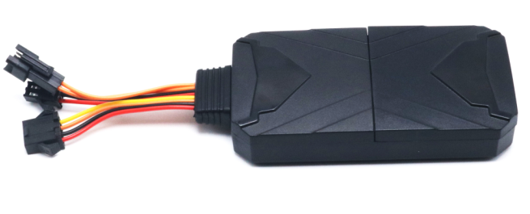

Please carefully read the user guide before use in order to quickly get the right to operate. Product appearance, color and accessories are subject to change without prior notice in this manual!
1.Products list
number | products name | count | remark
1 | GPS tracker | 1
2 | Power line | 1
3 | Relay | 1
4 | MIC line
5 | SOS line | 1
 | Instruction manual

2.Functions and Product parameters
◆ Real-time tracking ◆ One way communication
◆ Vibration/Displacement/Low battery/Power off/over speed alert
◆ SOS ◆ ACC detection ◆ Geo-fence ◆ MIC
◆ History Route ◆ Cut and resume oil remotely ◆ AGPS/LBS/GPS
3. Product parameters
4G Bands  WCDMA&GSM | FDD-LTE: B1/B2/B3/B4/B5/B7/B8/B17/B20/B28  TDD-LTE :B38/B39/B40/B41
 | B1 B2 B5 B8 & 850/900/1800/1900MHz
Backup Battery | 3.7V 200mAh
Operating voltage | 10-100V
Location time | Cold start 35s-80s
 | Hot start 1s
Location accuracy | 5 meters
Operating temperature | -20℃~+55℃
Dimension | 89*47*18mm
Weight | 53.5g

4.LED Indicator Definition
Green Indicator：GPRS/LTE signal
Status of indicator | Meaning
Flash | GSM/GPRS conversation start
Continuously in bright status | No GPRS signal
Green Led off | Power off or in sleep mode

Blue Indicator：GPS
Status of indicator | Meaning
Flash | GPS location successful
Continuously in bright status | GPS signal searching
Blue led off | Power off or in sleep mode

Red Indicator：Power charge
Status of indicator | Meaning
Continuously in bright status | charging
Red led off | Full battery or charged full

NOTE: When the equipment in power saving sleep mode, the light will turn off after about 10 minutes(settable) without any operation.
5.Start up
5.1 Find the part shown in the figure below and open the upper cover.
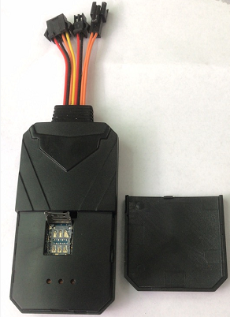
5.2 Put in a NANO SIM card with 4G&GPRS support as shown below:

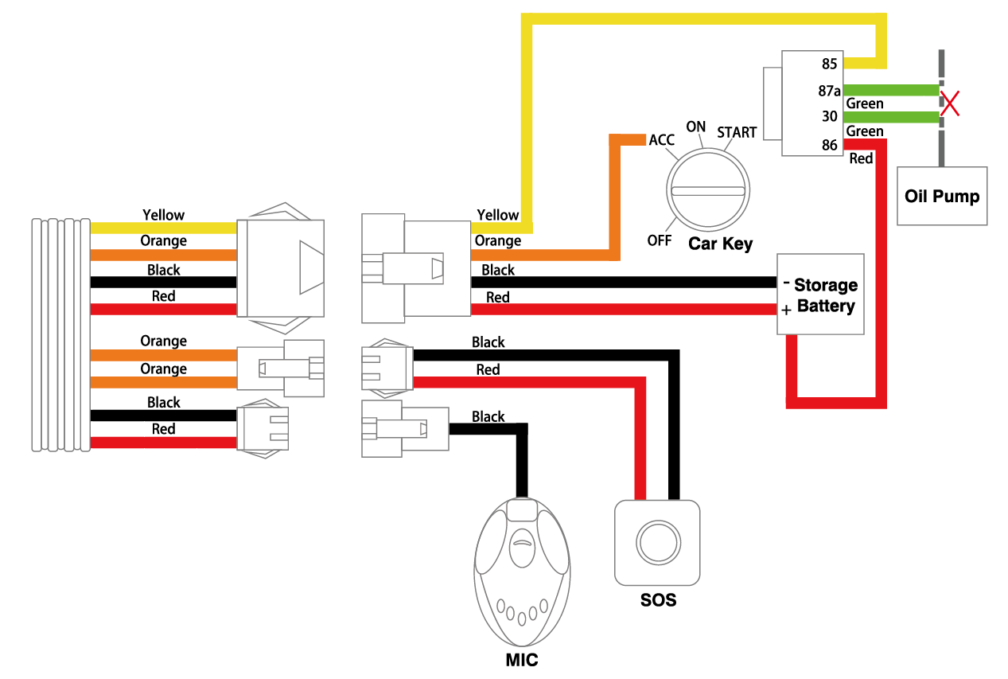

a, Open the cover, Insert a micro SIM card support 4G network into the slot and make sure the chip side is down.

b, Connect power cable and relay follow above picture.

c, Set admin number,by sending a SMS command to the SIM card inside device.
For example: admin123456 +86186******** (+86186********should be your phone number)

d, Set APN: APN123456 CMNET (please use your local APN instead of CMNET,if you do not know the APN content,you should contact your SIM card supplier)
- More Commands
(Note:Command letters are uniformly lowercase or uppercase)
Function | Command Format | Reply | Delete | for example
APN | apn123456,content | apn ok |  | apn123456 cmnet
 | apn123456,content,user name | apnuser ok
 | apn123456,content,user name,password | apnpasswd ok
admin number | admin123456+space+admin phone number | admin ok | admin123456 0 | admin123456 0
time zone | timezone+123456+space+GMT No. | timezone ok |  | timezone123456 +1
Timing mode(default 20s) | upload123456 20 | upload ok |  | RangeValue:10-86400s  (when the frequency is 600s and more, it will become the Timing mode)
Real-tine uploading | d123456
Tracker | tracker123456 | tracker ok
Position | g123456 | Google map
time sleep | sleep123456 time | sleep time ok
shock sleep(default) | sleep123456 shock | sleep shock ok
no sleep | sleep123456 off | sleep off ok
Extra Power off alarm | pwr1 | OK! Pwr Alarm:SMS | pwr0
SOS | SOS,phone1 number,phone2 number | SOS! S1: S2: | sos,, | SOS,186******,189******
SOS Alert | SOS+X | SOS1 |  | (X=0,1,2,3. 0 close,1 SMS,2 Call,3 SMS+CALL
Cut and resume oil | 555 | Cut oil OK | 666
Vibrationalalert way,sensitivity | vib3,9 |  | vibX,Y | X=1,2,3,0 (1 SMS,2 Call,3 SMS+CALL,0 off),y =1-9.
Overspeed alarm (50-120km/h) | speed123456 080 | speed ok
Move alarm (distance:100-5000m) | move300 | move ok | nomove ok
Arm&Disarm | SF | Arm delay in 0s | CF
Automatic arm / disarm  (Off by default) | auto1 | Auto arm by Standby 10 mins:ON | Auto0
Automatic arm / disarm time | acclt,600 | Auto arm by Standby 10 mins:OFF | accrt,20
Restart | rst | restart ok
Back to factory | format | No reply
Firmware update | checkupdate

7.Download phone APP

Method 1: Scan above QR to download;

Method 2: search “LKGPS2” in the app store or Google play store to download.

- Log in by website and phone APP
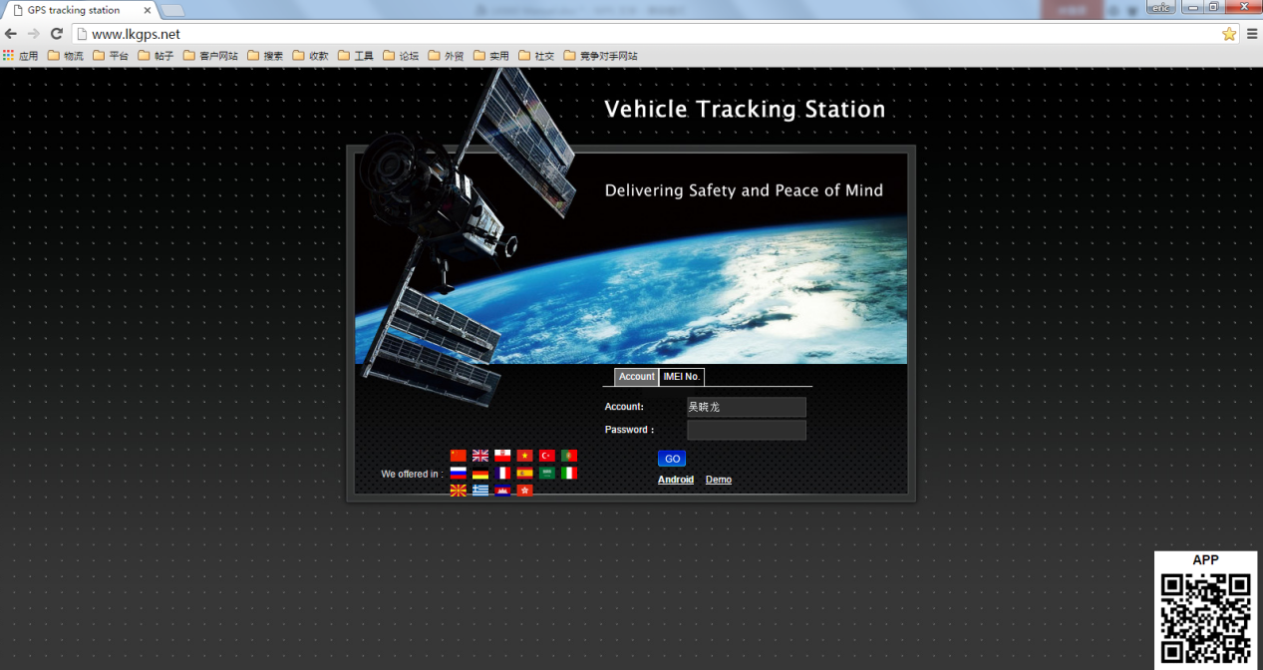
Log in by Website:
Open the website www.lkgps.net , choose IMEI, enter the 10-digit bar code of the device, the default password is 123456, click “GO” to log in into the platform.
Log in by Phone APP:
Please see the following photo:
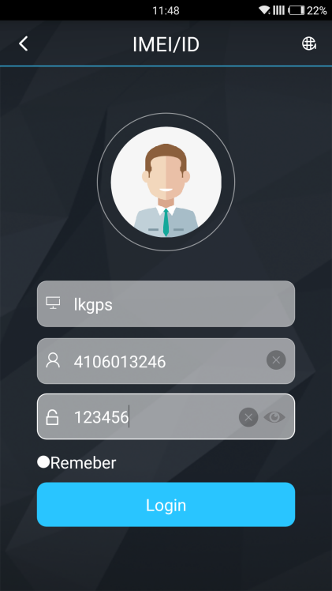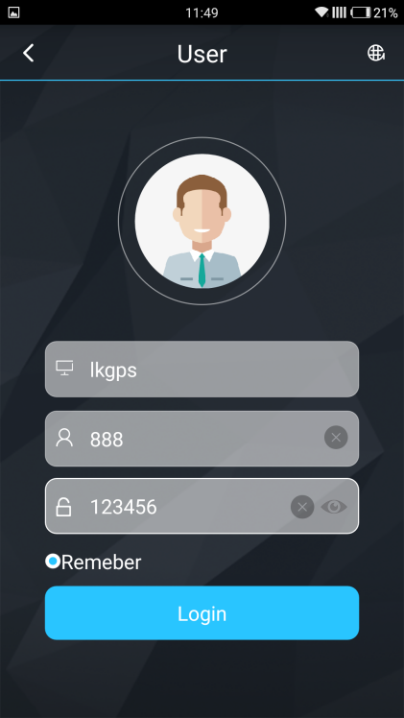

9.Faults & The solutions
Q：Start up Fail?
A：Check the cable connect right or not.

Q：The device can not obtain location information?
A：Place the unit at the open area to test.

Q：How to choose SIM card?
A: the SIM card must support GSM&GPRS，and ensure that the card has enough currency and credit.

Q: How to use in the foreign countries?
A：please set the APN before use，please edit the text “APN123456 CMNET “ and send it to the SIM card of the device，CMNET is Chinese operator’s APN, Replace the corresponding APN when use in other countries, APN details, please consult your local SIM card carrier.

10.Cautions
Please comply with the instructions to extend the unit life:
1. Keep the unit dry. Any liquid, i.e. rain, moisture, may destroy or damage the inside circuitry.
2. Don’t use & store the unit in dusty places.
3. Don’t put the unit in overheated or over cooled places.
4. Handle carefully. Don’t vibrate or shake it violently.
5. Clear the unit with a piece of dry cloth. Don’t clean in chemicals, detergent.
6. Don’t paint the unit, this may cause some foreign materials left in between the parts.
7. Don’t disassemble or refit the unit.
8. Please use the battery and charger provided by manufacturer. Using other batteries and chargers will cause unwanted situation.

