Head-up Display Operations Manual
VT1 (for Tesla only)
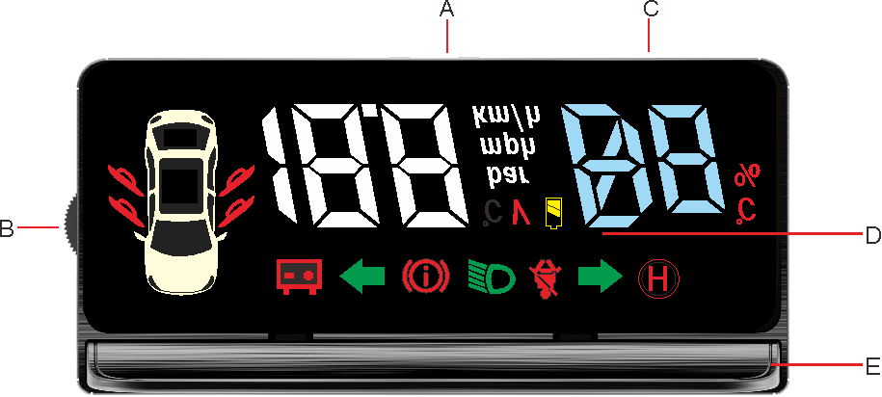
A Reflector B Wheel button C Body D Ambient light
Introduction to screen and its functions 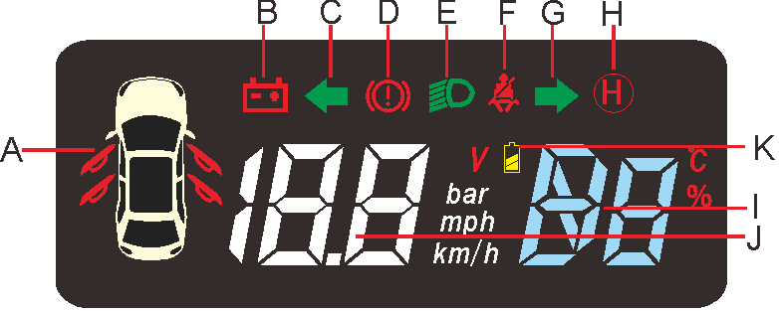
A Door indicator B Battery voltage warning indicator C Left turn signal D handbrake E Dipped headlight indicator F Safety belt indicator G Right turn signal; H Auto-hold/Brake warning indicator I Multifunction display area 2 J Multifunction display area 1 K Low battery warning light

1 Multifunction display area 1: display voltage before ignition, speed after ignition, mileage after, shutdown

2 Multifunction display area 2: display the battery percent, gears when shifting

Way to use the button
normal mode:
Push down: switching display of vehicle speed and voltage
Long press the down key: to display the gear and the battery in turn
Long press the up key: Close (open) the car body
Short press the middle button: enter or exit tire pressure mode
Press and hold the middle button: enter the setting mode
setting mode:
Push down: increase in value
Push up: decrease the value
Middle button: Tap to conﬁrm and long press to exit the setting mode
Introduction to alarm state
1 Voltage alarm When the battery voltage is lower than 11V, the buzzer alarm and the voltage alarm indicators will be on.
2 Handbrake alarm When HUD starts and it detects that the handbrake has not been put down, then the handbrake alarm indicator will be always on.
When speed is greater than 5km/h and the handbrake is not put down, then the handbrake alarm indicatorwill flash
3 Safety belt alarm When the HUD starts and the safety belt is not fastened, then the safety belt alarm indicator  will be always on. When the vehicle speed is greater than 20km/h and the safety belt is not fastened, then the safety belt alarm indicator will ﬂash.
4 Automatic brake When driving, the automatic brake intervenes and the brake warning light  ﬂash; when stopping, the automatic brake intervenes and the brake warning light will be always on.
5 Dipped headlight alarm When it detects that the low beam lamp is on, the low beam lamp indicator  will be always on. When the ambient brightness is insufficient, and the low beam lamp is not turned on, then the low beam lamp indicator will ﬂash.
6 Overspeed alarm When the vehicle speed exceeds 130km/h (default), the buzzer alarms (lasts for 5s) and the indicator of the vehicle speed (unit: km/h) will ﬂash.

Introduction to the setting mode
Long press the middle button of the scroll wheel to enter the setting mode. After that, the version number will be displayed first for entering the setting item 1. At this time, use the up and down keys of the scroll wheel to enter other setting items or press the middle button to enter the setting value. After the setting is completed, first exit to the setting item, and then press the middle button without release to complete the setting.
Reserved settings for tire pressure function, temporarily not supported
HUD installation process
Step 1: Insert the special plug into the vehicle interface in the flameout state.
Step 2: Connect to the HUD unit and conﬁrm whether the functions are normal.
Step 3: Place the HUD unit in an appropriate position and stick it to the dashboard with 3M tape.
Step 4: Arrange the line the way you want. Watch the installation video for specific installation process.
Precautions
1. The information shown by this product is for reference only.
2. The HUD button can be operated only when the vehicle stops.
3. The warranty period is one year and does not cover natural disasters and damages caused by incorrect operations.
4. It is forbidden to clean the panel with chemicals.
5. Accessories such as enclosure, data cable and reflective film are not within the scope of warranty.
6. This Manual is subject to changes without prior notice.
7. The connection line is used for this product only and our company will not take the consequences arising from connection with other product

Product sizes and electrical specifications Accessories
Length: 118Mm 1. HUD unit x1
Width: 56Mm 2. HUD data cable x1
Height: 13.6Mm 3. Special plug wire x1
Operating voltage: OBDII 12V 4. User guide x1
Maximum operating current 450Ma 5. 3M x1
Sleep current 0 Ma 6. reflecting film x1
Operating temperature: -25℃~85℃

Attention:
- For United States , the HUD is compatible with the year 2019-2020 (For model 3). If your Model 3 is before 2019, pls send us your connector phone so that we can send u a right connector from China directly.
- The standard package is for Model 3/Y. If your car is model X/S, pls contact with us for special connector also.
- Due to the vehicle Model 3 is updated software for cars in the year 2021, So. for the cars which are in 2021, the Gear position maybe not display, but other functions is ok.

Specific installation method scan code to watch video：
https://youtu.be/sWyvZTX0EUk

Fast Assistance, please contact:
www.vjoychina.com | sales@vjoycar.com | skype: vjoycar | whatsapp:0086-13621925935

