4G GPS tracking pendant
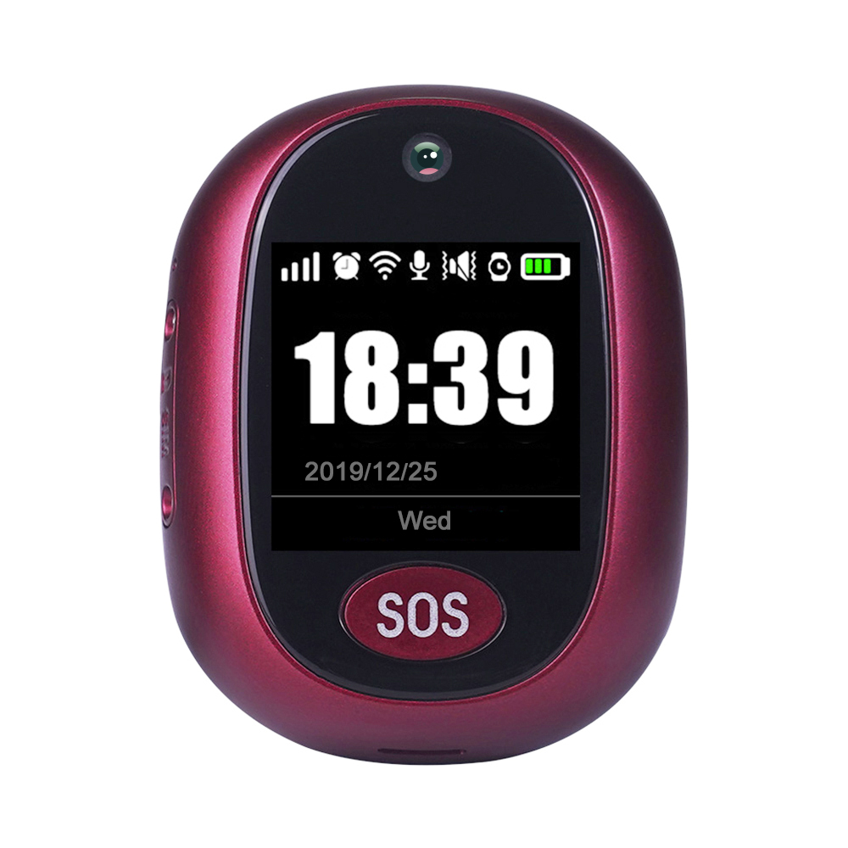

- Important! Please read below statements:
1. Due to external factors all GPS devices have position error, so the position provided by this device just for reference.
2. There may be delays caused by telecom operators at certain circumstance. Our company doesn’t assume to take responsibility of loss causes by this delay.

3. This tracker has version A and B based on frequency bands combinations. Please confirm the bands with your local SIM providers before use.
Main features:
- 4G LTE+3G WCDMA+2G GSM networks
- GPS + LBS +WIFI tracking ways
- Health management with Pill reminder, Step
- Waterproof IP67
- 1.3’ LCD HD screen (240*240pdi)
- Web platform/ Phone App/ SMS for positions check
- High pixel camera for photos
- Talking clock
- Low battery alarm
- Ringtone to find the pendant
Product specification：
Version A bands combination:
4G-FDD： Band 1/2/3/5/7/8
4G-TDD： Band 38/39/40/41
3G-WCDMA：Band 1/2/5/8
2G-GSM： Band 2/3/5/8
Version B bands combination:
4G-FDD： Band 1/2/3/4/5/7/8/12/20/28A
3G-WCDMA：Band 1/2/5/8
2G-GSM： Band 2/3/5/8
GPS locating time：30sec with cold boot (open sky)
29sec with warm boot (open sky)
5sec with hot boot (open sky)
GPS positioning accuracy：5-15m (open sky)
WIFI positioning accuracy：15-100m(Under WIFI range）
Working temperature：-20℃ ~ +70℃
Working humidity：5% ~ 95% RH
Host size：59(L)*45.3(W)*16(H)mm
Host Net weight: 41g
Battery:600mAh
Accessories:
1* GPS Tracker device | 1* USB charging cable
1*Screw driver | 1* User manual.
2*Spare screws | 1* Sim Card Ejector Pin
Step 1: Get a new SIM card：

Get a new Nano SIM card as below instruction.

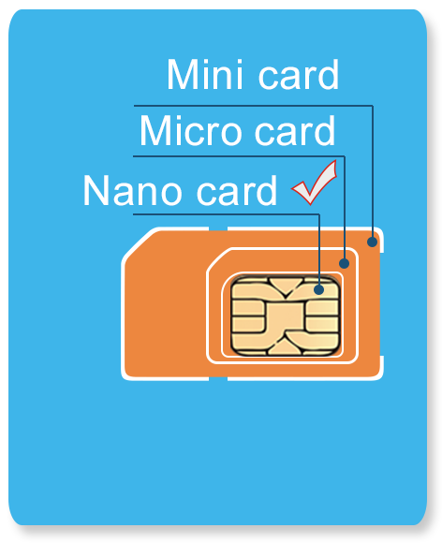
Activate the SIM card’s Cellular data plan and Caller ID display function. (Tracking needs consume data, making phone calls also needs charges.)

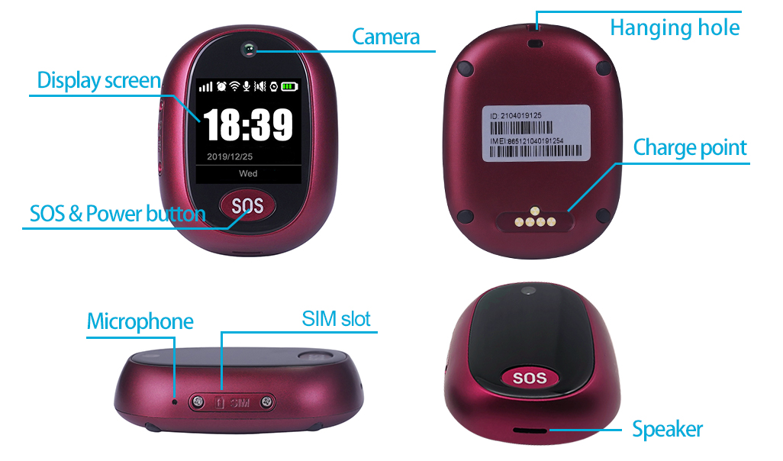
Step 2: Learn your GPS Tracking pendant details:

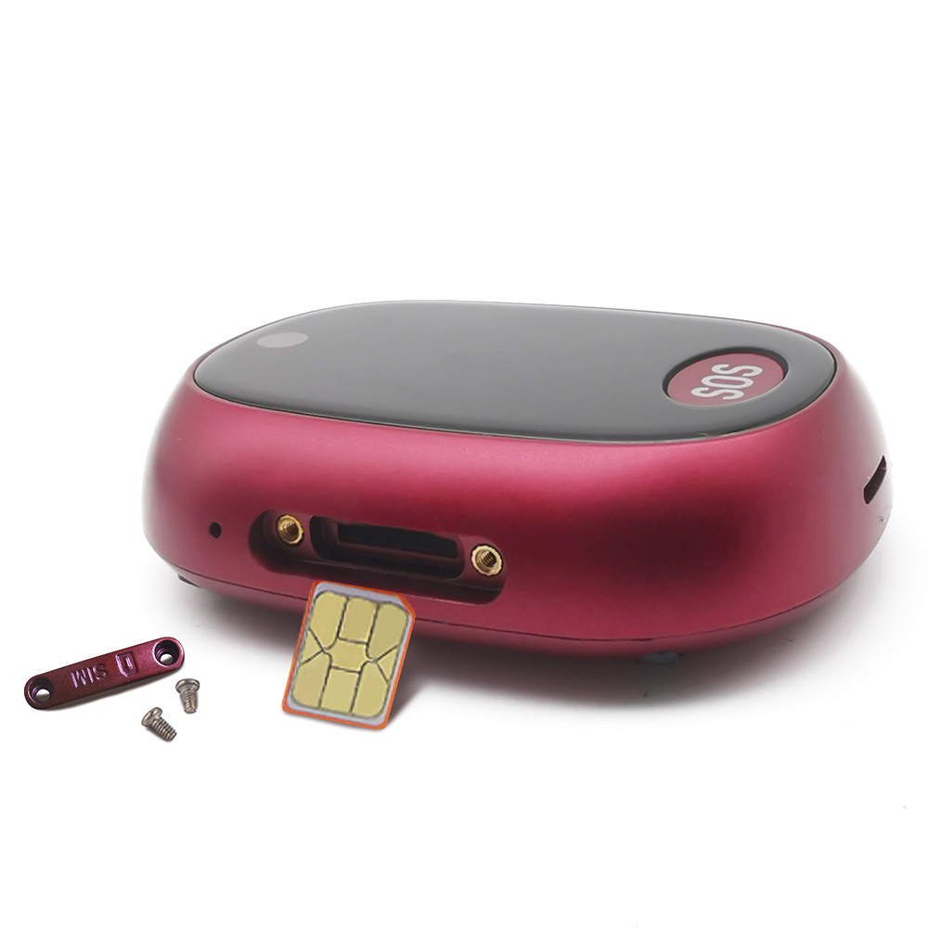
Step 3: SIM card installation and power on
1). Please make sure the tracking pendant is powered off before inserting a SIM card;
2). Open the Sim slot with screw driver and insert a SIM card into the slot according to the direction in left diagram.
3). To ensure waterproof, please install the SIM slot cover with screws as diagram shows.
4). Please use the magnet charger to charge the pendant.
5). Press 5 to 7 seconds of the power button to turn on it. The screen will light up with ringtone.
Status instructions：
When the screen is lit up, it displays GSM signal, battery, date, time and pendant work status as below chart.
 | 4G Network |  | GPS position OK
 | 3G Network |  | WIFI connection OK
 | 2G Network |  | Network signal
 | No Network |  | Battery level
 | No SIM card |  | Alarm clock remind

Step 4：Install APP by tracker Guardian
Our App can be installed by scanning the QR code in user manual or download from Apple store or Google play by searching “Anytracking”.
Web platform：www.gps123.org; Same login way as the one for App.
Step 5: Login App
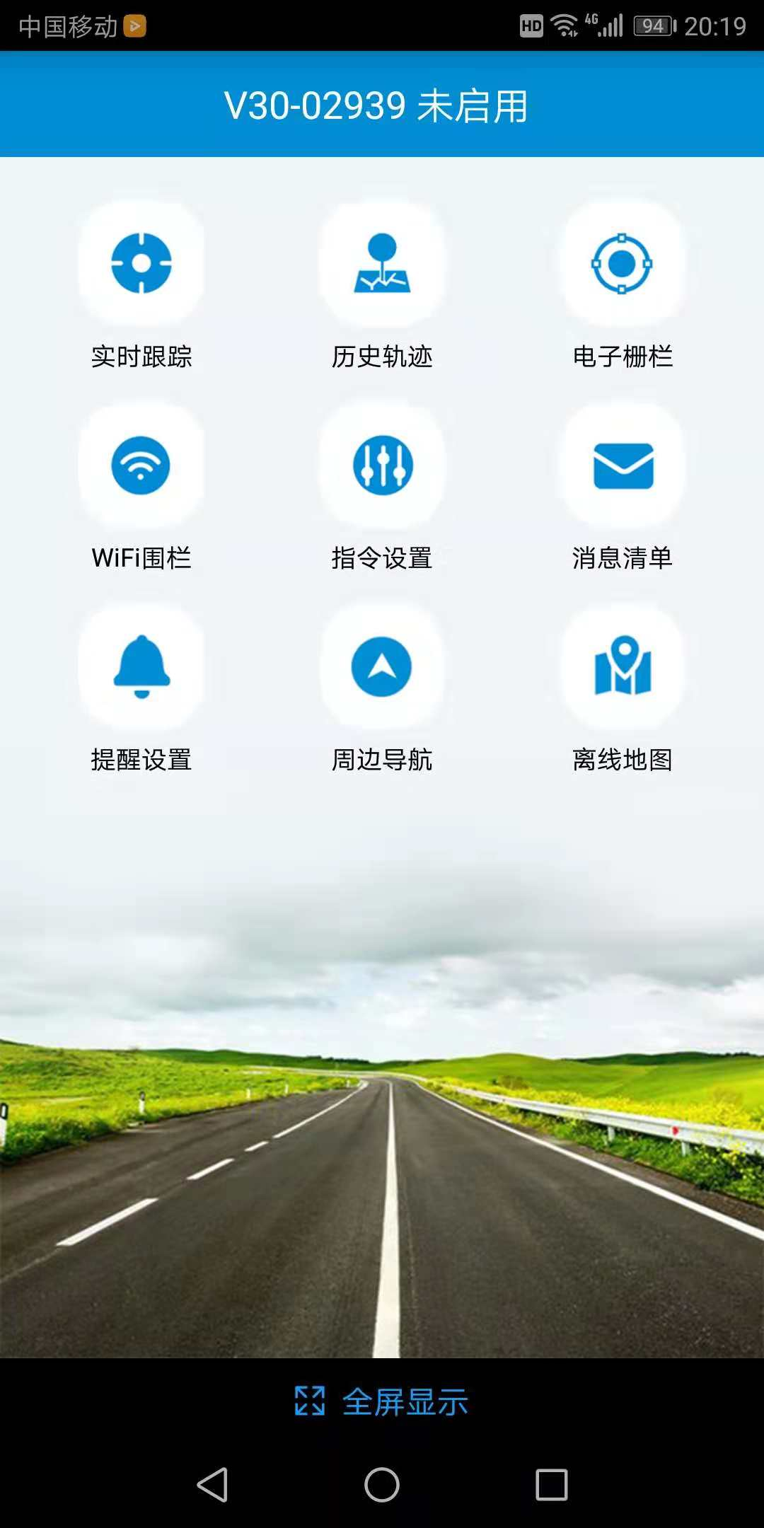
Login the App with the 10 digits ID No. on back label, default password is 123456. (To monitor more pendants at the same time, please contact the seller for a user account.)

Step 6: Location check
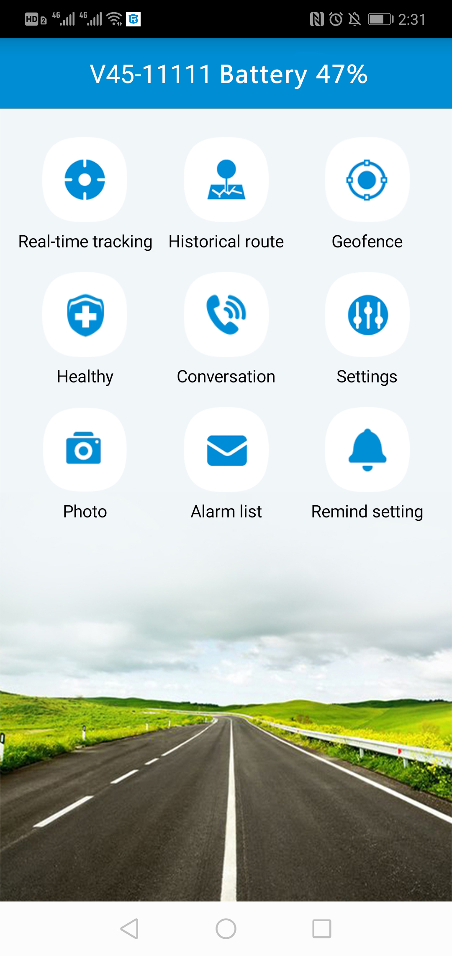
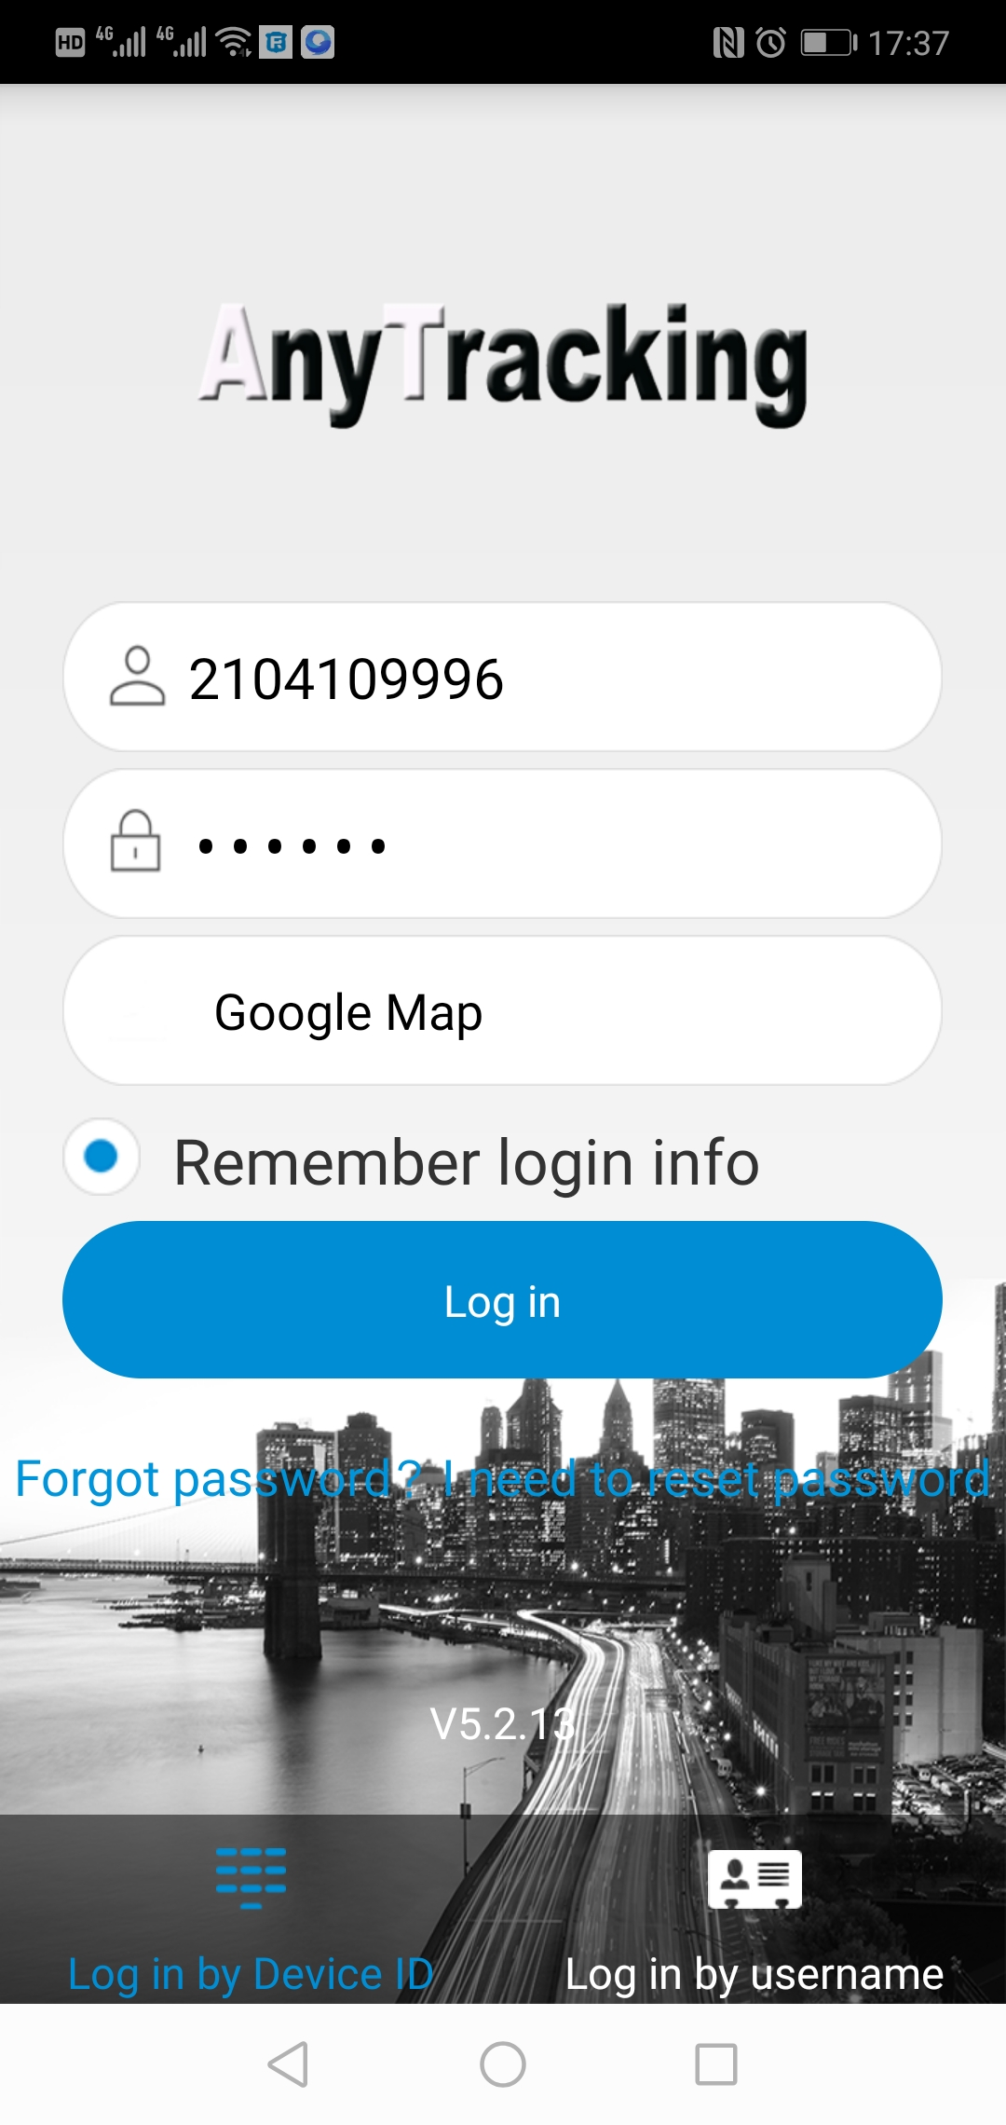
- Real time tracking and interval for uploading：Display the last location of GPS pendant. For the latest location, press the “Single-refresh” button on map upper right corner. Press the “interval for uploading” and choose different interval times.
- Historical route: Display the historical route of any day in recent 90 days. You can choose whether to filter out LBS location data. (note: LBS means the location data indoors, the accuracy is not good.)
- Geo-fence: Add, check or cancel geo-fence.
- GPS-fence: when the device gets into or out of the GPS-fence. The App will get alert. (note: we suggest the radius of GPS-fence over 300 meters to reduce false alerts.)
WIFI-fence：You can set 2 WIFI safe zones, when device leaves safe WIFI zones, the App will give notification.
- Health：
- Sedentary: Set sedentary reminder time period in App.
Health Step：Turn on this from both App and pendant settings to get wearer’s motion status.
Pill Alarm：Set medicine reminders accordingly.
- Conversation:
Call to Tracker: To call your pendant when click it; (This function works after filling in “Device phone number” in section of “About the device”.)
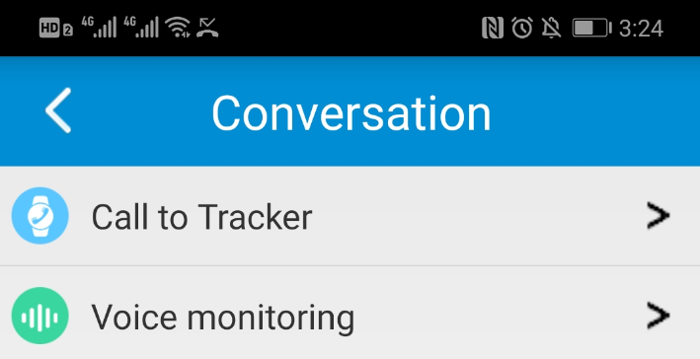
Voice monitoring: To request a one-way call from pendant to the monitoring number preset and hear the sound around the pendant.

- Settings：All settings need to work when App shows device online with the sim card’s data plan.
About the device：Check and edit tracker pendant’s information.
Change password：Change APP and Web platform’s password.
Main monitoring number：The number used for commands sending and SMS alerts receiving.
Set SOS number：Preset SOS numbers, when user long presses the SOS key, the tracker will call to these 3 SOS numbers. If no number answers, tracker will call them twice cyclically.
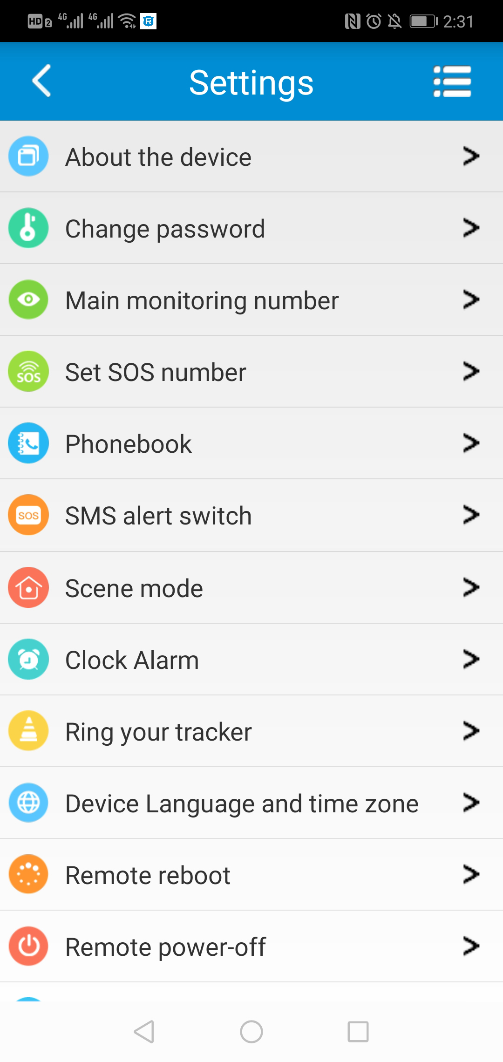
Phone book: Set at most 15 family-numbers for quick dialing calls in phone book. Other numbers calling will be rejected by the pendant.
SMS alert switch：Turn on this setting to enable the pendant to send SMS alerts to main monitoring number or turn off it.
Scene mode: Set the alarm ways of pendant’s coming call, pill reminder, alarm clock, etc. There are four modes: Ringtone reminder, vibration reminder, ring & vibration reminder and no reminder.
Clock alarm: Set three different alarm modes accordingly.
Find device: After the command sent, the pendant will give out ringtone to guide the guardian to find pendant and the wearer fast.
Device Language and time zone: Set pendant SMS alerts’ language and time zone. Options are Chinese and English; default time zone is +8.
Remote reboot: To reboot the pendant from this setting.
Remote power-off: To power-off the pendant remotely. (The pendant can be only turned on by manually after this setting. Please use with caution)
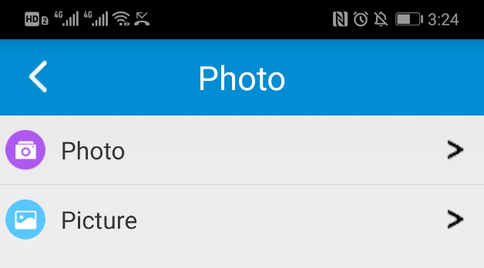
Factory-Reset: To default the device back to factory settings.

- Photo:
To request the pendant to take photos by App command.
Picture:
To check photos taken when SOS alert was triggered and taken by App command.
Step 7: Operation of the GPS pendant:
- Calling
SOS urgent help: Press the pendant SOS buttonfor3-5 seconds, the pendant will call the SOS numbers set in App until some of them picks up the call. Otherwise, the pendant will call all of them twice cyclically. Once SOS triggered, the pendant will take a photo of surroundings and sends it to the App for guardian to check.
Picking up a call: When a call comes, the screen will display with ringtone and vibration reminder. The pendant will pick up the call after two rings automatically; Press the button to reject the coming call.

Step 8: Power off the pendant
- When no SIM card in the pendant, press the power button for 5 to 7 seconds till a ringtone to power off it.
- When a SIM card inside, to avoid wrong operation, the pendant can be powered off only via App setting.
FAQ：
Q: After inserting a SIM card, it can get an SMS reply, but it displays “Not enabled” on the platform and APP.
A: Please check the pendant SIM Card has LTE data plan.

Q: Device shows online, but it shows “wait for the device responses” when you make settings with APP.
A: a. Device SIM signal is not good with poor GPRS data;
b. Device is busy in other process. Please wait a minute and try again.

Q: When call the pendant, it replies the number is busy now.
A: a. Please check the calling number was preset in App “Phonebook”. To ensure pendant user’s safety, we set only numbers in “Phonebook” get through calls to the pendant.;
b. Please make sure the pendant SIM card has caller ID display service.

Q: The displayed time on pendant screen.
A: The time display will adjust automatically when it has a SIM card and works with data.

Q: The location didn’t update in App map, but time updated?
A: a. Please take the pendant to open sky and click refresh button in App map to start a single location uploading;
b. The pendant enters sleep mode to save battery when it keeps stationary. Move the pendant to activate it from sleep mode and refresh the location in App map.

Q: The SIM card has 4G data plan, but the device still shows “Not enabled “or “offline”.
A: It needs to configure APN data, since we have pre-programmed most SIM cards’ APN, but hasn’t. Find out your pendant SIM card’s APN name, APN user name, password, MCC and MNC codes before doing below settings.
Please set main monitoring number first by sending below command from your own phone to the pendant sim number.
pw,123456,center,your own phone number#
After a reply, send below command to set APN into the pendant.
The command is: apn,apndata,user,password,MCC MNC code#
If user name and password are blank, please send the command as below way:
apn,apndata,,,MCC & MNC code#

(Note: The yellow parts are different according to different SIM providers. If user and password are blank, delete them from the command, but keep the comma. There is no space between them and all letters shall be in lowercase style.)

Q: Sometimes the WIFI fence has no alarm.
A: a. The tracker pendant doesn’t support 5G WIFI. For android phone, please choose 2.4G WIFI hotspot as WIFI fence;
b. IOS phone will choose the phone connecting WIFI for fence. If your phone connecting WIFI is a 5G one, please don’t set WIFI fence to avoid false alarm or no alarm situation.

Scan the QR code to download our free App

