4G GPS Tracker

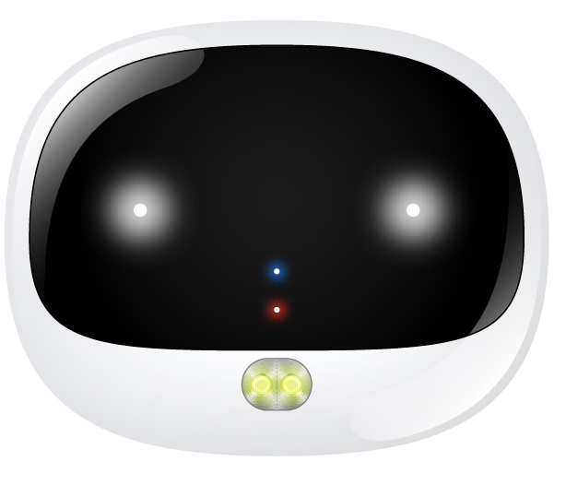

Important! Please read below statements:
1. Due to external factors all GPS devices have position
error, so the position provided by this device just for
reference.
2. There may be delays caused by telecom operators at
certain circumstance. Our company doesn’t assume to take responsibility of loss causes by this delay.

Main features:
- 4G LTE+3G WCDMA+2G GSM networks
- Waterproof IP67
- LED rolling lights based on light sensor automatically
- GPS positioning, with accuracy of 5m outdoor
- WIFI positioning, with accuracy of 30m indoors
- Web platform/ Phone App/ SMS for positions check
- Historical route
- Geofence: GPS fence & WIFI fence double care
- Step counting
- Voice monitor
- Low battery alarm
- Ringtone to find your pet

Product specification：
Version A bands combination:
4G-FDD： Band 1/2/3/5/7/8
4G-TDD： Band 38/39/40/41
3G-WCDMA：Band 1/2/5/8
2G-GSM： Band 2/3/5/8
Version B bands combination:
4G-FDD： Band 1/2/3/4/5/7/8/12/20/28A
3G-WCDMA：Band 1/2/5/8
2G-GSM： Band 2/3/5/8
GPS locating time：30sec with cold boot (open sky)
29sec with warm boot (open sky)
5sec with hot boot (open sky)
GPS positioning accuracy：5-15m (open sky)
WIFI positioning accuracy：15-100m(Under WIFI range）
Working temperature：-20℃ ~ +45℃
Working humidity：5% ~ 95% RH
Host size: 52(L)*42(W)*15(H)mm
Host Net weight: 35g
Battery capacity: 500mA
Accessories:

1* GPS anti-lost host | 1* back clip
1* USB magnet charging cable | 1* User manual.
2* Extra screws | 1* Screw driver

Step 1: Get a new SIM card：
1). Get a new Nano SIM card.
Choose Nano SIM card as below instruction.
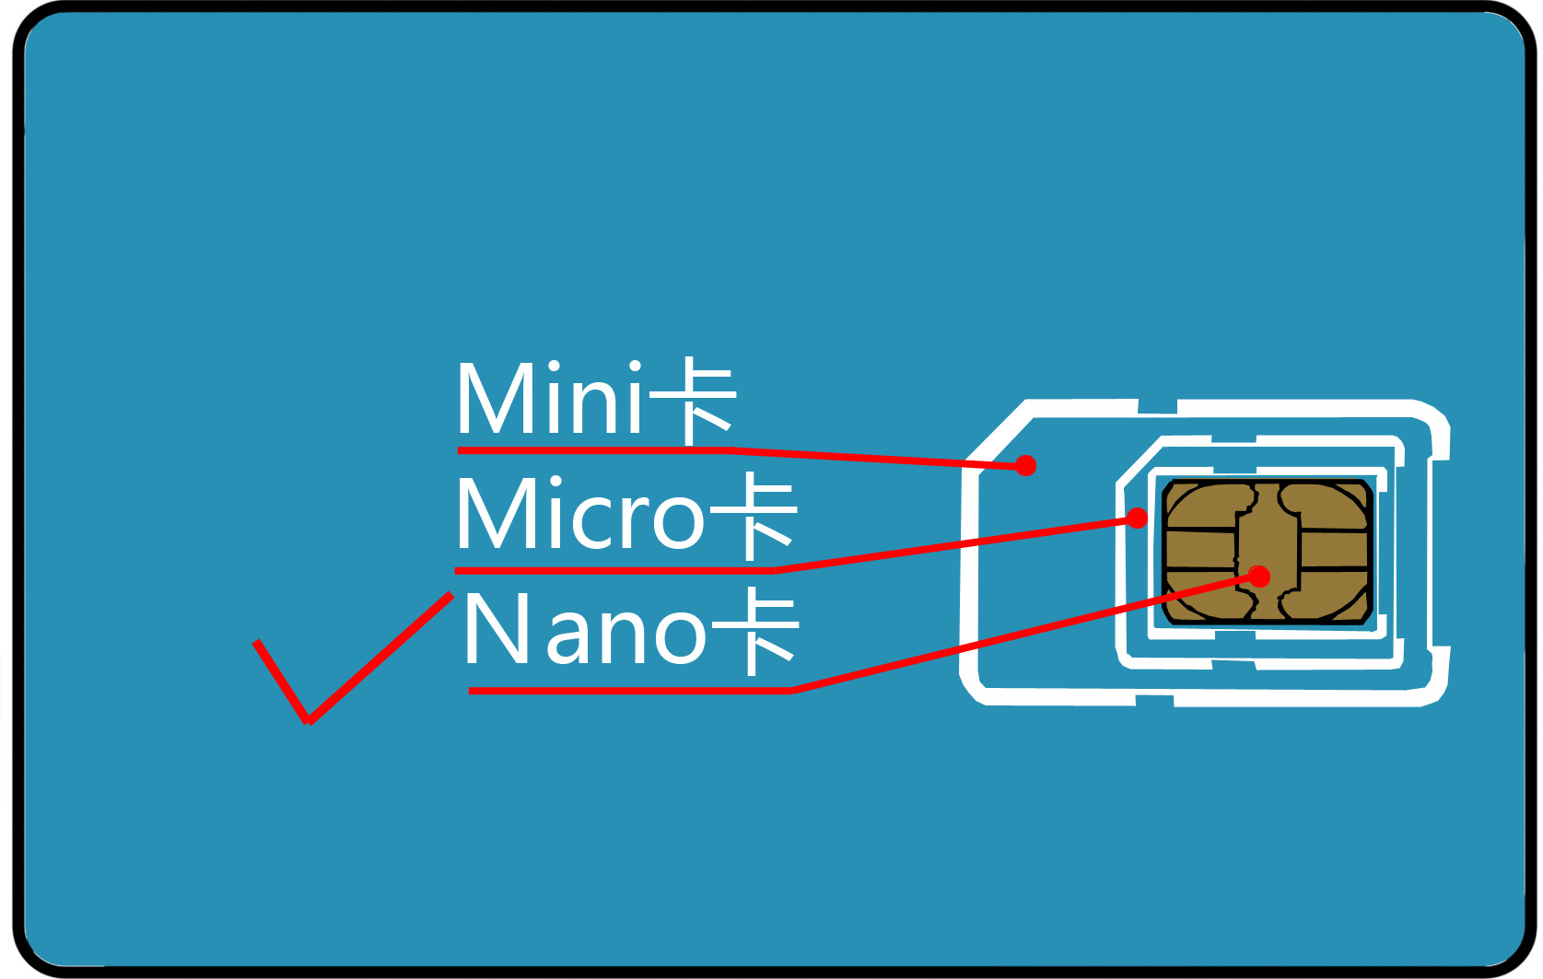
2). Activate the SIM card’s Cellular data plan and Caller ID display function. (Tracking needs consume data, making phone calls also needs charges.)

Step 2: Learn your Tracker device details:
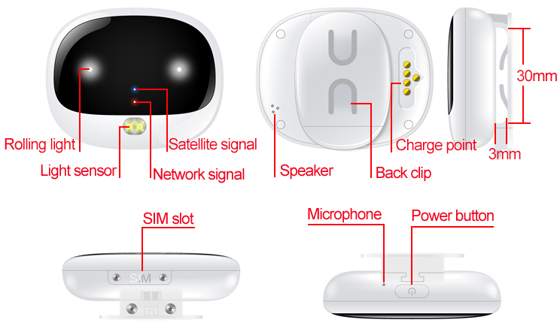

Step 3: SIM card installation and power on
1). Please make sure the tracker is powered off before inserting SIM card;
2). Open the Sim slot with screw driver and insert SIM card into the slot according to the direction in diagram below. When in correct way, the SIM card will give an elastic feel. If not, please stop and check SIM direction. (Warning: Wrong SIM card direction will cause damage to SIM base for normal use.)
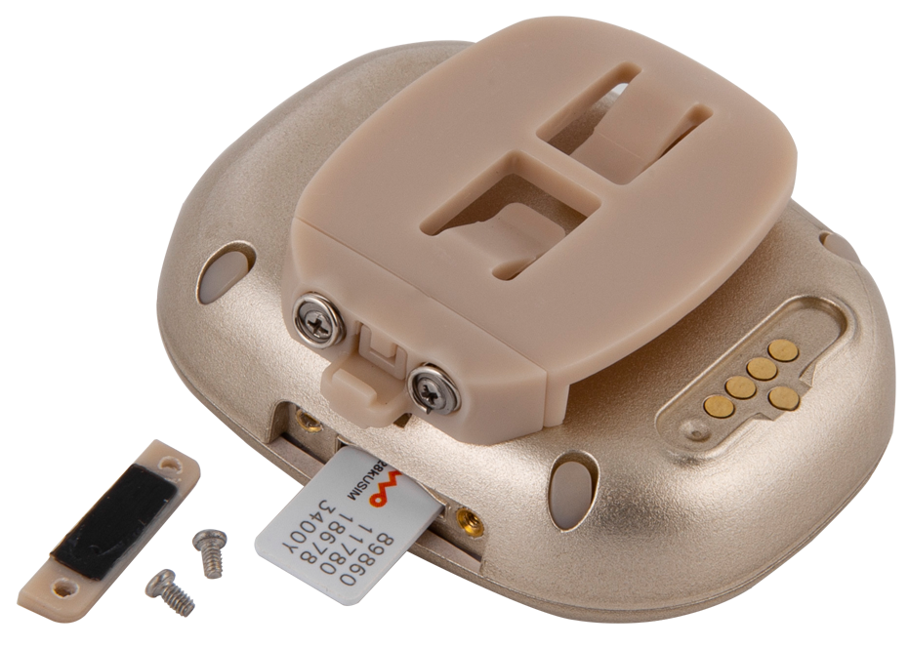
3). To ensure waterproof, please install the SIM slot cover with screws as diagram shows on right.
4). Please use the magnet charger to recharge the device.
5). Press 5 to 7 seconds of the power button to turn on it. (The front blue and red indicator lights on for 2 seconds and release the button.)

Indicators instructions：
1. GPS and GSM indicator details：
Color | Function | Slow flash | Fast flash | Off
Blue | GPS signal | Searching | Searched | Sleep
Red | GSM signal | Searching | Searched | Sleep
2. The 3-colored 2 smart rolling LED lights on device front face: when the environment gets dark, they will flash automatically, easier to know activity status of your pet. (As this function consumes battery fast, it is off by default. If need it on, set in App.)

Step 4：Install APP by tracker Guardian
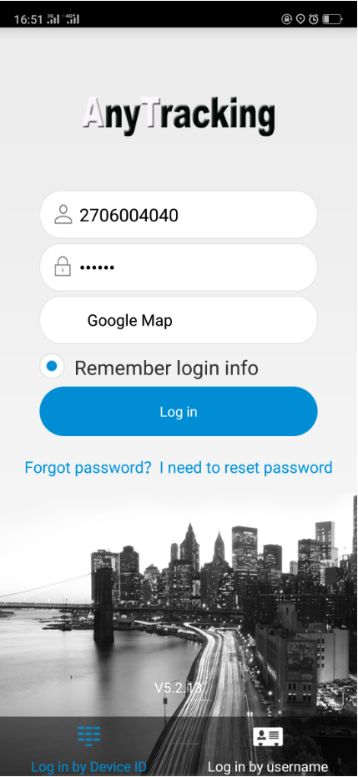
Guardian needs to scan the QR code in last page of this manual with smart phone, download and install the tracking App.

Step 5: Login App
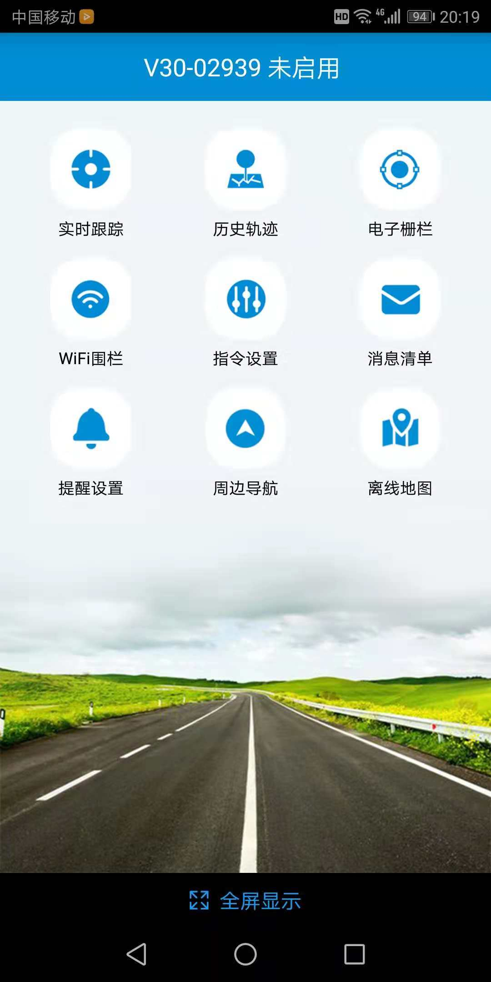
Login the App with the 10 digits ID No. on device back label, default password is 123456.
Step 6: Location check
- Real time tracking and interval for uploading：Display the last location of GPS tracker. For the latest location, press the “Single-refresh” button on map right top. Press the “interval for uploading” and choose different interval times.
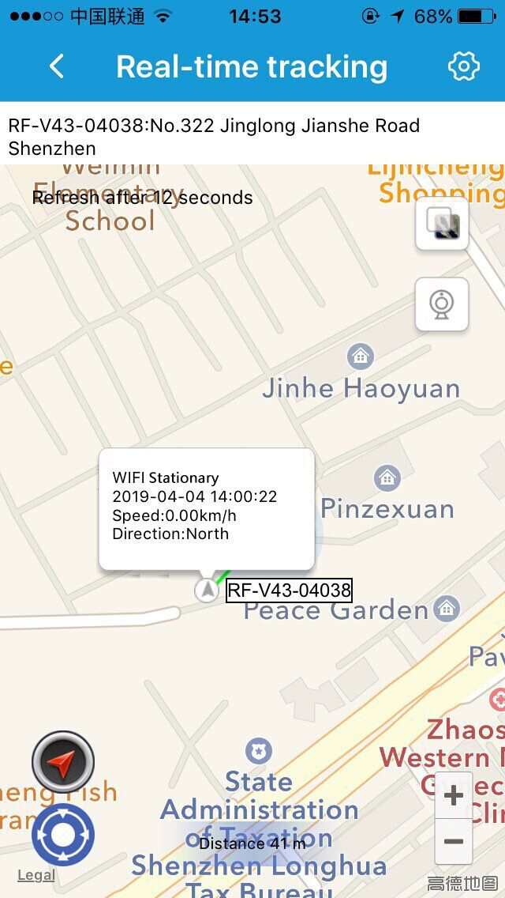
- Historical route: Display the historical route of any day in recent 90 days. You can choose whether to filter out LBS location data. (note: LBS means the location data indoors, error is large)
- Geo-fence: Add, check or cancel GPS-fence area, when the device gets into or out of the GPS-fence. The App will get alert. (note: we suggest the radius of GPS-fence over 300 meters to reduce false alerts.)
- WIFI-fence：You can set 2 WIFI safe zones, when device leaves safe WIFI zones, the App will give notification.

Step 7：App Settings
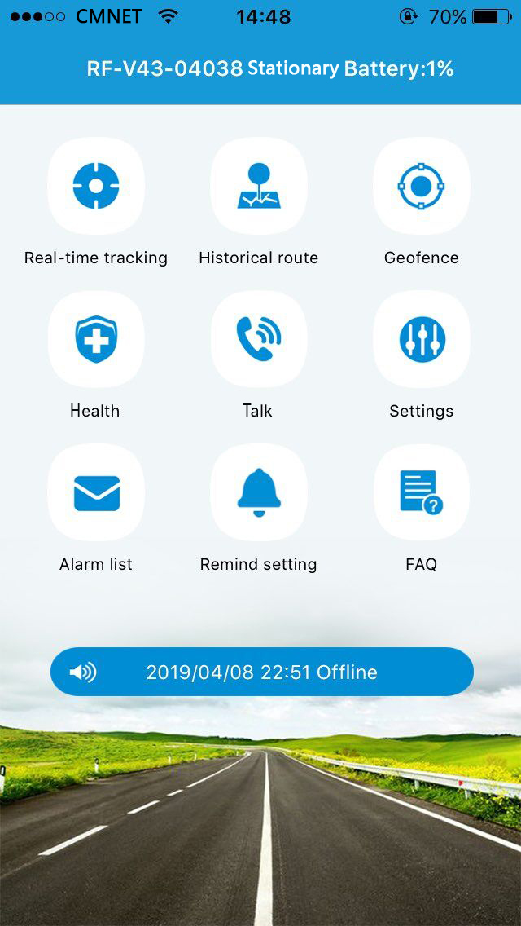
- Health：Check your pet’s health status, including steps and energy consumption.
- Talk:
1). Call to tracker: To call your pet tracker when click it;
2). Voice monitoring: To request a one-way call from tracker to the number you type and hear the sound around tracker.
- Settings
All settings need to work when App shows device online with the sim card’s data plan.
- About the device：Check and edit tracker’s information.
- Change password：Change APP and Web platform’s password.
3.Main monitoring number：The number used for commands sending and SMS alerts receiving.
4.Set SOS number：Preset SOS numbers to monitor the sound around tracker. (Note: For privacy of tracker user, non-SOS numbers couldn’t call the tracker.)
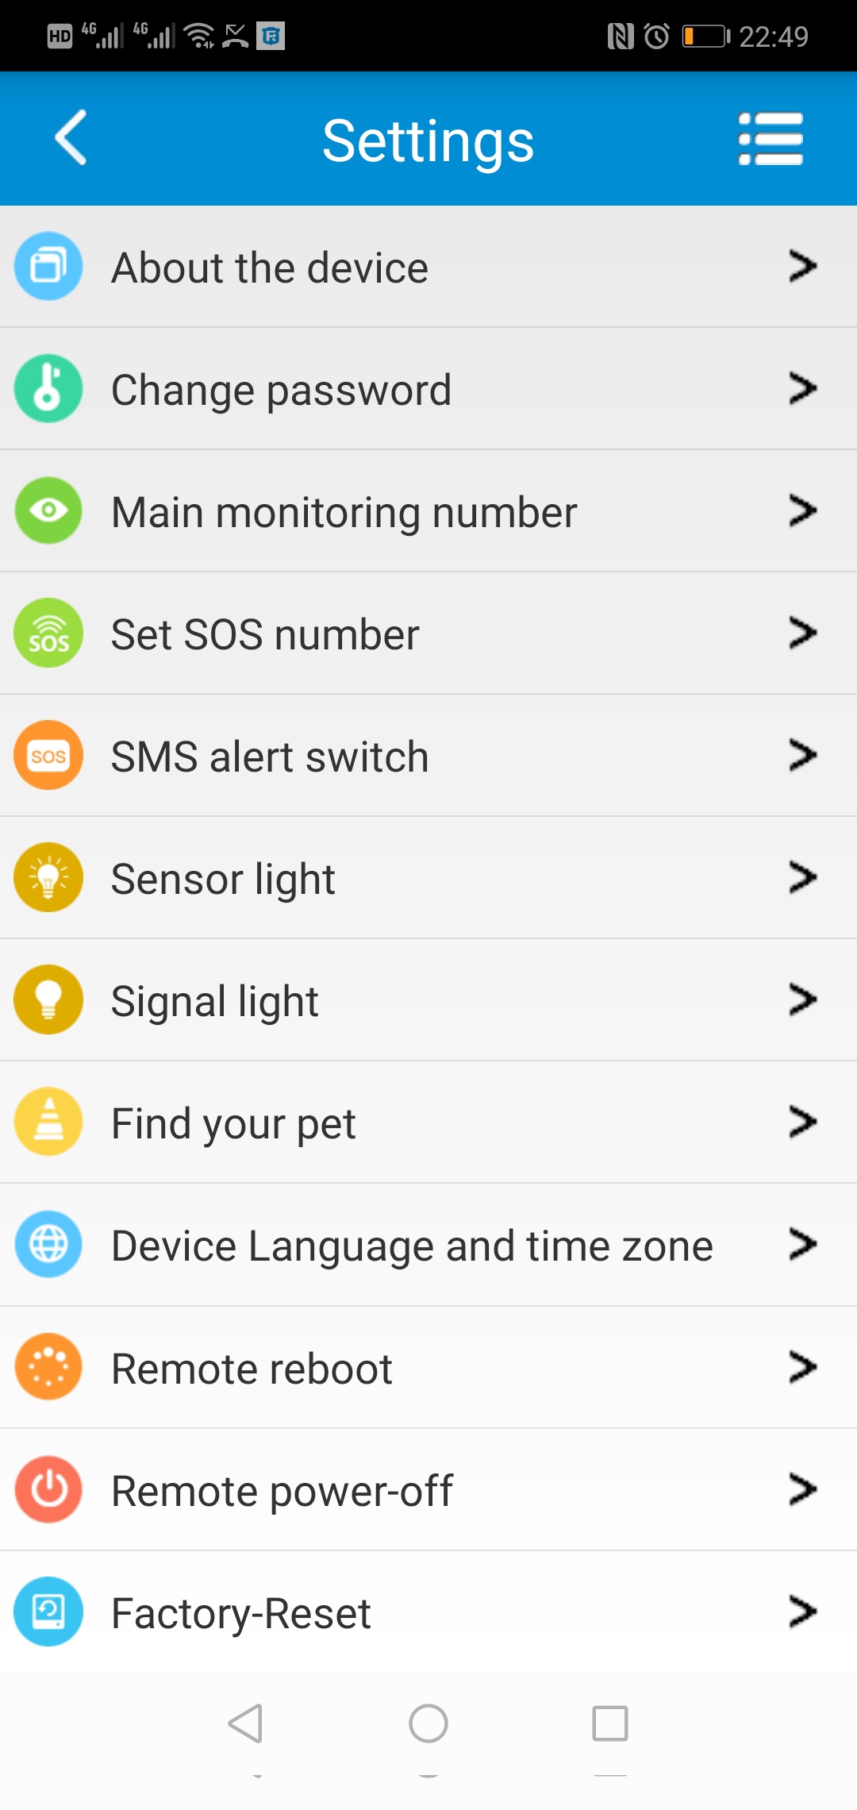
5. SMS alert switch：Turn on this setting to enable the tracker to send SMS alerts to main monitoring number.
6. Sensor light: Turn on or off the sensor lights on tracker, to enable they to be automatically on in darkness surroundings, which makes the tracker easier to be found.
7.Signal light: Turn on or off the signal indicator lights on tracker;
8. Find your pet: When activate this function, the tracker will send out ringtone for being found easily.
9.Device Language and time zone: Set tracker SMS alerts’ language and timezone. Options are Chinese and English.
10. Remote reboot: To reboot the tracker from this setting.
11. Remote power-off: To power-off the tracker remotely.
12. Factory-Reset: To default the device back to factory settings.
- Alarm list: To list all alerts sent by tracker.
- Remind setting：To turn on or off App notifications and modes of them.
- Logout: Log off from the App, and no more notification from the tracking App.
For more functions of the App and web platform, please login our PC tracking platform: www.gps123.org.

Step 8: Power off the tracker
1. When no SIM card in the tracker, press the power button for 5 to 7 seconds till a ringtone to power off it.
2.When a SIM card inside, to avoid wrong operation, tracker can be powered off only via App setting.

Matters need attention：
- Please use this tracker in the area of good network signal.
- For a better performance, please charge the new device for 3 hours.
- Standby time: When location uploading time is every 10 minutes, the standby time is 72 hours, talking time is 6 hours (Actual test); When turn off APP and web platform function, the standby time is about 15 days. Note: Above test data is under the status of strong GSM network.
- To extend battery life, please recharge and discharge the tracker fully at least one time in 3 months.
- To get a good waterproof effect, please fasten the screws after inserting a SIM card and cover the SIM slot rubber with right direction.
- The tracker is waterproof IP67, but we don’t suggest to dip it into water for too long time or swim with it.
- Please don’t open the tracker case by yourself, as it may affect the waterproof and lose the warranty right.
- The tracker uses Cell tower signal (LBS/GSM) or WIFI when indoors, the locating accuracy depends on tracker distance to signal tower and other facts, like metal and surroundings. Due to the restrictions and influences of the use environment, the civil equipment has deviations in positioning which is not a quality problem, and is not subject to quality problems for after-sales processing.

FAQ：
Q: After inserting a SIM card, it can get SMS reply, but it displays “Not enabled” on the platform and APP.
A: Please check the tracker SIM Card has GPRS data plan.
Scan the QR code for App download
Search: Anytracking
in IOS App Store or Google Play

Q: Device show online, but it shows “wait for the device responses” when you make settings with APP.
A: a. Device SIM signal is not good with poor GPRS data;
b. Device is busy in other process. Please wait a minute and try again.

Q: The SIM card has GPRS data plan, but the device still shows “Not enabled “or “offline”.
A: It needs to configure APN data, since we have pre-programmed most SIM cards’ APN, but hasn’t. Please set main monitoring number first by sending below command from your own phone to the tracker sim number.
pw,123456,center,your own phone number#
After a reply, send below command to set APN into the tracker.
The command is: apn,apndata,user,password,MCC MNC code#

(Note: The yellow parts are different according to different SIM providers. If user and password are blank, delete them from the command. There is no space between them and all letters shall be in lowercase style.)

