OBD multi-function LCD
Model: V10
user 's manual

Before using this product, please read the manual carefully, fully understand and play all the functions of the product. So that you can experience the speed at the same time to ensure their own driving fun and safety
Product description
Thank you for purchasing the automobile OBD multi-function display produced by our company. This product reads the driving data of the vehicle through the OBD2 platform of the car ECU computer, such as vehicle speed, rotation speed, fuel consumption, water temperature and voltage, etc., and instantly reads the driving information under the condition that the wide field of view does not shift during the car driving, so as to prevent the driver from driving Looking down at the instrument during the process affects safety, this product does not rewrite any data in the ECU.
The OBD universal driving computer is equipped with a very powerful fault detection device. The system clearly displays the fault information in the form of text, and has the function of eliminating the fault. It has an accelerated competition mode display, a brake performance test display, and a readout of the entire vehicle. Data flow information display, and other functions in one.
It adopts the latest integrated circuit design with stable performance, beautiful appearance, more convenient and safe installation method, installation and adjustment test can be completed in 3 minutes.

- Instrument appearance
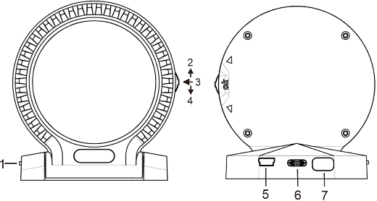
Description of each component:
1. Power switch
2. Up key, swipe up
3. OK key, press down vertically
4. Down button, toggle down
5.OBD B instrument serial interface
6.OBD A cable data interface
7. Automatic photosensitive window

- Instrument installation
1.Prepare LCD instrument and OBD cable before installation
2.Find the automobile OBD interface and connect the OBD cable with the instrument
3.Start the engine and turn on the power switch
4.The instrument is powered on for self-test and the boot screen is displayed. After the self-test is completed, the working interface is entered and the installation is completed
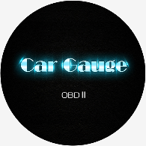
Boot screen

- Instrument fixing
1.Tear off the adhesive film at the bottom of the liquid crystal meter and fix it at the appropriate position according to personal vision
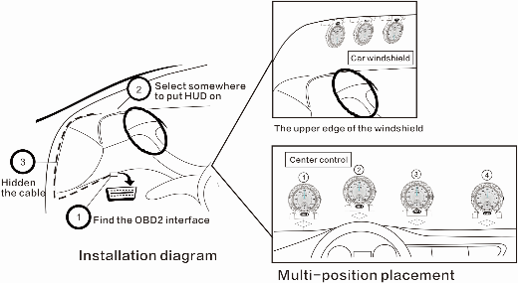

2. LCD meters can support multi-table series. If you need to display different pictures and data, you can buy multiple series (it is recommended that no more than 5 series meters should be used)

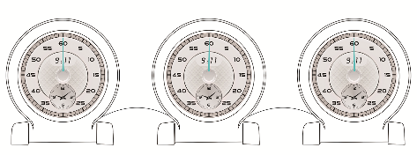

l Normal use
In the normal working state of the machine, you can short press the up, middle and down keys to switch the displayed contents.
1 .Short press the up key to display five main interfaces in a cycle:

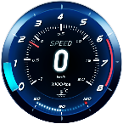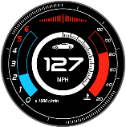
1 2 3

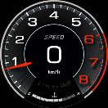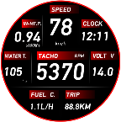
4 5

2. Press OK key to display the clock interface
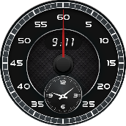

3.Short press key to cycle display 7 kinds of pointer + digital interface (the function only supports some vehicles).
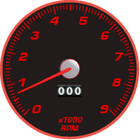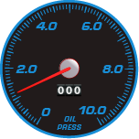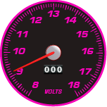
RPM Oil pressure Voltage

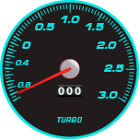 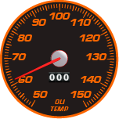 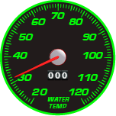Turbine pressure Oil temperature Water temperature
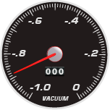
Vacuum ratio
l System settings
In the normal working state of the machine, press and hold the OK key for 3 seconds to enter the main setting menu.
You can dial the up and down keys to the item to be set and press OK to enter the setting.After setting, press and hold the OK key to exit and save.
System settings
1 | Function setting
2 | Alarm settings
3 | Unit setting
4 | Function testing
Set main menu
Function setting：
Function setting
1 | return
2 | language | English
3 | Buzzer | OFF
4 | Flip screen | OFF
5 | Time: hours | 00
6 | Time: minutes | 00
7 | brightness | 0
8 | Speed coefficient | 100
9 | Fuel consumption coefficient | 331
10 | Starting voltage threshold | 1.7V
11 | Off Mode | 1
12 | Restore factory settings
1. After setting, return to the upper menu
2. Language: you can choose simplified Chinese, traditional Chinese and English
3. Buzzer: this function can turn on and off the buzzer sound
4. Flip screen: turn on this function if the machine is installed upside down
5. Time: hour: set hour value
6. Time: minute hand: set minute hand value
7. Brightness: set screen backlight brightness, 0 for automatic adjustment, 1-5 for manual adjustment.
8. Speed factor (default: 100)
If the speed displayed by the machine is inconsistent with the instrument panel, this parameter can be adjusted for calibration.If the machine displays 100km / h and the car dashboard displays 98, set the value to 98, and vice versa.
9. Fuel consumption factor (default: 331)
The fuel consumption of different displacement models is different. It is necessary to set the corresponding instant fuel consumption coefficient. The system default fuel consumption coefficient is 331. If the fuel consumption displayed on the instrument panel is greater than or less than the fuel consumption displayed on the machine, the coefficient can be increased or reduced until it is close to or accurate.
10. Threshold value of starting voltage: threshold value of voltage fluctuation for engine starting (default value: 1.7V)
11. System auto shutdown mode (default: 1)
1 It is intelligent mode. If the engine speed and
vehicle speed are both 0, the system will shut down
automatically.
2 It is a normal mode. If the vehicle data cannot be read correctly, the system will shut down automatically. It is recommended that vehicles with automatic start and stop should use this shutdown mode.
12: restore factory settings: this function can be restored to the factory preset value
Alarm setting：
Alarm settings
1 | return
2 | Fatigue driving | 120min
3 | water temperature | 115℃
4 | Speed 1 | 150km/h
5 | Speed 2 | 150km/h
6 | Speed 3 | 150km/h
7 | Speed 4 | 150km/h
8 | Battery low voltage | 10.5V
9 | Battery high voltage | 16.5V
1. After setting, return to the upper menu
2. Fatigue driving: the default is 120 minutes
3. Water temperature alarm: the default is 115 ℃
4-7: speed 1 --- speed 4: four different speed alarm values can be set, and the default value is 150km / h
8.Low battery voltage alarm: the default value is 10.5V
9.Battery high voltage alarm: the default value is 16.5v

Unit setting：
Unit setting
1 | return
2 | temperature | ℃
3 | speed | Km/h
1.After setting, return to the upper menu
2.Temperature unit: degree centigrade, degree Fahrenheit
3.Speed unit: km/h, mile unit mph
Function testing：
Function testing
1 | return
2 | Clear DTC
3 | Brake test
4 | Accelerated test
1.After setting, return to the upper menu
2.Clear DTC：Clear fault code
3.Brake test：Automatically trigger and calculate braking distance and time from 100km / h to 0km / h
4. Accelerated test：Automatically trigger and calculate acceleration time from 0km/h to 100km/h

