Car GPS Slope meter
(Model:VP18)

Product Introduction：
HUD short for Head Up Display,The main function is to display the car dashboard information (e.g.speed,Driving direction, altitude etc ),and keep the driver eyes always on road to avoid the dangerous of lowering down head to read the dashboard.

Product function:
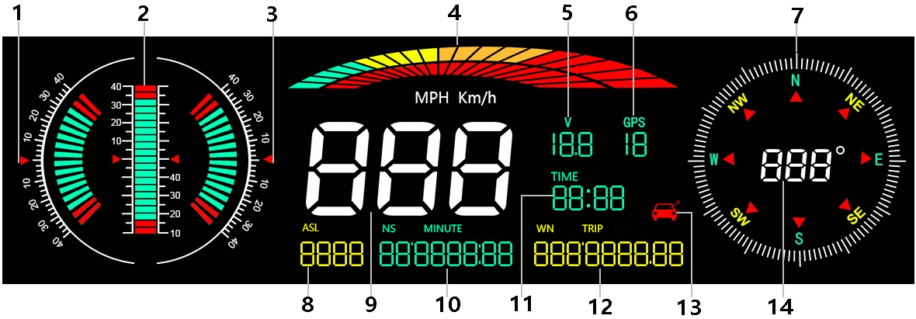

1. Left tilt Slope meter
2. Front and rear Slope meter
3. Right Slope meter
4. Decorative icons
5. Voltage display
6. GPS number: flashing means searching for satellites, GPS light stops flashing and displays the number of satellites after the satellites are found
7.Driving direction: Driving direction indication:W=West, N=North, S=South, E=East when the vehicle speed >5KM / H
(NW: Northwest NE: Northeast SW: Southwest SE: Southeast)
8. Altitude
9. Speed
10. Longitude display,driving time
11. The clock defaults to the UTC+8, and the time in the UTC+8 is displayed after the satellite signal is searched (adjust the local time zone according to the location)
12. Latitude display,mileage display
13. Fatigue driving icon, flashing reminder after accumulated driving for >4 hours
14. Compass direction scale

Button functions：

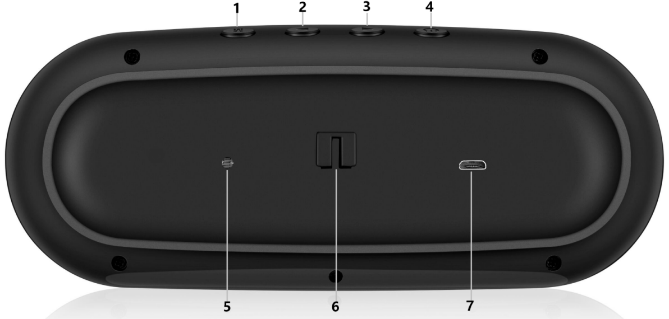

short press: press 1s
long press: press 2s hold and release after display appears

1. Short press ‘M’ (1) To switch the display mode after normal display
(2) Enter setting mode to switch menu value

Long press ‘M’ (1) To enter the setting (Menu 1-10) after adjustment
- press and hold again for 5 seconds to save and exit

2.Short press ‘<’ (1) To switch latitude and driving time
(2) decrease the menu or parameter value after entering the setting

Long press ‘<’ (1) To turn off the buzzer
(2) long press again for 5 seconds to turn on the buzzer

- Short press ‘>’ (1) To switch between longitude and mileage,
(2) Increase menus or parameters after entering the setting

Long press ‘>’ (1) The screen is all on,
(2) long press again to exit and all on

4. Power switch: (1) short press to calibrate the Slope meter
(2) long press to turn off, long press again to turn on

5. Photosensitive hole

6. Suction cup bracket
7. USB cable interface

GPS Slope meter use
GPS flashing is in the state of searching for stars. Please move the car to an open road. After the satellite is found, the GPS light stops flashing and stays on for normal use.

Slope meter Calibration
After the Slope meter is displayed normally, it is placed steadily, short press the power button, and you hear a beep, the calibration is completed

Switch alarm sound
After the HUD is displayed normally, long press the ‘>’ key for 5 seconds to turn off the buzzer, and long press the ‘>’ key again for 5 seconds to turn on the buzzer

Display mode switch
After starting the connection agreement, short press the ‘M’ key to switch the display mode

Factory reset
Long press the ‘M’ key for 5 seconds to enter the setting item, short press 10 times the menu will display 10, adjust the parameter value to 1 and press the ‘M’ key for 5 seconds to save

Enter setting mode
Long press the 'M' key for 5 seconds to enter the setting items (1-10), the menu will display 1. Increase the menu options through the'>' key, short press the M key to enter the parameter value and flash, short press the'>' key to adjust the parameter value, short Press the M key to return to the menu, long press the M key for 5 seconds to save and exit
Menu | Functions | Adjust  Range | Explanation | Default value | Setting screen
1 | language selection | 0-1 | 0=English  1=Chinese | 0 | 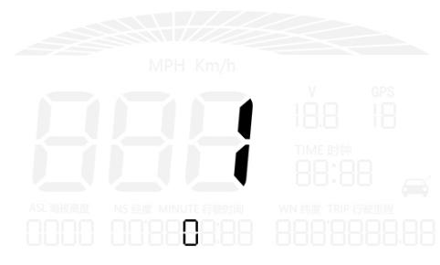
2 | Speed | 50-150 | Adjust the parameter value when there is an error between HUD and dashboard. Ex:dashboard displays 100 KM, HUD displays 105 KM. Please adjust the parameter value to 102.(107-5) | 107 | 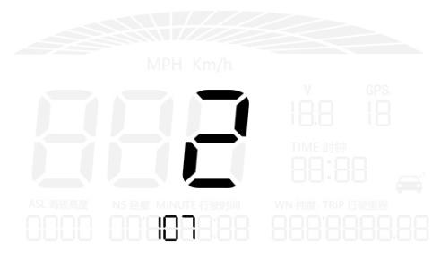
3 | Over speed alarm | 30-250 | Overspeed alarm is 150KM / H,users can freely set this value | 150 | 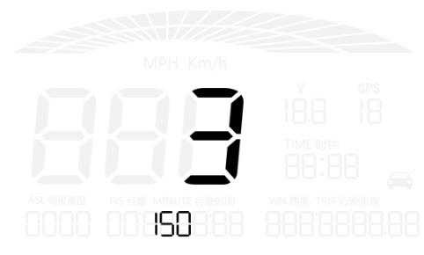
4 | Speed unit | 0-1 | 0=KM  1=MPH | 0 | 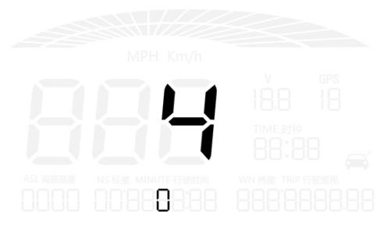
5 | Fatigue driving reminder | 1.0-8.0 | Fatigue driving reminder is 4 hours | 4.0 | 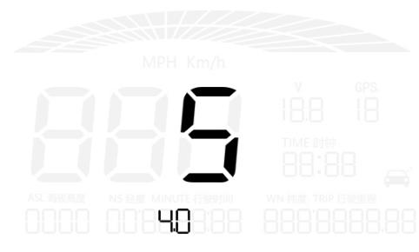
6 | Brightness level | 0-8 | 0-automatic photosensitive mode 1-8 is manual adjustment | 0 | 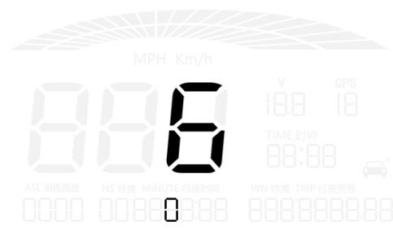
7 | Time zone calibration | 00:00-23；00 | Time zone adjustment, select the time zone of your own area, you can directly adjust to the local time after searching the satellite | 8：00 | 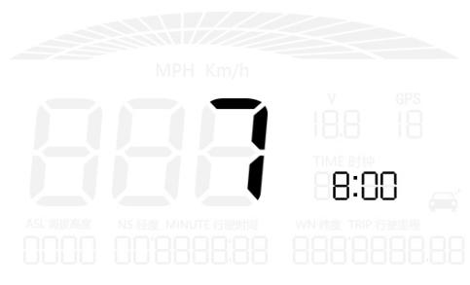
8 | Fine adjustment of left and right angle | 50-150 | Adjust when the left and right tilt angle is deviated | 100 | 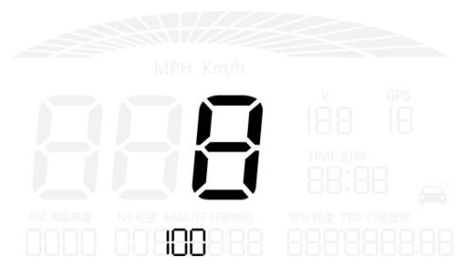
9 | Fine adjustment of front and rear angle | 50-150 | Adjust when the front and rear tilt angle is deviated | 100 | 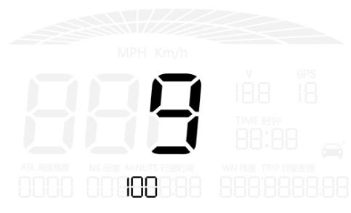
10 | Factory reset | 0-1 | The default is 0, after adjusting to 1, press the ‘M’ key vertically for 5 seconds to save and exit | 0 | 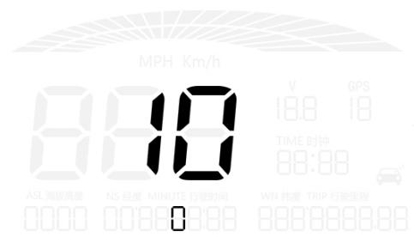

GPS Display RFQ:
1.Nothing on the screen,no power
Check if the USB interface has power or the connection is loose, pull it out and plug it in again several times, or replace the USB cable

2. Language selection
Long press the M key for 5 seconds to enter the 1 item of the setting item (0 is English and 1 is Chinese), short press ">" to select, long press "M" to save

3.No speed
The GPS is flashing to search for stars. Please move the car to an open road. After the satellite is found, the GPS light will be on and off, and it can be used normally.

4. Inaccurate speed
- First check the speed unit is correct or not, the speed unit including KM/H and MPH(speed unit switch item 4)

- The car manufacturers usually make the dashboard speed 5-7% higher than the ECU. The international standard is based on satellite data.
- Fine-tuning the vehicle speed, e.g. meter display 100 Km/h, machine display 105Km/h,default value 107-5=102
- a.Under the condition of power-on, press and hold the 'M' button for 5s to enter the menu options, the menu displays 1
b. short press 'M' to enter the parameter value 107 and flash (the instrument displays 100 KM / H device displays 105KM / H, adjust the parameter value to 102 through the '<' button)
c. After adjusting, press and hold the 'M' button for 5 seconds to exit

5.There is an error of travel direction
It will be normal until >5KM/H

6.Speed is still on display after the car stops
Satellite drift will be caused in underground parking,tunnel,overpass or blockers,please drive your car on open road,then this situation can be solved after the satellite numbers >5

7.Entering the tunnel, the satellite signal flashes in the underground parking lot, no speed
Satellite drift will be caused in underground parking,tunnel,overpass or blockers,please drive your car on open road,then this situation can be solved after the satellite numbers >5

