Car Head Up Display
(Model:VM16)
Product Introduction：
HUD short for Head Up Display,the main function is to display the car dashboard information (e.g.speed,RPM,water temperature,voltage,trip distance etc ),and keep the driver eyes always on road to avoid the dangerous of lowering down head to read the dashboard.

Product function:
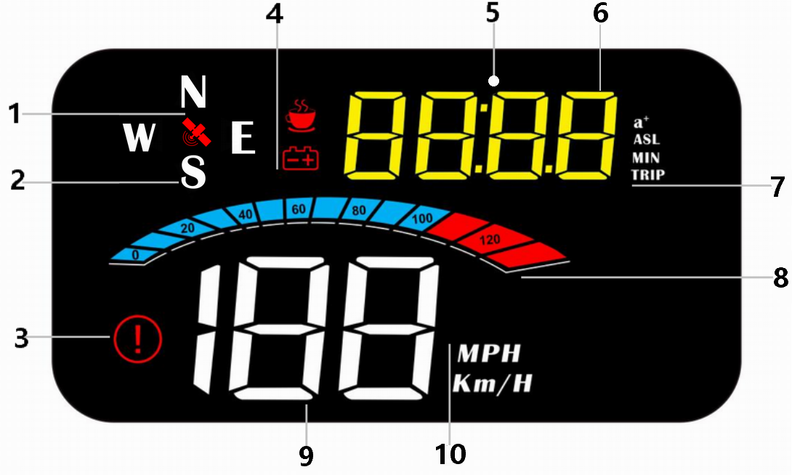

- Satellite icon, flashing means searching for satellites, the GPS light stops flashing and stays on after the satellites are found
2. Driving direction: After the vehicle speed >5KM / H, display the driving direction,
W=West, N=North, S=South, E=East
3. Overspeed alarm icon flashes when the vehicle speed exceeds the set value
4. Voltage icon and fatigue driving icon
5.Light sensor:HUD can automatically adjust the brightness according to the environment
6. Multi-function display area
7. a + =100km acceleration, ASL=altitude, MIN=travel time, TRIP=travel mileage
8. Display speed progress bar
9. Speed display area
10. Speed unit: MPH=Mile/hour ,KM/H=kilometer/hour

Button functions：

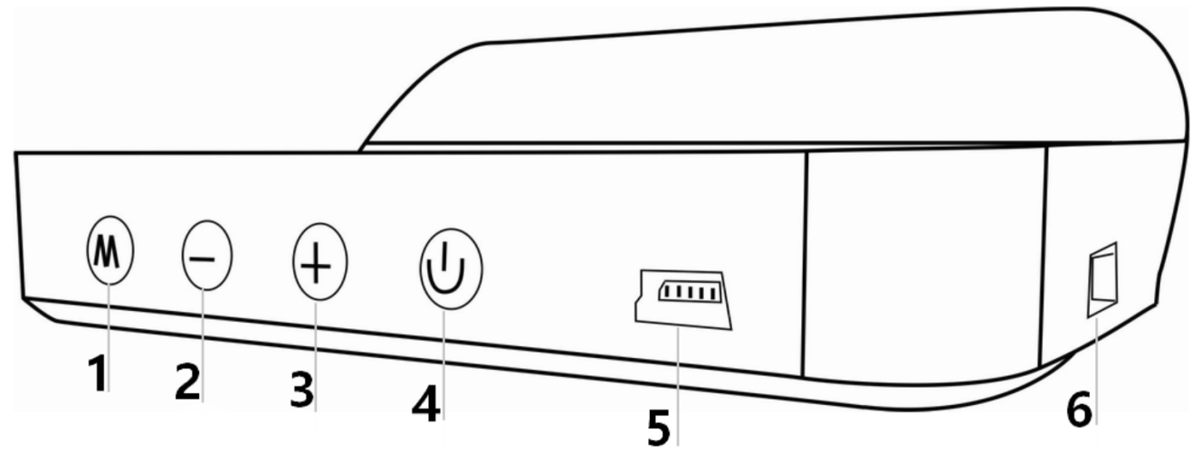

short press: press 1 second and release,
long press: press 5s until the display image changed

1. Button
Short Press
- To Switch voltage, water temperature, vehicle speed
(2) To switch menu options or parameter values in menu setting mode
Long Press
(1)To enter into menu settings ( instructions for Menu 1-8)
(2)To save and exit once finished setting

- Button
Short press
- to switch the speed icon
- reduce the menu or parameter value after entering the setting
Long Press
to turn off the buzzer, press and hold again for 5 seconds to turn on the buzzer

- Button
Short press, Menu + or parameters value +

Long Press ,to make the screen full bright, long press again to exit full light

4.Power switch: long press to turn off, long press to turn on again
5.Connection port 1: freely choice between interface 1 or 2
6.Connection port 2: freely choice between interface 1 or 2

GPS system use
GPS flashing is in the state of searching for stars. Please move the car to an open road. After the satellite is found, the GPS light stops flashing and stays on for normal use.

Restore setting:
Long press the ‘M’ button for 5s to enter the setting items, short press 8 times the menu display 8 Adjust the parameter value to 1 Long press ‘M’ button for 5s

Turn off/on the buzzer
Long press and hold the ‘-’ button to turn off the buzzer, again to turn on.

Display mode switch
After HUD is turned on, short press the ‘+’ button to switch display mode.

Power test
Satellite>5, the time it takes to accelerate the speed from 0-100KM / H, mainly to test the power of the car

Menu setting
Please watch the reflective image on the windshield for operation when setting.Long press and hold the 'M' button to enter into setting menus(1-8). The menu is displayed 1,short press the '+' button to increase the menu options,short press '+' or '-' button to adjust the parameter value, short press M button to return to the menu, long press M button to save and exit.
Menu | Functions | Adjust  Range | Explanation | Default value | Setting screen
1 | Speed | 50-150 | Adjust when speed is not correct. For example, the instrument displays 100 KM / H, the device displays 105KM / H, and the parameter value is adjusted to 102 | 107 | 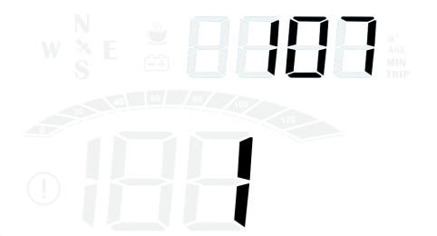
2 | Over speed alarm | 30-250 | Over speed alarm is 150KM/H,users can freely set this value | 150 | 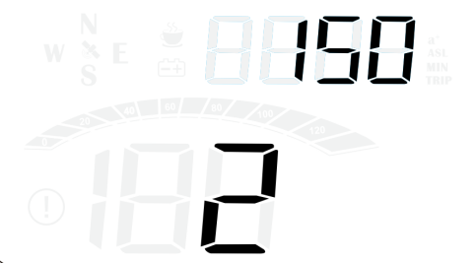
3 | Fatigue driving reminder | 1.0-8.0 | Remind after continuous driving exceeds the default value of 8.0 hours | 8.0 | 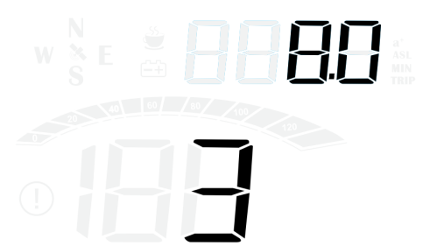
4 | Brightness level | 0-5 | 0-automatic photosensitive mode, 1-5 is manual adjustment | 0 | 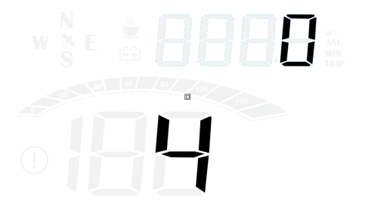
5 | Speed unit | 0-1 | 0=KM  1=MPH | 0 | 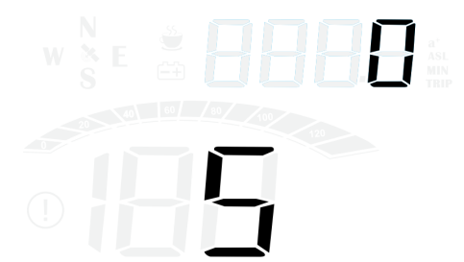
6 | Time calibration | 00:00-23:00 | Time adjustment, choose the time of your area, after searching for satellites, you can directly adjust to the local time | 8：00 | 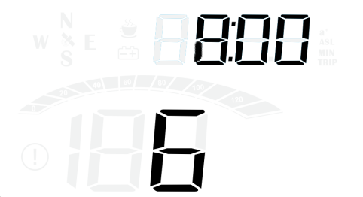
7 | voltage setting | 0-15.0 | The default is 13.2 | 13.2 | 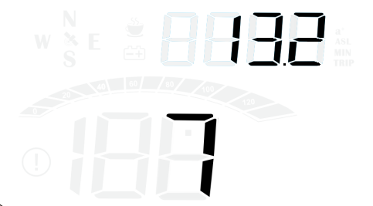
8 | Factory reset | 0-1 | The default value is 0. When set to 1, press ‘M’ for 5 seconds to save and exit | 0 | 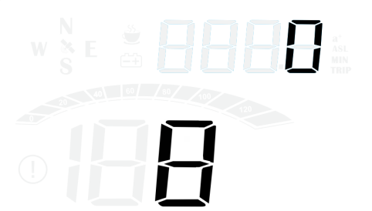

GPS Display FAQ：
1.Nothing on the screen,no power
Check if the USB interface has power or the connection is loose, pull it out and plug it in again several times, or replace the USB cable

2.No speed
The GPS is flashing to search for stars. Please move the car to an open road. After the satellite is found, the GPS light will be on and off, and it can be used normally.

3. Inaccurate speed
- First check the speed unit is correct or not, the speed unit including KM/H and MPH(speed unit switch item 4)
- The car manufacturers usually make the dashboard speed 5-7% higher than the ECU. The international standard is based on satellite data.
- Fine-tuning the vehicle speed, e.g. meter display 100 Km/h, machine display 105Km/h,default value 107-5=102
- a.Under the condition of power-on, press and hold the 'M' button for 5s to enter the menu options, the menu displays 1
b. short press 'M' to enter the parameter value 107 and flash (the instrument displays 100 KM / H device displays 105KM / H, adjust the parameter value to 102 through the '-' button)
c. After adjusting, press and hold the 'M' button for 5 seconds to exit

4.There is an error of travel direction
It will be normal until >5KM/H

5.Speed is still on display after the car stops
Satellite drift will be caused in underground parking,tunnel,overpass or blockers,please drive your car on open road,then this situation can be solved after the satellite numbers >5

6.check the number of satellites
Short press ‘M’ button to switch the speed, voltage and number of satellites ( >5 satellites can be displayed normally)
7.Entering the tunnel, the satellite signal flashes in the underground parking lot, no speed
Satellite drift will be caused in underground parking,tunnel,overpass or blockers,please drive your car on open road,then this situation can be solved after the satellite numbers >5

