Car Head Up Display
Model:VC5
(This product Design Patent and Display Images Copyright had been registered with customs record)

HUD short for Head Up Display,the main function is to display the car dashboard information (e.g.speed,RPM,water temperature,voltage,trip distance etc ),and keep the driver eyes always on road to avoid the dangerous of lowering down head to read the dashboard.

Kindly Attention
Model VC5 is OBD+GPS dual system. Please switch to GPS system when OBD mode is not available.
OBD2 mode working voltage: 5V~18VDC (12vdc/200mA)

Product function:
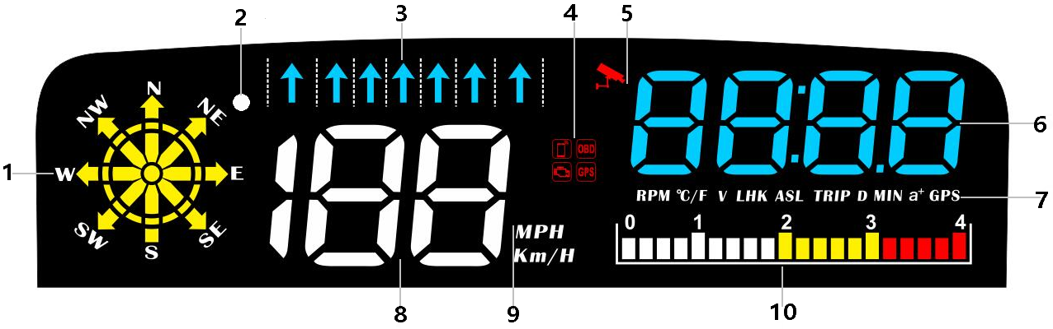
- Compass: Show the driving direction when the vehicle speed >5KM / H, Display navigation information when using navigation.
(W=West, NW=Northwest,N=North,NE=Northeast,E=East,SE=Southeast, S=South,SW=Southwest)
2.Light sensor: HUD can automatically adjust the brightness according to the environment
3.Lane display: With the navigation function of the mobile phone APP, display the lane where the vehicle is driving (the overseas version does not support this function)
4. Fault code icon,Phone connection icon,OBD system,GPS system (GPS icon will flashing until satellite signal been founded)
5.Camera monitoring area (overseas version does not support this function)
6.Multi-function area: RPM,water temperature,voltage,fuel consumption,altitude,mileage,navigation distance point,driving time,power test,satellites number,clock
7.RPM=rotating speed,°C/F=water temperature,V=voltage,LHK=fuel consumption,ASL=altitude,TRIP=travel mileage, D=navigation distance point,MIN=travel time,a + =100km acceleration test,GPS=satellites number(GPS system can be used after 5 satellites are found)
8.Vehicle speed display
9.Speed unit: MPH=Mile/hour, KM/H=kilometer/hour
10.RPM icon

Button functions：
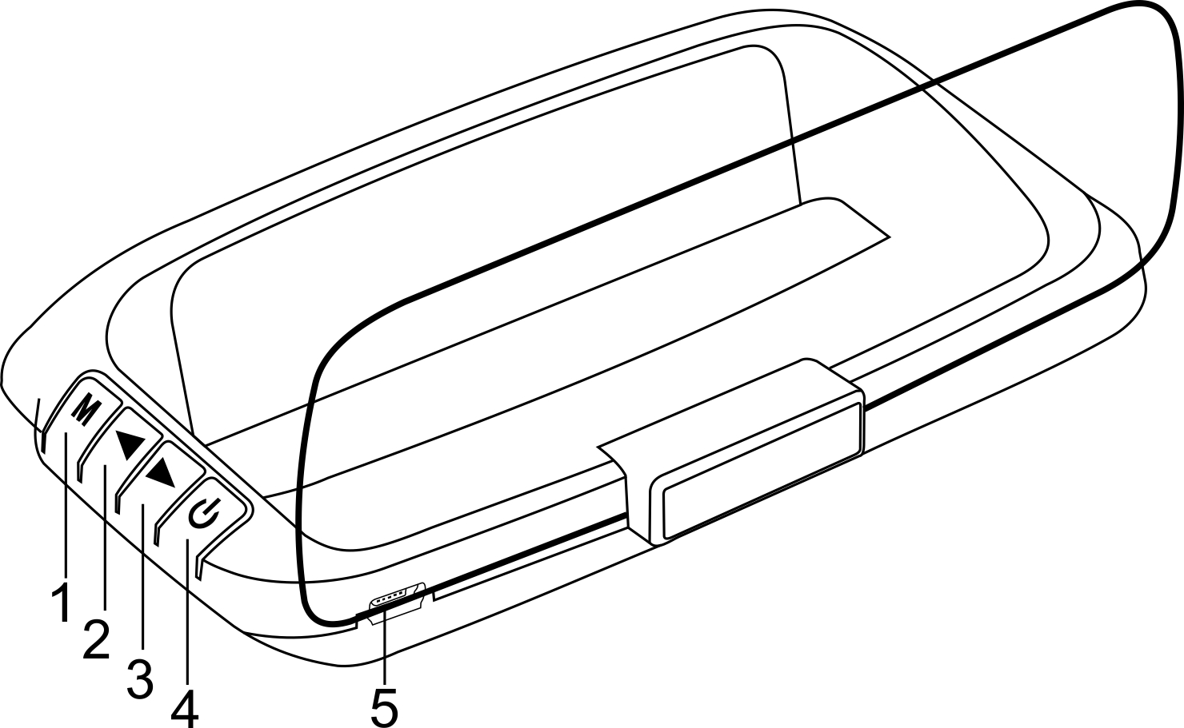
short press(1 second press)
long press(3 second press),release after the display screen changes

1、Button
A.Short Press
(1) OBD system: to switch functions between RPM,voltage,water temperature,altitude,fuel consumption,driving time,mileage,clock,100 kilometers acceleration.
(2) GPS system:to switch functions between voltage,altitude,travel time,travel mileage,clock,100km acceleration,number of satellites.
B.Long Press
- To enter into menu settings (Menu 1-14)
- To save your settings and exit

2、Button‘<’
A.Short Press ‘<’
(1) Switch the mode OBD or GPS within 5 seconds when the power-on screen flashes
(2) To switch the RPM icon
(3) Decrease the menu or parameter value after entering the setting
B.Long Press ‘<’
(1) Turn off the buzzer,again to turn on the buzzer

- Button‘>’
A.Short press ’>’
(1) Switch the mode OBD or GPS within 5 seconds when the power-on screen flashes
(2) Increase the menu or parameter value
B.Long press ’>’
To clear engine fault codes(till all of the LED lights is lighting),again to return to your main page

4、Power switch:
Long press to turn off,again to turn on

5、Connection port:
OBD line and cigarette lighter line interface

System selection
Please short press ‘<’ button to switch the mode OBD or GPS when the OBD icon flashes, it will automatically enter the last selected system after 5 seconds of inactivity.

OBD System (For OBD2 car)
Functions:Vehicle speed,engine RPM,fuel consumption,water temperature,voltage,clock,mileage,travel time,travel distance,altitude,number of compass satellites, RPM icon

GPS System (For all car)
Functions:Vehicle speed,time,voltage,travel time,travel distance,travel direction,altitude,satellites number,speed Icon

When the OBD system is not compatible,please switch to the GPS system and plug with the USB cable

GPS system use
GPS flashing is in the state of searching for stars. Please move the car to an open road. After the satellite is finding,the GPS light stops flashing and stays on for normal use.

Restore setting:
Unplug the power,long press the ‘M’ key and don’t release it, plug in the power and release the ‘M’ key after the screen is fully lit.

Clear the fault codes
1.Powering on the connection agreement,
2.Long press the ‘<’ key and the HUD screen will light up and clear the fault code,
3.Long press the ‘<’ key again to exit.

Turn off/on the buzzer
Long press and hold the ‘>’ button to turn off the buzzer,again to turn on.

Display mode switch
After HUD is turned on,short press the ‘<’ key to switch the modes.(concise/racing/standard mode)

How to use Navigation
Please connect HUD with your smart-phone by Bluetooth,then APP can display a synchronized navigation information,compatible intelligent phones which meet the following requirement(Android 4.0 and IOS Iphone 5 or ↑)
Android Phones:Please search keyword ’WiiYii’ in the Android Market
Iphone:Please search keyword ’WiiYii’ in the APP Store
Scan below QR code to download

- Please download “Wiiyii”APP, install HUD and actuate your car,manually turn on the Bluetooth and positioned,click the icon of WiiYii,system will automatically search the Bluetooth and connect
- If the mobile phone cannot connect to the Bluetooth device correctly, please follow the instructions below:
HUD needs to be displayed normally. If the OBD system cannot be connected, please switch to the normal display of the GPS system.
Whether the mobile phone Bluetooth is connected to other devices, Delete the paired Bluetooth device, and bind WYHUD

3.Turn off the Bluetooth and on again, or restart the phone
(For more questions, please refer to the FAQ on the next page)

Setting Mode(Menu mode)
Please refer to the reflective image on the windshield for operation when setting. Long press and hold the ‘M’ button to enter into setting menus(1-14). The menu is displayed 1,short press the ‘<’ button to increase the menu options,short press ‘<’ or ‘>’ button to adjust the parameter value, short press ‘M’ button to return to the menu, long press ‘M’ button to save and exit.
Menu | Function | Adjust  Range | Explanation | Default value | Setting screen
0 | Speed | 50-150 | Adjust when speed is not correct. For example, the instrument displays 100 KM / H, the device displays 105KM / H, and the parameter value is adjusted to 102 | 107 | 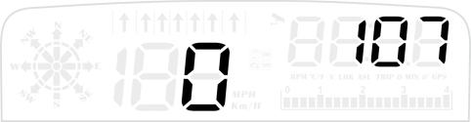
1 | Fuel Consumption | 50-150 | Adjust parameter value when there is error in fuel consumption | 100 | 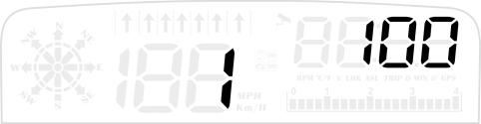
2 | RPM Alarm | 100-7500 | Alarm after the speed reaches the set default value of 7500 rpm | 7500 | 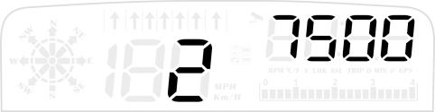
3 | Alarm mode | 0-1 | 0= Close alarm  1= Four levels alarm  (60, 80. 100, 120) | 0 | 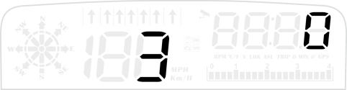
4 | Over-speed Alarm | 30-199 | Over-speed alarm is 150KM/H, users can freely set this value | 150 | 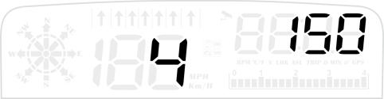
5 | Brightness Level | 0-5 | 0-automatic photosensitive mode, 1-5 is manual adjustment | 0 | 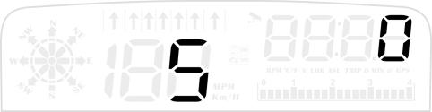
6 | Water Temperature Alarm | 50-150 | Water temperature alarm is 120℃, users can freely set this value | 120 | 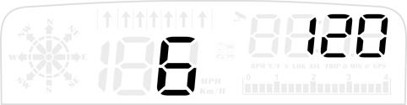
7 | Voltage alarm | 0-15.0 | Voltage alarm is 10V, users can freely set this value | 10.0 | 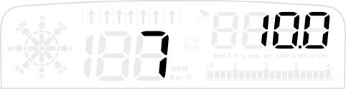
8 | Fatigue Driving Reminder | 1.0-8.0 | Remind after continuous driving exceeds the default value of 4.0 hours | 4.0 | 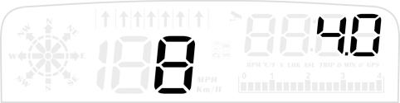
9 | Speed Unit | 1-2 | 1=KM/H  2=MPH | 1 | 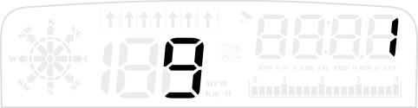
10 | Temperature Unit | 1-2 | 1= Celsius  2= Fahrenheit | 1 | 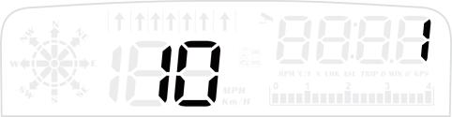
11 | Shutdown Voltage | 0-15.0 | 1.Auto start-stop car or hybrid electric car adjust the value to 1  2.Adjust the voltage to 13.2 volts when unable to shut down(Shut down after 3 minutes when the voltage is <13.2 V) | 0 | 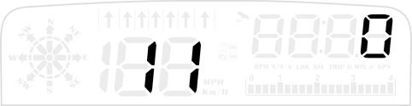
12 | Shutdown Time | 5-300 | Shut down 20 seconds after the fire break, turn off the gas and electricity to 180, that is, shut down after 180 seconds. | 20 | 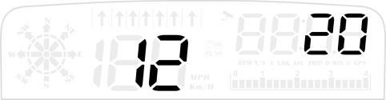
13 | Time Calibration | 00:00-23:00 | Time adjustment, choose the time of your area, after searching for satellites, you can directly adjust to the local time.  (dial up to increase time zone time, dial down to decrease time zone time) | displays 8 before the star is found, and displays the GMT+8 (China time) | 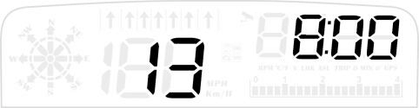
14 | Factory Reset | 0-1 | The default value is 0. When set to 1，Long press vertically scroll button for 5 seconds to save and exit | 0 | 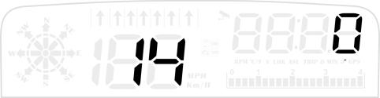
Remind warning:
Please disconnect the HUD if you don’t drive for more than a week.Generally speaking car battery’s standby time is 1 month,we kindly suggest you to unplug the OBD device when the car is not used for a long time due to different vehicle conditions.

OBD FAQ：

1.No function is displayed,no power
Check whether the OBD cable is tight connection, pull down repeatedly to confirm, please try it on another car if still not workable, analysis if it is a cause from OBD diagnostic interface,if yes,please repair it and connect the device again.

2.Only the car voltage displays and be automatic power off after 30 second
(1) This product is only available for OBDII and EOBD cars when it is in OBD2 mode
(2) OBD2 is a car protocol (Suitable for cars produced after 2008)
- This product OBD2 mode does not support OBD I and JOBD
(4) Switch to the GPS system using the USB cable to display, within 5 seconds of power short press the ‘<’ button to select the GPS system.

3.Wrong operation leads to crashes
(1)Are there other OBD devices on your car(parking sensor, TPMS, lock lift window, ELM27)
(2)Had your car been modified and brushed(central navigation,electronic throttle controller,fixed speed cruise,reset the computer system)
(3)No matter engine start stop,keyless entry or remote start will cause a crash,unplug other OBD devices, and do a factory reset (see the menu settings)
Please switch to GPS system (short press ‘<’ within 5s) which should be connected with a USB cable.

4.Inaccurate speed
(1)Please check that the unit is correct KM/mile MPH, (speed unit switch please refer to the settings : Item 9)
(2)When the car leaves the factory, the manufacturer increases the speed displayed on the dashboard by 5-7%, and the international standard is based on the data from the trip computer.
(3)Fine-tune the vehicle speed, such as the instrument display 100 Km/h, HUD display 105Km/h dial on the dial to adjust the parameter value to 102

5.Unclear in daytime with double shadow
There is a high-brightness reflective film
(1)Wipe the glass clean
(2)Spray a little water
(3)Tear off protective film “1” and stick the reflective film on the windshield
(4)Tear off protective film “2”

6.Automatic start-up will auto off when step the brake and hybrid cars will turn off during driving.
Method one: Enter the menu item 11 and adjust the value to 1. (See the menu settings)
Method two: Setting shutdown delay to 300 seconds on the item 12, so that it can turn off after 5 minutes

7.HUD cannot auto shut down
After the car engine stops, the RPM and speed on the machine can not be turned off, please enter the setting menu turn to item 11, set voltage to 13.2V or 13.5V, so that the car can be turn off after 3 minutes. (See the menu settings)

8.Shut down during driving after adjusting the voltage
After the voltage is set, if the machine is turned off during driving, it is recommended to adjust the value of the item 11 to 12.8V or 12.5V.

9.Shut down and restart
Indicates that the voltage is higher than the starting voltage 13.2V, enter the setting menu and switch to item 11, set voltage to 13.6-13.8V (the device can only be turned on after the vehicle voltage is higher than the setting voltage)

GPS FAQ：

1.Nothing on the screen,no power
Check if the USB interface has power or the connection is loose, pull it out and plug it in again several times, or replace the USB cable

2.No speed
The GPS is flashing to search for stars. Please move the car to an open road. After the satellite is found, the GPS light will be on and off, and it can be used normally.

3.Can not automatically turn on or turn off repeatedly during driving
When the OBD line is connected: the device will shutdown once the voltage is <13.2V for 3 minutes.
Vehicle long press the scroll button for 5s to enter item 11 of the setting menu, and adjust the parameter value voltage to 13.0V or 12.8V

4.Inaccurate speed
(1) Check whether the unit is correct, kilometers KM/mile MPH(switch the speed unit on the item 9)
(2) When the car leaves the factory, the manufacturer increases the speed displayed on the dashboard by 5-7%. International standards are based on satellite data.
(3)Fine-tune the vehicle speed, such as the instrument display 100 Km/h HUD display 105Km/h dial on the dial to adjust the parameter value to 102

5 The speed is stuck and does not work during driving
The power supply of the USB power cord is <5V, please use an OBD cable for power supply

6.Wrong driving direction or random jump
It will be normal until >5KM/H

7.Speed is still on after the car stops
Underground parking lots, tunnels, and overpasses, when there are obstructions, the signal will be unstable. Satellites will drift. Please drive to an open road. If the number of satellites found is more than 5, it will be normal.

8.Check the number of satellites
Pull down the scroll button to switch to the GPS icon ( more than 5 satellites can be displayed normally)

9.Cannot automatically turn off after the car shutdown
When the OBD cable is connected, the HUD will automatically shut down after 3 minutes
If the machine is not turned off after 5 minutes after stopping the flame, adjust the voltage setting parameter value of item 11 to 13.5V ( (See the menu settings).

Navigation FAQ ：

1.Install APP
Scan QR code to download this APP(see manual)
Iphone: Search keyword ‘WiiYii’ in APP Store
Android phones: Search keyword ‘WiiYii’ in Android Market
(1)Please download this software
(2)Manually turn on the Bluetooth and location
(3)Click the icon of WiiYii,system will automatically search the Bluetooth and connect

2.Use APP:
(1) After installing the APP software correctly,
(2) [1]Turn on Bluetooth on the mobile phone [2]Turn on location services [3]Turn on network
(3) Click the WiiYii APP, the system will automatically search for Bluetooth devices and connect

3.APP Bluetooth connection is not successful
(1)The HUD needs to display normally
(2)Whether the Bluetooth of the mobile phone is connected to other devices,delete the paired Bluetooth devices,and then bind WYHUD
Turn off Bluetooth again and turn on the phone Bluetooth,or restart the phone
- Make sure that other phones turn off Bluetooth

4.Phone cannot search for WiiYii APP
(1)Check the phone system version and whether it supports Bluetooth 4.0, Apple system IOS9 or above, Android 4.4 or above
(2)Need mobile phone to search for WYHUD via Bluetooth,open your network
(3)Turn on GPS navigation positioning, you can enter the navigation address after successful positioning

5.App Bluetooth connection is successful,no display of input address
Please turn on the location service,open your network,check the signal,please move to a place which has a strong signal,and enter the address again

6.HUD stuck during navigation or when you switch the display interface, speed display is normal
Turn off the power-saving mode of the phone, turn off the screen forbidden function, or click to enter the phone navigation page and stay on the phone navigation page

7.Navigation is 10-20 meters away from the indication point
Since the GPS positioning error is about 5-10 meters, it is normal for the satellite signal to be 10-20 meters when the signal is weak.

