C1090 USER GUIDE

- Features
- Head-up display the driving speed.
- Driving time and mileage calculation and display.
- Over-speed alarm.
- Fatigue driving alarm.
- Altitude display.
- Local time display with auto timezone adjustment.
- C1090 6.2 inch large size screen.
- Easy Setup. Power through vehicle cigarette lighter. Support 12-36V.
- Compatible with all Cars & Trucks. GPS signal guided calculation.
No wiring needed to the VSS (vehicle speed signal).
- Display MPH or KMH.
- Auto adjust brightness through sensor for Day & Night driving.
- Green color data display, easy on your eye.
- Total mileage display when car stops.

2. Product function diagram
Driving speed
Kilometers
Miles

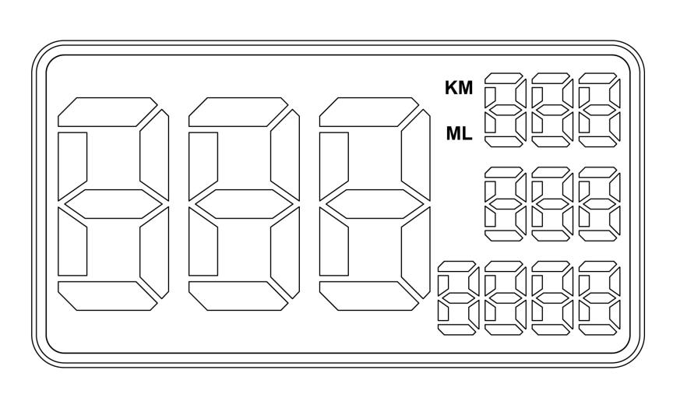

Single driving time

Single driving mileage

- Altitude: During driving, after GPS positioning success.
2. Time: During driving, after GPS positioning success.
3. Total mileage: Flashing when car stops or without GPS signal.

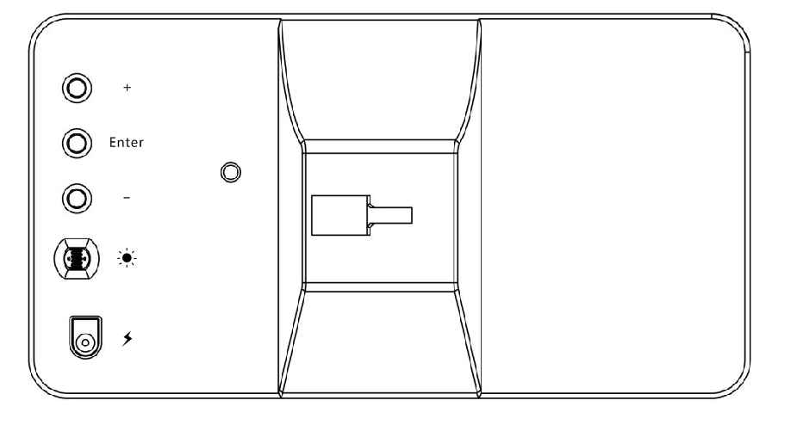
Enter button
Power (12-36V)
Light sensor
+ Up
- Down

- Content of the packaging
- GPS HUD Speedometer
- Car Charging Cable
- Stand
- User Manual
- Gift Box

- Operation Video
Please scan QR code to watch the C1090 Operation Video.

- Operation Guide
- Set over-speed alarm rate
A: Press Enter button once, show 001
B: Adjust the alarm speed rate with the “+” and “-” button.
C: The default alarm speed rate is 120 KM /H.
- Driving speed calibration
A: Press Enter button twice, show 002
B: If the display speed on the device is different from the car speedometer, you can calibrate the display speed with the “+” and “-” button. Default rate is 005.
C: Press “+” to increase, “-“ to decrease speed rate. 1KMH (or 1MPH) by each press.
D: The calibration range is -20 to 20
- Altitude value calibration
A: Press Enter button three times, show 003
B: Adjust the Altitude rate with the “+” and “-” button. The default rate is 850. Press “+” to increase, ”-“ to decrease altitude rate. 5 meters (miles) by each press.
C: The calibration range is 750-950.
D: When speed is displayed by “KM”, altitude unit is in meter.
When speed is displayed by “ML”, altitude unit is in feet.
- Timezone calibration
A: Press Enter button four times, show 004
B: Adjust the time zone rate with the “+” and “-” button.
C: The calibration range is -90 to 90 minutes.
- Set the speed meter unit (KM or Mile):
Long press the "Enter" button to switch speed meter unit.
"ML" refers to speed unit in Mile. “KM” refers to speed unit in KM.
- Screen display Settings
A: Press “+” and hold to see the driving speed only, repeat operation to see full information display.
B: Press “-“ and hold to see time display at the bottom right corner, repeat operation see altitude display.
- Factory defaults:
A: Press Enter button 5 times, show 005.
B: Press “-“ button to restore the factory defaults and clear the total mileage record.
- Fatigue Driving Alarm
In every hour, system will trigger a fatigue driving alarm with continuous driving time displayed, in order to remind driver to avoid drowsy-driving.
Example: 001 means one-hour continuous driving, 002 means two-hour continuous driving, and so on.

- Data display
A: Single driving mileage
Mileage is continuously accumulated on each drive, and will be cleared when power off.
B: Single driving time
Driving time is continuously accumulated on each drive. Unit is minutes, and will be cleared when power off.
C: Total mileage
The total mileage will be flashing display when car stops, and data will be saved when power off. The maximum total mileage display is 9999 kilometers, which will be automatically clear after reaching the maximum value.
D: Altitude The altitude value deviation range is 20~100 meters.
E: Time
-- System default as local time, 24-hour system, the first 2 digits refer to hour and last two digits refer to seconds.
-- Timezone will be adjusted automatically.

- Technical parameters
- GPS positioning time: 1 to 5 minutes in the open air (The bad weather will affect the positioning time).
There is no GPS signals indoors.
- Speed deviation: Since the speed data comes from the GPS satellite, slight deviation is unavoidable.
- Input voltage: DC 12V~36V
- Working temperature: -30 to 80 ºC (-22 to 176 ºF)
- Driving data deviation is around 2%
- All driving data will be cleared when power off except the total mileage.
- Device dimension: 150x80x18mm ( 6x3x0.7in).
- Weight: 232g with package.

