4G TK SERIES USER GUIDE

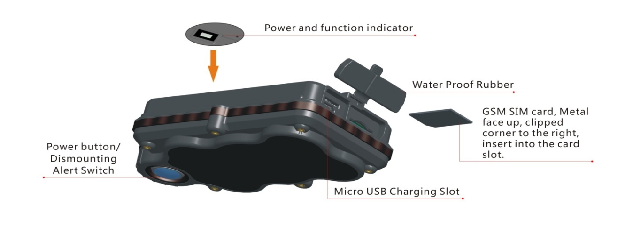
1. Package Contents

a. Tracker unit
b. Micro USB charging cable
c. User Guide

2. Installation Manual

We strongly recommend that you charge the Tracker before using it for the first time. The tracker will turn on automatically once the SIM card is inserted. Please DO NOT PRESS ANY BUTTON when you use it for the first time.
2.1 SIM Card Pre-installation - specifications and notes

a. GSM Normal SIM Only– BIG SIZE SIM CARD
b. SIM card should have its GPRS function enabled.
c. SMS request will function only if Caller ID function is enabled.

2.2 SIM Card Installation and Removal

a. Open waterproof rubber cover
b. Insert SIM card into the SIM slot, metal face up, clipped corner to the right.
c. The green indicating light will keep flashing while detecting GSM signal, and turns on steadily for few seconds and then turns off.
d. Call the Tracker's phone number (assigned by the service provider) and it should get through without answering. (If you are using a data only service plan, skip this step.)
e. Ensure the waterproof rubber cover is closed after SIM installation

2.3 Tracker Installation Notes

a. Avoid high metal environments to make sure tracker is able to receive GSM and GPS signals.
b. Avoid extreme temperature environments (like above the car engine).

3. Button Operation

3.1 Button Operation for GPS Function
NOTE: button presses must be less than 2 seconds for short presses, and use the blue control button on the bottom of the tracker

a. Power On: 4 short presses and 1 long press. The green indicating light will keep flashing while detecting GSM signal, and turns on steadily for few seconds and then turns off.
b. Power Off: Send SMS command *poweroff* to the Tracker's phone number. The blue indicator light will flash 5 times.
c. Charge: A red light is steadily on during charging and turns off when it is fully charged.

3.2 SOS Button

2 short presses and 1 long press will trigger an SOS alert to the registered master number and will be uploaded to the server.

3.3 Drop Alert

The Tracker is equipped with a Drop Alert button. When it is mounted on a metal surface for over 1 minute, it will trigger a SMS drop alert to the master number and will be uploaded to the server If the tracker is removed, System default as On.

4. Quick User Guide

Scan to watch operation video

4.1 Sim Installation

Insert the activated SIM card into the SIM slot, metal face down.
The green indicating light will keep flashing while detecting GSM signal, and turns to steadily on for few seconds and then turns off.

4.2 Tracking via App
a. Please make sure device is placed under clear sky and kept in motion while testing.
b. Scan QR code on the side of the box.
c. Tap Location button and you will see the latest location of the device.
If location is not updated, please follow 4.3 to set APN, and then repeat 4.2.c.
d. Tap Android App/ IOS App to download APP
e. Scan the above QR Code to watch the APP operation video.
f. Login with SN (sticker on the box) + default password 123456, before account registration.
g. If you have more than 1 tracker, please register an account, and login with the registered email address and password. And please add devices in the device management section.

Note: Default tracking mode is set to real-time tracking (6 locations/minute during motion status).
Please go to app (Device Management section) to select other tracking modes for data/ power saving when needed.

4.3 Set APN

APN is Access Point Name. The correct APN must be set to enable the device to send data to the server. Different SIM have different APN, make sure you have confirmed the correct APN information with the Sim provider when you purchase the Sim.
Command
*apn* APN’s name*username* password*
Some APN goes without username and password, you can just leave them blank.
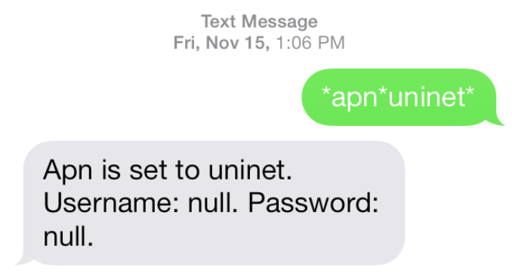

Example: Orange France
APN: orange.fr
Username: orange
Password: orange
Correct command format *apn*orange.fr* orange*orange*
Example: China Union
APN : uninet
Username: null
Password: null
Correct command format *apn*uninet*

Your cell phone will receive confirmation saying that the appointed APN is set (See screenshot).

5. SMS Operation
If you would like to use SMS instead of App to control track the tracker, please follow the operation below:

5.1 Registering the “Master” Controller

Use cellphone to send SMS *master*123456*+country code plus your cellphone number* to the device Sim number. 123456 is the default password, it can be changed by changing password command as showed on 5.1.1.
Example
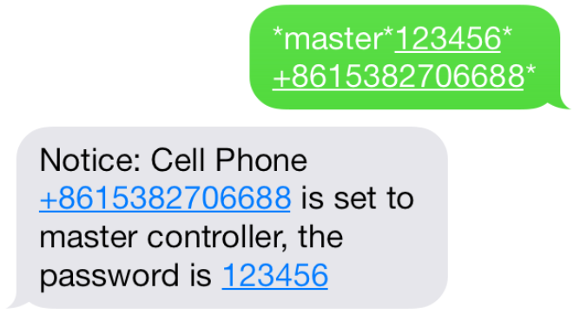
*master*123456*+319876543210* (+31 refers to Netherlands country code, 9876543210 refers to the cell phone number)

Once your cellphone receives the confirmation sms, it will become the only master phone to the tracker (See screenshot).

NOTE: The device will ONLY listen and respond commands from this number unless you choose to turn on the multi controller function and open the device to any cell phone number.

5.1.1 Changing the Password:
SMS: *password*654321* (654321 refers to new password)

Changing password command has to be sent only from the master number. And new password has to be applied to when you need to register the device with a new master number.

5.2 Motion Alert

The motion alert enables the Tracker to send a sms alert when motion is detected.

5.2.1 Set Vibration Sensitivity

There are 5 levels of the motion sensitivity. 1 being the most sensitive, 5 the least, default setting is 1.
SMS: *sensitive*1-5*

5.2.2 Set Motion Alert
There will be a SMS alert send to the master number when any motion is detected (after 3 minutes of non-movement). System default is alert off.
SMS: *smsalert*
To enable the motion alert function.
SMS: *alertoff*
To disable the motion alert function.

6. Tracking via SMS

6.1.1 SMS: *locate*
Master number will receive the latest GPS information of latitude, longitude, speed and altitude. If the GPS location is invalid the closest cell tower information will be used instead.

6.1.2 SMS: *locatemap*
The Master number will receive a Google map link. Click the link to view the map via your cellphone browser. If the GPS location is invalid the closest cell tower location will be used instead. Available for smart phone users only with web browser.

7. Tracking via Website and Applications

Tracking Website: www.miitown.com

ID: SN number (on the side sticker on the box)/ Registered email address
Password: Default as 123456. (It can be changed on the tracking website).

Recommended Web browsers are Chrome, Firefox or cell phone default browser.

7.1 Real-time Tracking (High Power Consumption)

Routetrack function enables tracker to upload 6 locations to the server every minute when Tracker is in motion. System default is on.

7.1.1 Routetrack

SMS: *routetrack*1-99*
1-98 represents the number of hours that the routerack function works. 99 is always on.
Example:
*routetrack*1* means uploading 6 location GPS data every minutes for 1 hour

7.1.2 Rsampling
Rsampling is to set routetrack data collecting interval.
The smaller interval, the higher accuracy, but the higher power consumption.
SMS *rsampling*1-999*
1-999 represents seconds of data collecting interval, default as 10 seconds

7.1.3 Rupload
Rupload is to set routetrack data upload interval.
The smaller interval, the higher accuracy, but the higher power consumption.
SMS *rupload*60-999*
60-999 represents seconds of data uploading interval, default as 60 seconds, minimum rate should not be less than 60.
Example:
*rsampling*30* plus *ruplaod*120* means 4 location data will be uploaded to the server every 2 minutes when routetrack function is on.
SMS:*routetrackoff*
To turn off route track function.

7.2 Check GPS Location (Medium Power Consumption)

The Check function enables the Tracker to upload GPS locations at a set interval. If the GPS location is invalid, the closest cell tower location is used instead.
SMS: *checkm*5-9999*
5-9999 represents the number of minutes that the Tracker's GPS location data is uploaded, minimum rate should not be less than 5.
Example
*checkm*360* means uploading GPS data every 6 hours.

- The Checkm function can work with Routetrack and Checkgsm functions at the same time.
- System default is *checkm*4320* which is 1 location uploaded to the server every 72 hours.
- Location data will be uploaded to the server whether Tracker is in motion or stationary.

7.3 Check GSM Location (Low Power Consumption)

- The Checkgsm function enables the Tracker to upload ONLY the GSM location at a set interval.
- Data will be uploaded to the server whether Tracker is in motion or stationary.
- This function can be used with the Routetrack and Checkm functions at the same time.

SMS: *checkgsm*5-1800*
5-1800 represents the the number of minutes of Checkgsm’s data upload interval, default as off; rate should not be less than 5.
Example
*checkgsm*30* means uploading GSM data every 30 minutes.

7.4 Track Off

Track off will disable all the tracking functions including routetrack, checkm, checkgsm, timing locate, and period locate.
SMS：*trackoff*

8. Upload Alert

The upload alert function enables tracker upload alert status to the server including motion alert, low battery alert and drop alert etc. User can check alert status on the tracking website or message section in app. This function is defaulted to ON.
SMS：*uploadalert*on*
To enable upload alert function.
SMS：*uploadalert*off*
To disable upload alert function.

9. Sleep Function (Lowest Power Consumption)

9.1 Interval Sleep

The Tracker will go into deep sleep and wake up after the set interval, then stay awake for 12 minutes. If there are no new commands received within 12 minutes, the Tracker will go back into deep sleep for the next set interval.

Note: System will shut down GPS and GSM modules during deep sleep, so no SMS commands can be received or responded to.

SMS：*sleep*1-99*
1-99 refers to the hours of appointed sleep interval.
Example
*sleep*6* means to enable tracker to go to deep sleep mode and wake up in every 6 hours.

9.2 Motion Sleep

The Motion Sleep function enables the Tracker to stay in deep sleep mode and wake up once motion is detected. System will upload the current location of the tracker. If motion continues, system will stay on using current tracking settings. If there is no further motion detected, tracker will go back into deep sleep in 12 minutes.

Note: System will shut down GPS and GSM modules during deep sleep, so no SMS commands can be received or responded to.

SMS: *sleepv*
To enable motion sleep function.
SMS: * sleepoff*
To turn off motion sleep function.

10. Status Query

SMS: *status*

To check the Tracker's setting status and performance. GPS traking data will show up only when routetrack function is on.

11. SOS Alert

The SOS Alert function enables the Tracker to send an SOS alert to as many as 3 numbers when the panic button ispressed. The registered master number is the default first SOS alert number.

11.1 Register the SOS alert numbers

SMS: *master*123456*cellphone number 1*cellphone number 2*cellphone number 3*

NOTE: Please make sure country code is included in the cellphone number.

11.2 SOS Panic Button

The Power button is also the Panic button. If there is a SIM card inserted, 2 short presses and 1 long press will trigger the SOS alert. Preset numbers will receive the following SOS SMS: “SOS! HELP! SOS!! HELP!! SOS!!! HELP!!!” System default is off.

SMS: *soson*
To enable SOS alert function.
SMS: *sosoff*
To turn off SOS alert function.

12. Reboot

SMS: 88888888

Reboot system, previous settings will not be cleared.

13. Master Query

SMS: 999999

To check registered master number, password and Tracker’s serial number.

14. Default

SMS: default
To reset Tracker to factory defaults, previous settings will be cleared. No reply for this command, the green indicating light will keep flashing while detecting GSM signal, and turns on steadily for few seconds and then turns off.

15. Multi Controller

Allows any cellphone number to check the Tracker's location and status besides the master number.

SMS: *multiquery*

To enable multi controller function.

SMS: *multiqueryoff*

To turn off the multi controller function.

16. Tracker Information

SMS:*about*

To check the Tracker's information including software edition, serial number and IMEI number.

Command Setting List

Function | Command | Description
APN Settings | *apn*APN’s name  *username*password* | Enable Tracker to access Internet.
Master Setting | *master*123456*country code (plus) cellphone number* | Register master number.
Vibration Sensitivity | *sensitive*1-5* | Set motion alert sensitivity, 1 is the most sensitive, 5 is the least
Motion Alert | *alertoff* | End motion alert
 | *smsalert* | Motion alert via SMS
Google Map Search | *locatemap* | Google Map link with current location.
LLC Query | *locate* | latitude, longitude, speed and altitude of current location.
Real-time Tracking | *routetrack*1-99* | tracker will upload 6 locations every minute. 1-98 represents routetrack data upload interval in hours. 99 represents always on.
Real-time Tracking sampling interval | *rsampling*1-999* | 1-999 represents seconds of routetrack sampling interval
Real-time Tracking upload interval | *rupload*60-999* | 60-999 represents seconds of routetrack upload interval
Real-time Tracking Off | *routetrackoff* | End routetrack function.
Check Location | *checkm*5-9999* | 5-9999 represents minutes of check function  data upload interval
 | *checkoff* | End check function
 | *checkgsm*5-1800* | 5-1800 represents minutes of check gsm function  data upload interval
Track Off | *trackoff* | End all the tracking functions.
Upload Alert | *uploadalert*on* | Enable upload alert function
 | *uploadalert*off* | End upload alert function
Deep Sleep | * sleep*1-99* | 1-99 represents tracker wake up interval in hours.
Motion Sleep | * sleepv* | Motion Sleep function with motion alert.
Sleep Off | *sleepoff* | End Deep Sleep function.
Status query | *status* | Check system status.
Multi Controller | *multiquery* | Enable multi controller function.
 | *multiqueryoff* | End multi controller function.
SOS Alert | *soson* | Enable SOS alert function.
 | *sosoff* | Disable SOS alert function.
tracker Information | *about* | Software edition information, tracker’s serial number and imei number
Reboot | 88888888 | Reboot the system, previous settings will NOT be cleared.
Master Query | 999999 | Registered master number information, password and tracker’s serial number.
Low Battery Alert Number | *lowbat*country code (plus) cellphone number* | To set low battery alert number.
Factory Default | default | Default system, previous settings will be cleared.
Power Off | *poweroff* | Power off the Tracker.

Hardware Specifications:

Model | Size | Weight | Battery
TK05C | 129x59x31mm, 5x2.3x1.2in | 230g, 8.1oz | 5000mAh
TK10C | 155x59x35mm, 6.1x2.3x1.4in | 340g, 12oz | 10000mAh
TK20C | 155x59x48mm, 2.2x2.2x1.8in | 530g, 18.7oz | 20000mAh

GPRS: MTK
Frequency: 4G Global Bands
GPS: High sensitivity chipset
Antennae: Internal
Position Accuracy: >=5m
Cold start:<27s, Warm Start: <5s, Hot Start: 1s

