C60S USER GUIDE
- Feature:
- Head-up display
- Driving time and mileage calculation and display
- Easy Setup--Plug & Play---Power through vehicle cigarette lighter. No professional installation is required.
- Compatible with all Cars & Trucks. Use GPS signal guided calculation. No wiring needed to the VSS (vehicle speed signal).
- Display MPH or KM/h
- Auto adjust brightness through sensor for Day & Night driving.
- Vehicle driving speed display. Green color speed display, easy on your eye.
- Over-speed Alarm setting

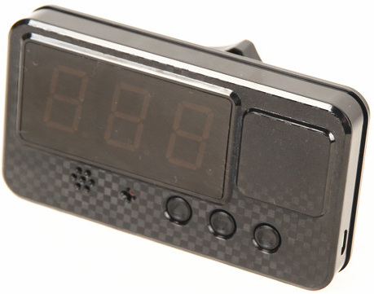

- Product Image:

USB Charging Slot

UP Button
Down Button
Enter Button

- Content of the packaging:

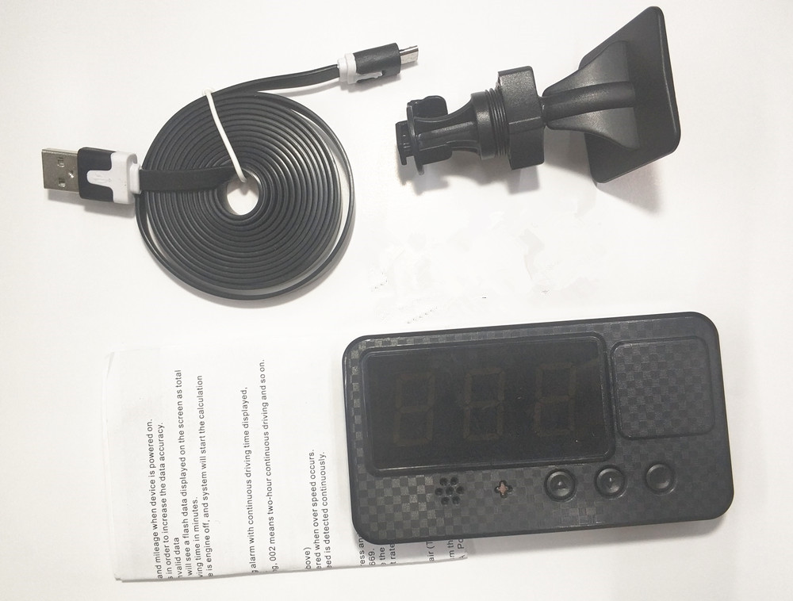

- GPS HUD speedometer
- USB cable
- Plastic holder

- User Manual
- Gift Box

- Operation Guide:
- Set the over-speed alarm rate
A: Press the Up Button or Down Button to increase or decrease the speed rate
B: The default alarm speed rate is 120KM/h
- Set the speed meter unit (KM or Mile)
A: Long press the Enter button, if you see number 100 shown on the screen, which means KM/h
B: Long press the Enter button, if you see number 161 shown on the screen, which means MPH
C: The default speed meter unit is set as KM/h
- Driving data record display
- System will start calculating total driving time and mileage when device is powered on.
- Parking time is not included in the calculations in order to increase the data accuracy.
- Mileage less than 1KM will be considered as invalid data
- Once the vehicle stops for a few seconds, you will see a flash data displayed on the screen as total mileage, and then the no flash data is total driving time in minutes.
- All driving data will be cleared once the vehicle is engine off, and system will start the calculation again when the car power resumed.

- Fatigue Driving Alarm
In every hour, system will trigger a fatigue driving alarm with continuous driving time displayed, in order to remind driver to avoid drowsy-driving.
Example: 001 means one-hour continuous driving, 002 means two-hour continuous driving and so on.

- Over Speed Alarm
- Set the over speed alarm rate (As described above)
- A three times “Beep” sound alarm will be triggered when over speed occurs.
- No more alarm will be triggered when over-speed is detected continuously.

- Adjustable Speed
The display speed could be adjusted by hand. Press and hold the up button and Enter button at the same time. It will show the numbers from 650 to 669.
Default speed rate is 665, if you want to increase the display speed with 1KM/H, adjust rate to 666; And if you want to decrease it with 1KM/H, adjust rate to 664.
- Technical Specifications
- GPS positioning time: 1 to 5 minutes in the open air (The bad weather will affect the positioning time).
There is no GPS signals indoors.
- Speed deviation: Since the speed data comes from the GPS satellite, slight deviation is unavoidable.
- Input voltage: DC 5V Input current: DC 30-60mA Power bank for power supply is supported.
- Working temperature: -30 to 70 degree
- Driving data deviation is around 2%
- All driving data will be cleared when power off

