LK880 QUICK TOUR
Real-time tracking | Remote Training Collar

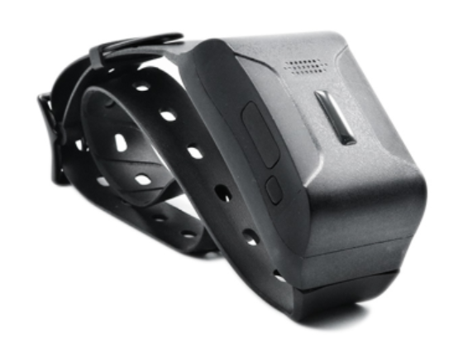

This product is based on LTE / GPRS network and GPS satellite positioning system.It is the most technologically advanced dual positioning of GPS and AGPS. IPX-68 waterproof professional is designed for individuals and hound. A new pet tracker and activity state 4G GPS locator for pets.

Please carefully read the user guide before use in order to quickly get the right to operate. Product appearance, color and accessories are subject to change without prior notice in this manual!

- Product Accessories
No. | product name | quantity | remarks
1 | GPS | 1
2 | charging cable | 1
3 | screwdriver | 1
4 | Manual | 1

2. Product function
◆ Real-time tracking / AGPS assisted positioning,
◆ Upload methods: timing, real-time mode;
◆ Vibration dog training in multiple modes, and its own speaker;
◆ Virtual fence / history track playback / displacement / low power alarm etc., alarm data upload to cloud background.
◆ Real-time health oversee (sleep, step counting);
◆ LED indicator: charging, GPS, communication, dog training status;

- Product parameters
Product name | 4G Pet（Dog training）GPS Tracker
Model | LK880
Suitable Object | Dog and other medium or large-sized animals
4G Bands  （Option） | North America version A: LTE-FDD—B2/B4/B12;  WCDMA—B2/B5  Europe version E: LTE-FDD—B1/B3/B5/B7/B8/B20  LTE-TDD—B38/B40/B41  WCDMA—B1/B5/B8;GSM—900/1800MHz  South America SA: LTE-FDD—B1/B2/B3/B4/B5/B7/B8/B28  LTE-TDD—B40  WCDMA—B1/B2/B5/B8;GSM—850/900/1800/1900MHz
Network | GSM/GPRS/LTE
Battery | 3.7V 1000mAh polymer lithium battery
Start-up time
Cold start 35s-80s
Start-up time  Cold start 35s-80s | Hot start 35s-80s
GPS accuracy | 10m
LTE module | Sim7600
GPS | -159dBm
Operating temperature | -20℃~70℃noncondensing
operating humidity | 5%-90%
storage temperature | -40℃ ～85℃
SIM card | Nono-card，self-bouncing card
Dimension | 90*46*28mm
Weight | 65g

- LED Indicator Definition
Green Indicator：GPRS/LTE signal
Status of indicator | Meaning
Flash | GSM/GPRS conversation start
Continuously in bright status | No GPRS signal
Green Led off | Power off or in sleep mode

Blue Indicator：GPS signal
Status of indicator | Meaning
Flash | GPS location successful
Continuously in bright status | GPS signal searching
Blue led off | Power off or in sleep mode

Red Indicator：Power charge or Find dog
Status of indicator | Meaning
Continuously in bright status | charging/finding
Red led off | Power off or charged full

NOTE: When the equipment in power saving sleep mode, the light will turn off after about 5 minutes(settable) without any operation.

- Start up
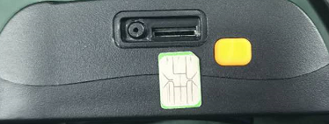

a, Open the USB rubber plug by hand , Insert a nano SIM card support LTE/ GSM/GPRS network into the slot and make sure the chip side is up.
b, switch the power button,the device would turn on.
c, Set admin number,by sending a SMS command to the SIM card inside device.
For example: admin123456 +86132******** (+86132********should be your phone number)
d, Set APN: APN123456 CMNET (please use your local APN instead of CMNET,if you do not know the APN content,you should contact your SIM card supplier)
Or Start up (that to active device)
- Open the cover by screwdriver, Insert a nano SIM card support LTE/ GSM/GPRS network into the slot and make sure the chip side is up.
- Turn on the unit outdoors by Pushing the button to“On”the indicator is on.
(when the green light and blue light are both flashing , you can do setting by step as below:)
- Set admin number,APN and open GPRS as below:
Step | SMS format for setting |  | Reply from unit
1.set admin: | admin123456+space+your phone number |  | Admin OK
2.set APN: | apn123456+ space+local apn content |  | Apn OK
3.set IP or domain | SZCS,123456,DOMAIN=a.lkgps.net:7700  (device default IP automatically,don’t need set) |  | SET IP OK
4.check signal: | status | BAT:6, GPRS:1,GSM:2,GPS:1,ACC:0,oil:0,Power:1,S:0
5.Call your tracker: | just called it and it sent back the location exact location

- In 10 or 40 seconds, the unit will begin to work and acquire the GSM signals as well as the GPS signals. The indicator will keep flashing every 3 seconds when the unit has received the signals.
- If the device is still not work on platform, pls check query parameters sms “param1” to conform IP address .

- More Commands
Function | Command Format | Reply | Delete | for example
Apn | apn+123456+space+content | apn ok |  | apn123456 cmnet
Apn | apnuser+123456+space+content | apnuser ok
Apn | apnpasswd+123456+space+content | apnpasswd ok
admin number | admin123456+space+admin phone number | admin ok | noadmin12345 | admin123456 132********
time zone | timezone+123456+space+GMT No. | timezone ok |  | timezone123456 +1
Timing mode（default 30s） | upload123456 30 | upload ok |  | RangeValue :10-86400s（when the frequency is 1800s and more, it will become the Timing mode)）
Real-tine uploading | d123456
Position | G123456# or where | google map
Power low alarm | LOW,1
Power save mode | sleep123456 time | sleep time ok | sleep123456 off | sleep off ok
shock sleep | sleep123456 shock | sleep shock ok
Restart | rst | restart ok
Back to factory | format | No reply
Language setting | lag1 | English oK
Signal status | status | BAT:6, GPRS:1,GSM:2,GPS:1,ACC:0,oil:0,Power:1,S:0
Parameter query | Param1 | software version number, device ID, domain name, APN, network signal, security status, vibration sensitivity
More details command by APP , please check from app while device is online.

- Download phone APP


Method 1: Scan above QR to download;

Method 2: search “LKGPS2” in the app store or Google play store to download.

- Log in by website and phone APP
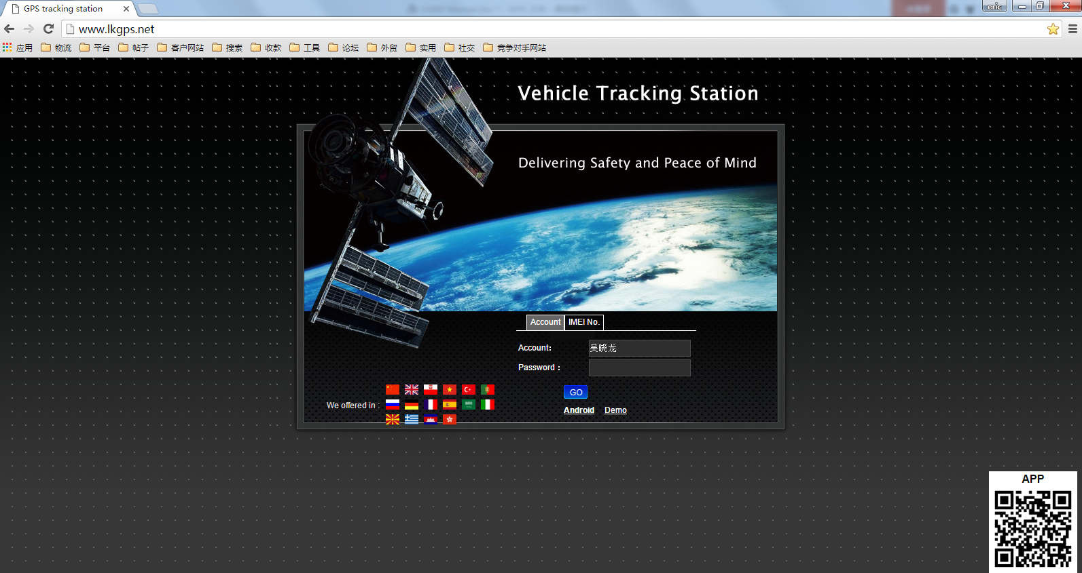
8.1 Log in by Website:
Open the website www.lkgps.net, choose IMEI, enter the 10-digit bar code of the device, the default password is 123456, click “GO” to log in into the platform.
8.2 Log in by Phone APP:
Please see the following photo:
8.2.1 APP please refer to the figure below for login：
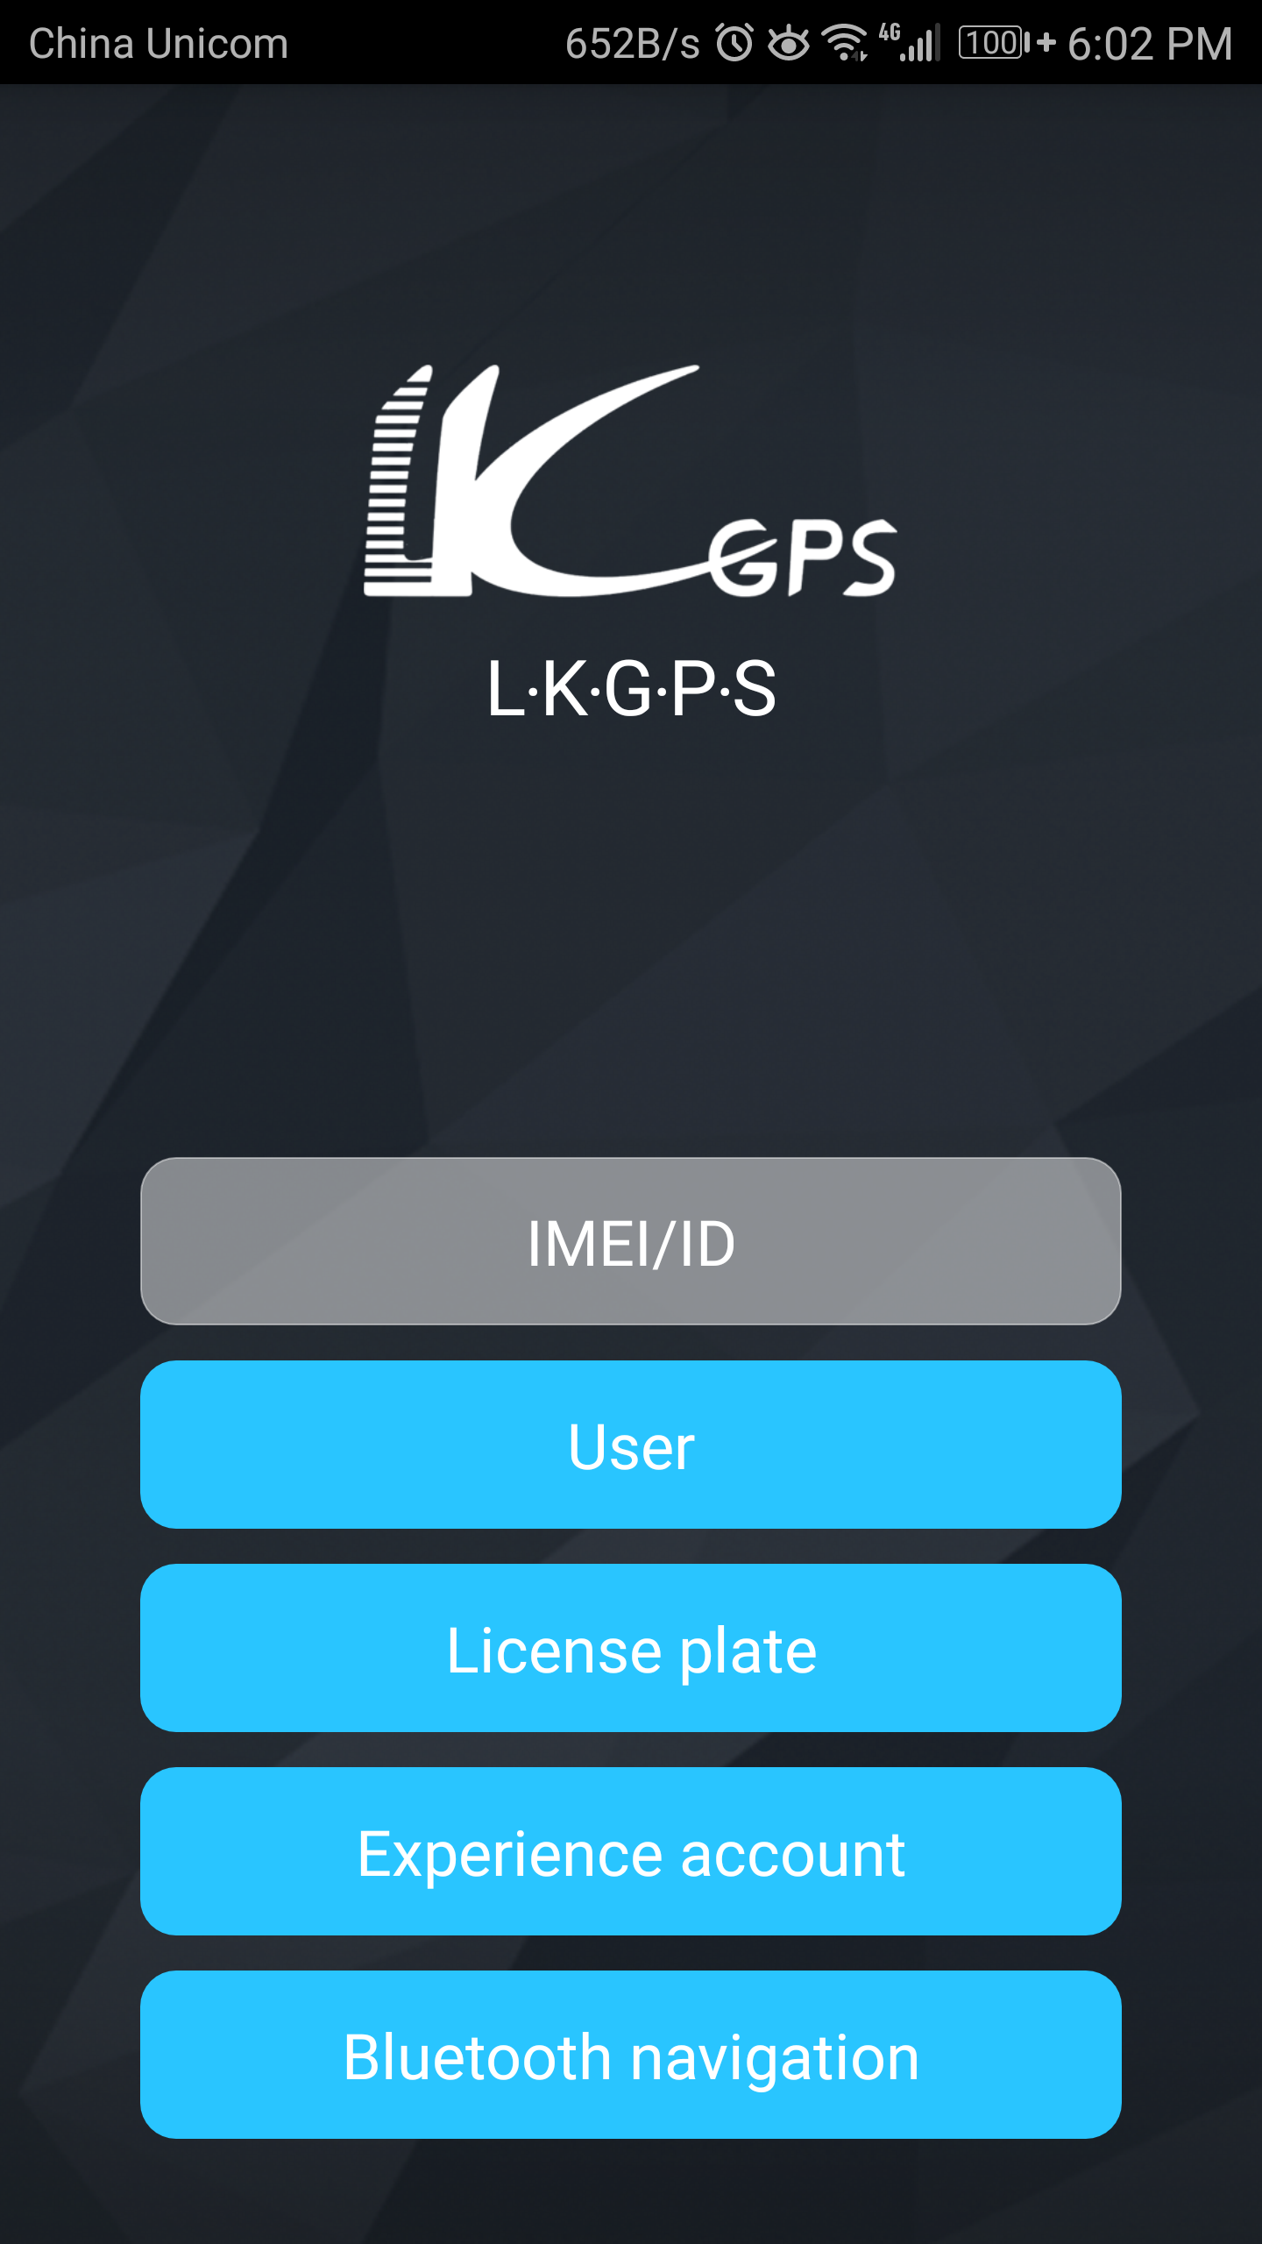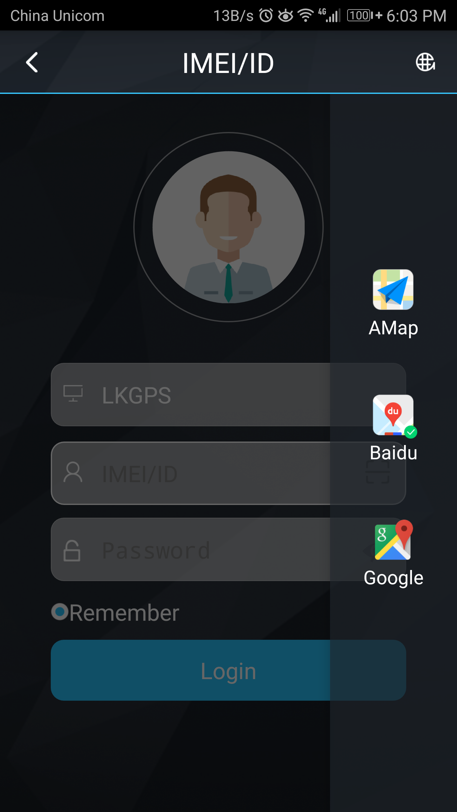

8.2.2 Select "IMEI / ID login" for the first login, select "lkgps" for the first column of address, input 10 digits on the device barcode, and the default password is 123456,
Click "log in" to log in
After logging in, set up and improve the user information, you can use other login methods
Note: (1) the optional items in the address column of the first column: select "666" for domestic users and "lkgps" for foreign users,
(2）Error "wrong user name or password" appears in the address bar, unable to log in normally
8.2.3 How to use the interface of stand-alone software
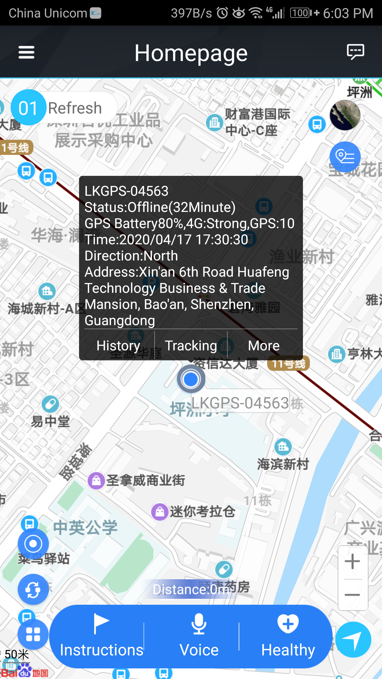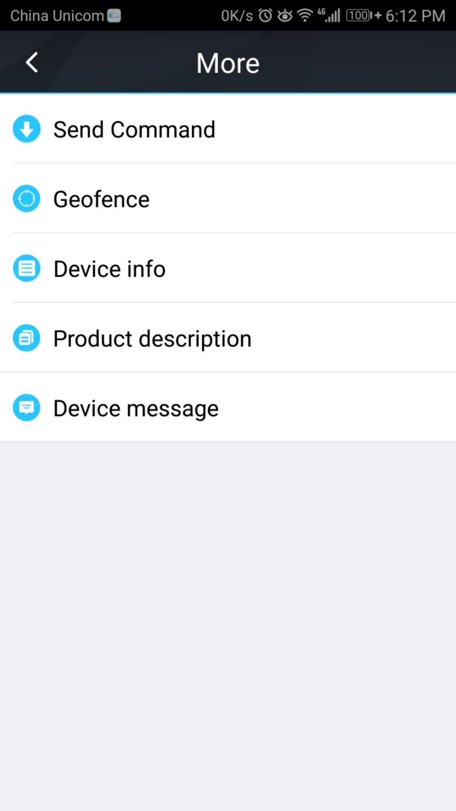

The settings include: reminder settings (mobile phone sound and vibration settings), password modification, skin replacement, instructions for use (multi version instructions), log out of the current login

More settings include: command issuing (instruction 1, instruction 2, instruction 3, instruction 4, instruction 5, instruction 6, instruction 7, instruction 8, instruction 9)

Electronic fence, equipment information (equipment name, equipment number, expiration time, equipment model, equipment SIM card number, type, gender, weight, age, birthday, owner name, owner phone number, icon), product description, equipment message

Instruction: instruction 1, instruction 2, instruction 3, instruction 4, instruction 5, instruction 6, instruction 7, instruction 8, instruction 9
Voice: Voice training
Health: step counting, sleep

Note: (1) if you need to use a multi machine version of the advanced account, please contact the equipment manufacturer. You can use it after opening the exclusive account. The software operation interface is slightly different

8.2.4 Dog training function

2.3.1 Command setting(edit command name from APP)

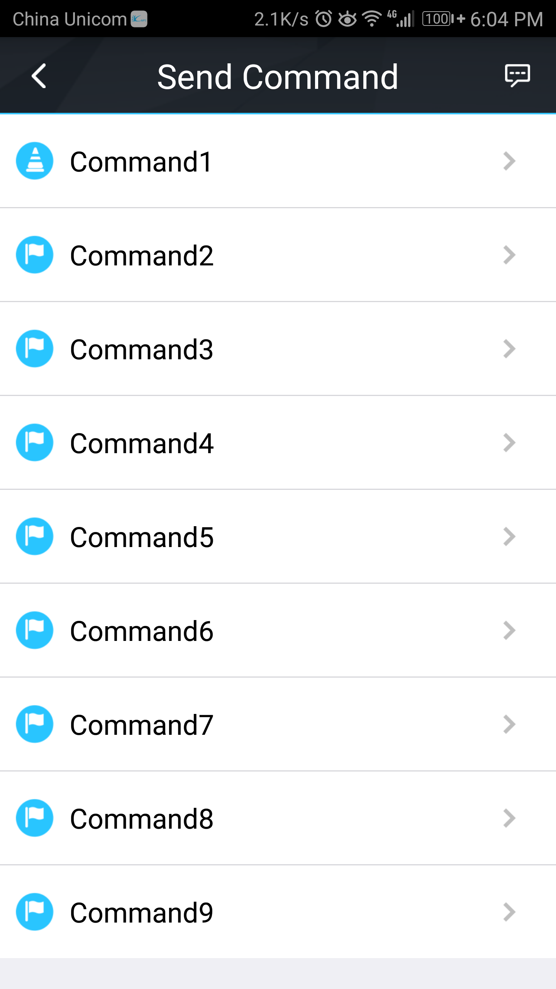
8.2.5 Dog Training interface Send command by short press Rename by long press
Default command name | Function | Vibration type
Command 1 | Weak Vibration for 0.5s | One Vibration for 0.5s
Command 2 | Interval Weak Vibration for 10s | Interval Vibration，0.5s every time，20 times,for 10s
Command 3 | Medium vibration for 0.8s | One Vibration for 0.8s
Command 4 | Interval Medium vibration for 10s | Interval vibration，0.8s every time，13 times for 10s
Command 5 | Strong vibration for 2s | One Vibration for 2s
Command 6 | Interval vibration for 10s | Interval Vibration,1.25s every time，9 times for 10s
Command 7 | “Ticking”for 0.5s | One ticking for 0.5s
Command 8 | “Ticking”for 10s | Interval ticking，0.5s every time，20 times for 10s
Command 9 | On：Light flashes | Off：Light turns off

8.3 How to use health Oversee interface
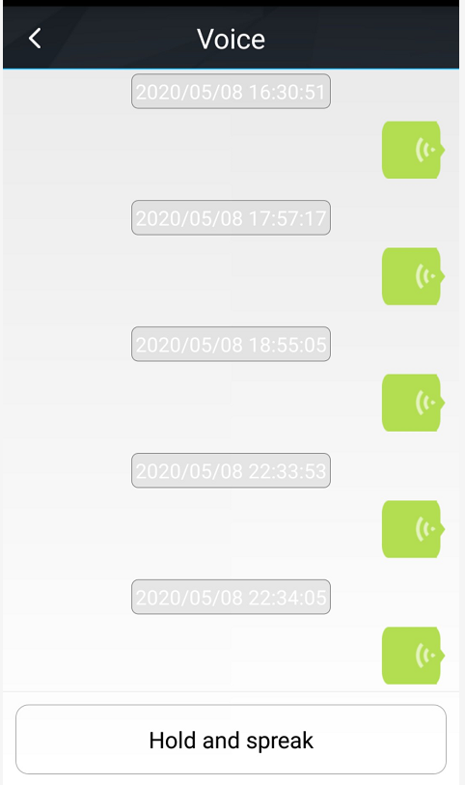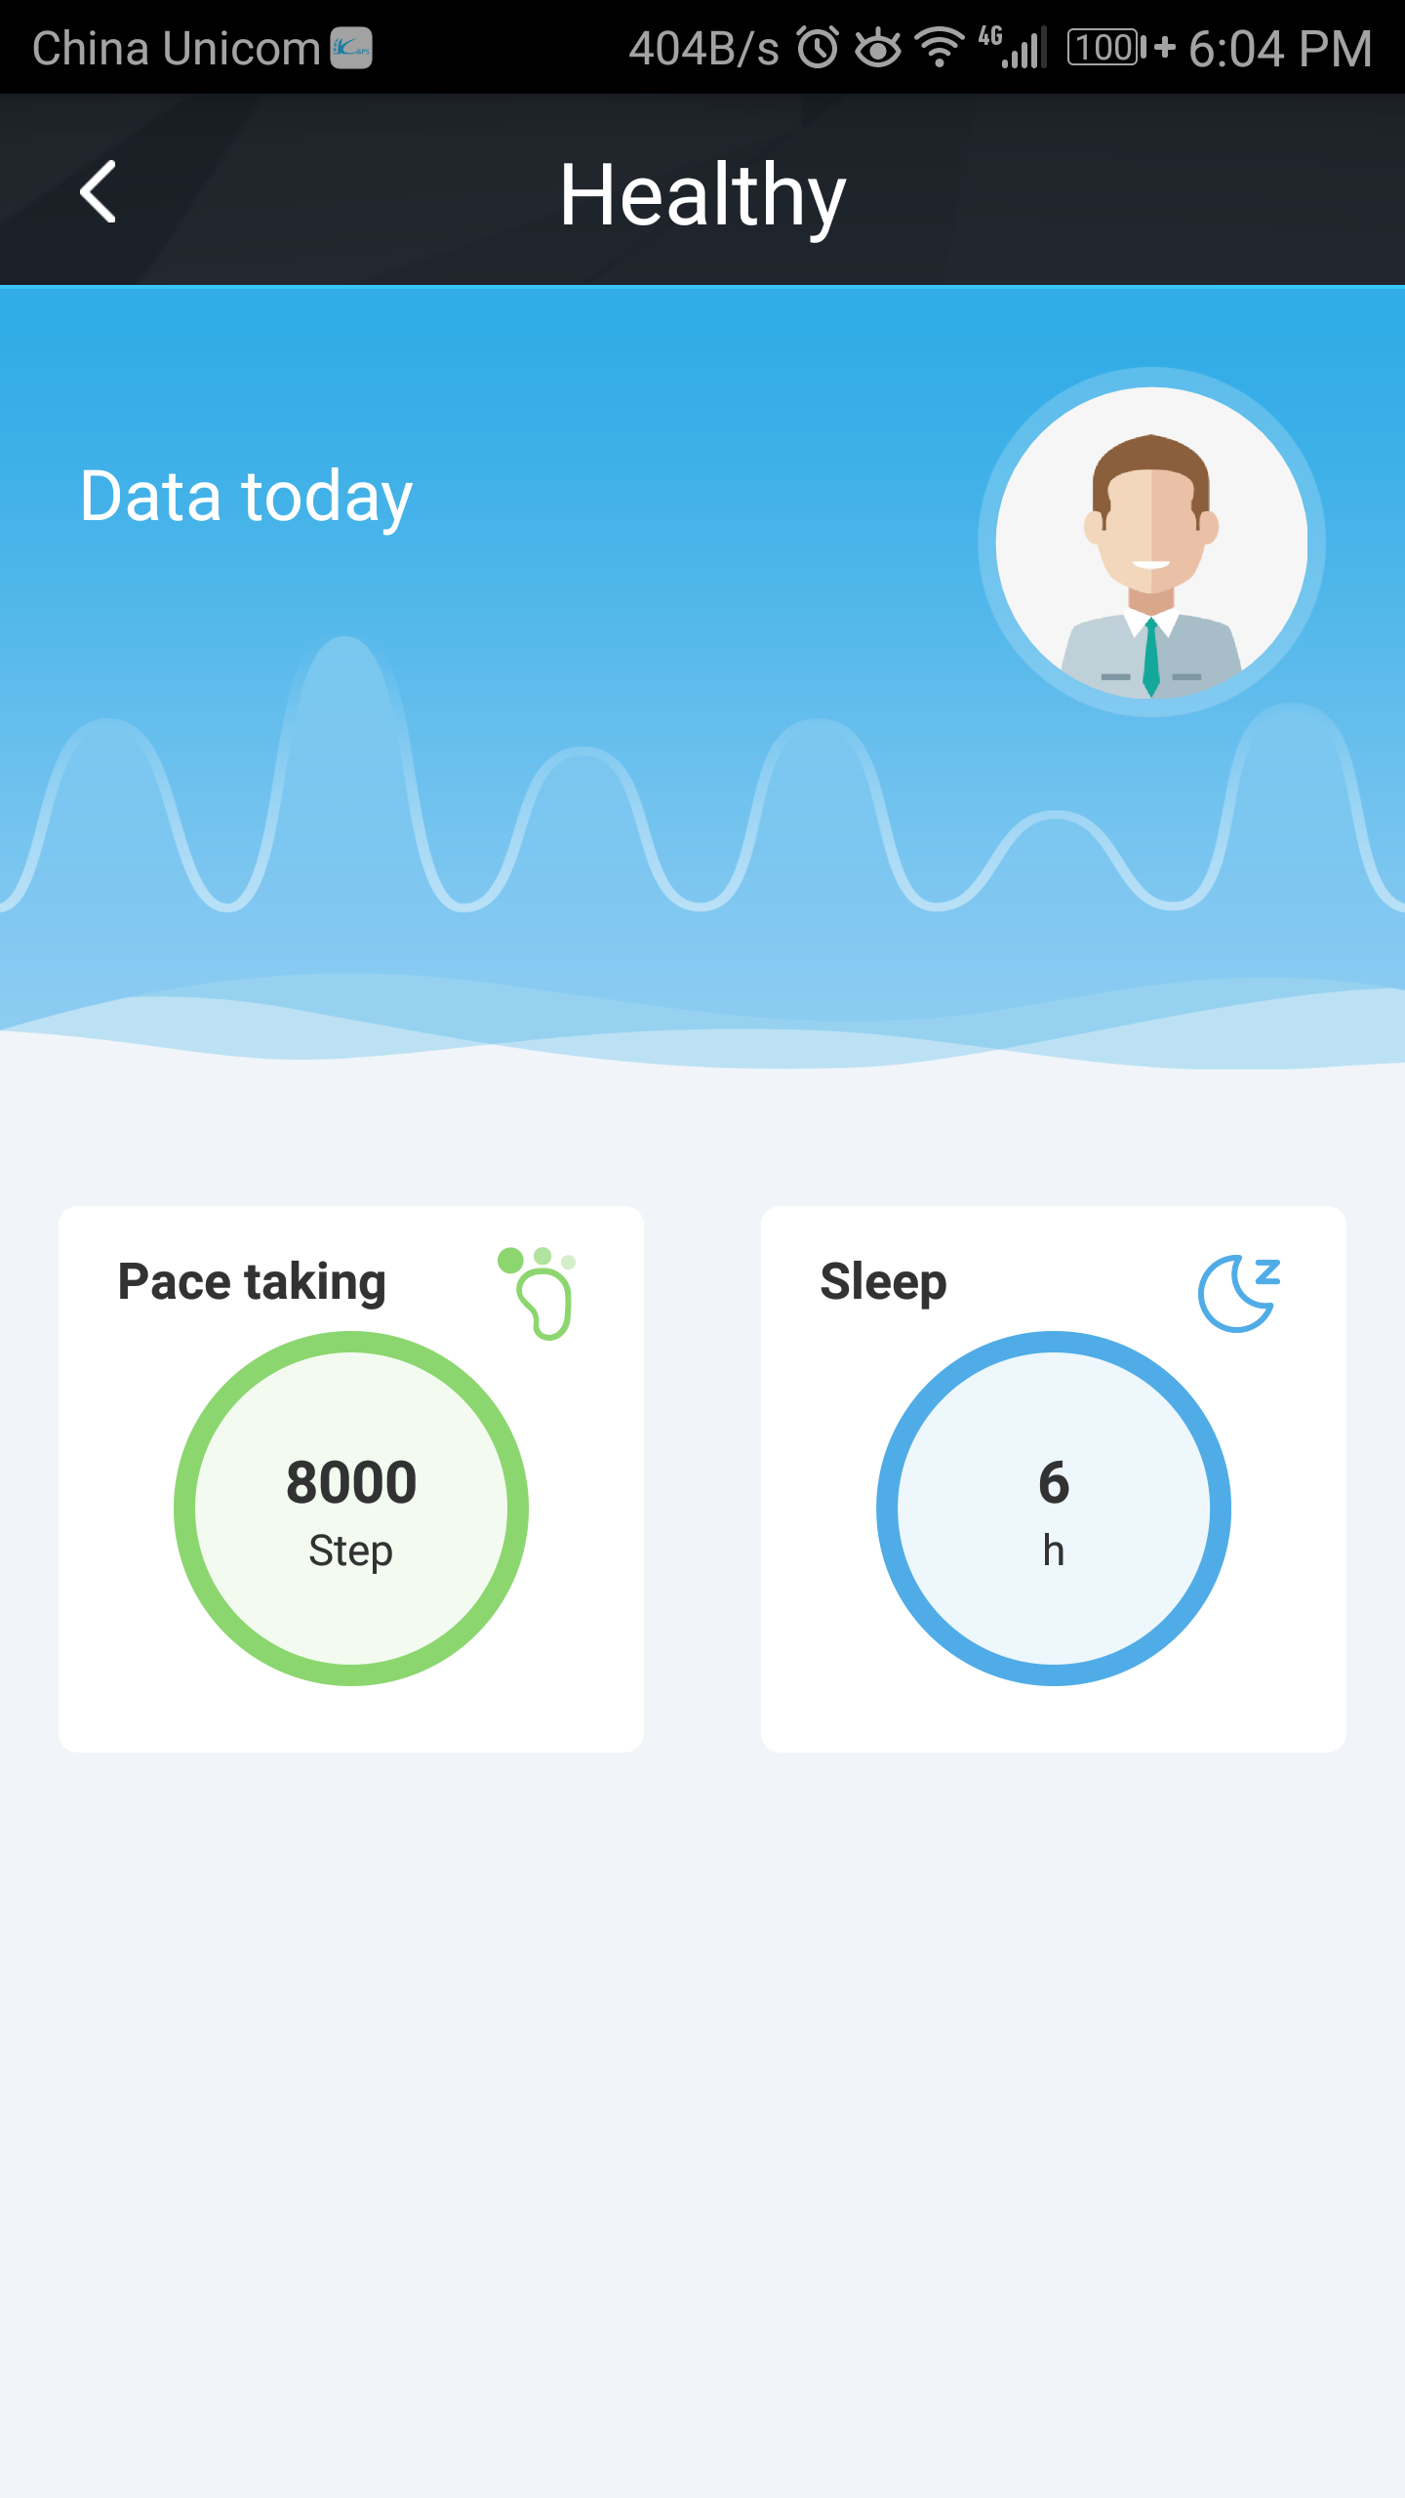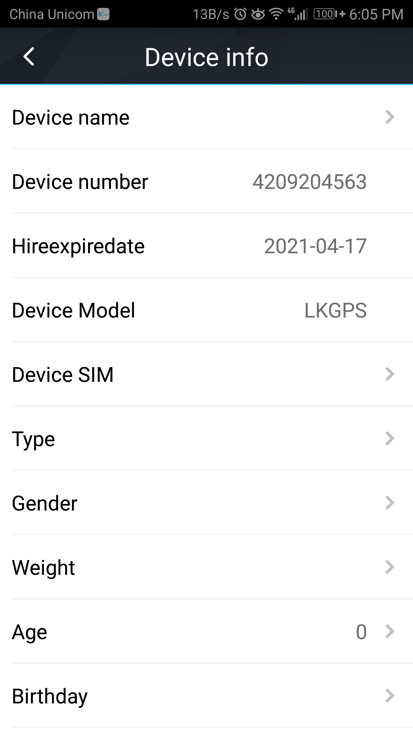

9.Faults & The solutions
Q：Start up Fail?
A：Check the battery charge full or not.
Q：The device can not obtain location information?
A：Place the unit at the open area to test.
Q：How to choose SIM card?
A: the SIM card must support 4G，and ensure that the card has enough currency and credit.
Q: How to use in the foreign countries?
A：please set the APN before use，please edit the text “APN123456 CMNET “ and send it to the SIM card of the device，CMNET is Chinese operator’s APN, Replace the corresponding APN when use in other countries, APN details, please consult your local SIM card carrier.

10.Cautions Please comply with the instructions to extend the unit life:
1. Keep the unit dry. Any liquid, i.e. rain, moisture, may destroy or damage the inside circuitry.
2. Don’t use & store the unit in dusty places.
3. Don’t put the unit in overheated or over cooled places.
4. Handle carefully. Don’t vibrate or shake it violently.
5. Clear the unit with a piece of dry cloth. Don’t clean in chemicals, detergent.
6. Don’t paint the unit, this may cause some foreign materials left in between the parts.
7. Don’t disassemble or refit the unit.
8. Please use the battery and charger provided by manufacturer. Using other batteries and chargers will cause unwanted situation.

