Automobile HUD head-up display C20 Touch screen multi-function display

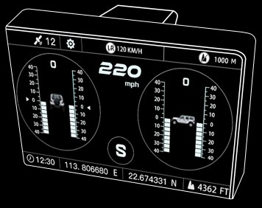Automobile HUD head-up display C20

User Manual

版权所有！未征得公司的书面同意任何公司或个人不得以任何形式（电子、 机械、 影印、 录制或其他 形式）对本说明书进行复制和备份。本手册专为公司产品的使用而设计， 对于将之用于指导其他设备操作而导致的各种后果本公司不承担任何责任。

因使用者个人或第三方的意外事故，滥用、 误用该设备， 擅自更改，或修理该设备，或未按公司的操作与保养要求而导致设备损坏、 遗失所产生的费用及开支等，公司及其分
支机构不承担任何责任。 | 主要功能
 | - 横滚角 | ·指南针 | - 海拔高度
 | - 俯仰角 | ·GPS车速 | - 时间日期
 | - 星期 | - 实时电压 | - 航向角
正式声明：本说明书所提及之其他产品名称，目的在于说明 | - 行驶时间 | - 行驶里程 | - 卫星颗数
该设备如何使用，其注册商标所有权仍属原公司。 | - 超速报警 | - 海拔高度报警

产品简介
汽车智能护航多功能显示器 C20，是一款结合坡度仪、HUD 抬头显示器、指南针等多数据的多功能显示仪表，大大提高产品对用户的安全防护等级，为车主保驾护航。
通过GPS/北斗双通道模块向卫星获取数据，双信号稳定等优势，通用于市面上所有车型，是自驾爱好者的必备神器。

功能与特点

请保存此说明书
主要特点
- 适用于所有10-30V车辆。
·搭载高精度双通道卫星GPS模块。
·全自动监测车辆行驶状况。
·采用高灵敏触摸显示屏，显示分辨率高。
·采用ABS耐高温材质设计。
·随车启动，停车自动休眠功能。
·中文、繁体、英文三种语言切换。

工作环境及技术指标
电源： DC10V~30V; 工作温度：－40°C~＋80°C; 俯仰角： －40°~＋40°; 横 滚 角 ： －40°~+40°; GPS数据刷新速率：1s; 电压测量范围：DC10V~30V; 电压测量精度：0.5V; 速度精度：＜0.36Km/h; GPS冷启动时间：32s（平均）； GPS热启动时间：ls（平均）；
无线传输频率：2.4GHz; 重量：0.23kg;

整机结构
显示界面及功能介绍显示界面1

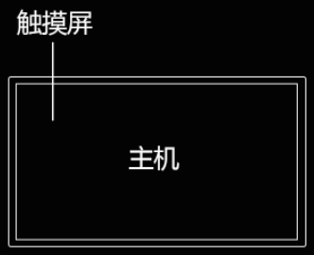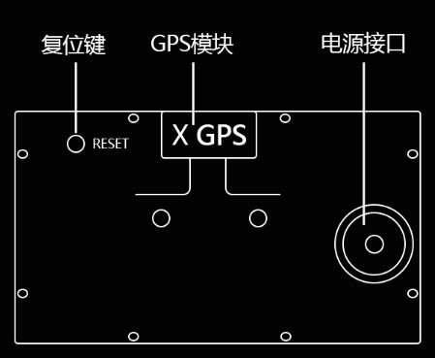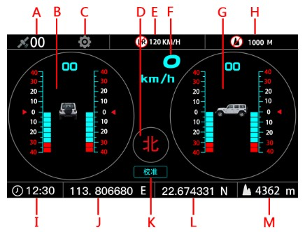复位键：
恢复出厂设置，短按，听到提示音即可。

GPS接收器：
内置GPS模块，开机自动搜索连接GPS信号。
A.卫星颗数 B.横滚角
C.功能设置 D.指南针
E.超速报警 F.GPS车速
G.俯仰角 H.海拔高度报警
I .时间 J. 经度
K.校准(坡度复位) L.纬度M.海拔高度

显示界面2 显示界面4

A.行驶里程 B.行驶时间 C.实时电压 D.指南针E.航向角 F.超速报警值 G.海拔报警值

车速显示界面

显示界面3 显示界面5

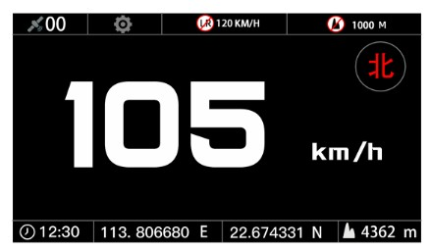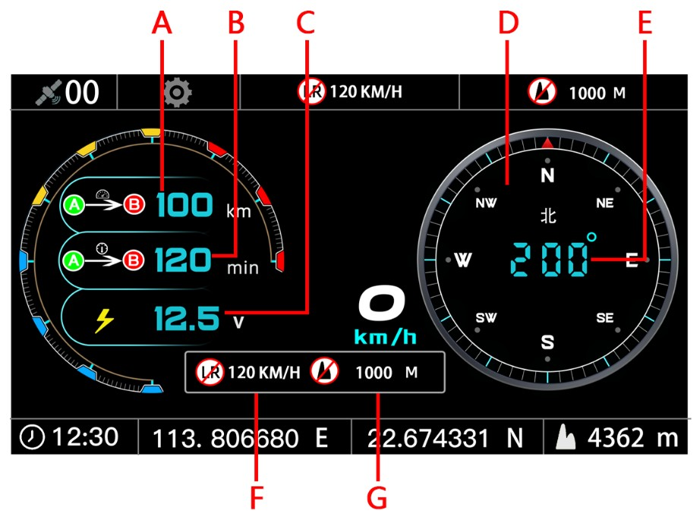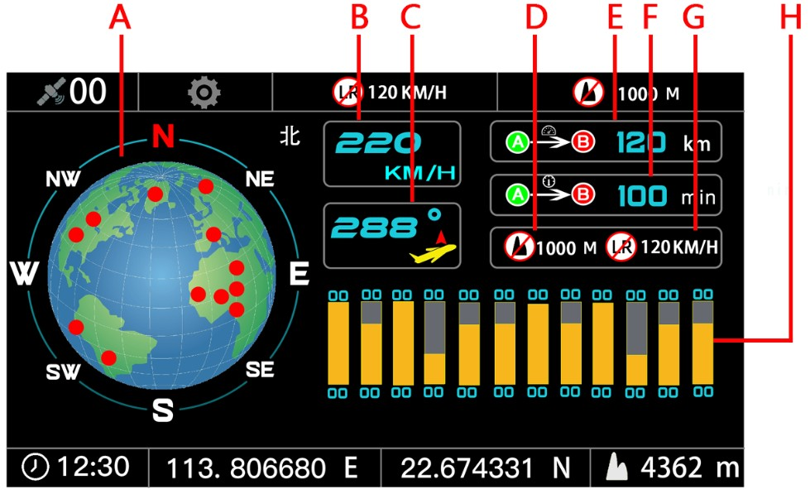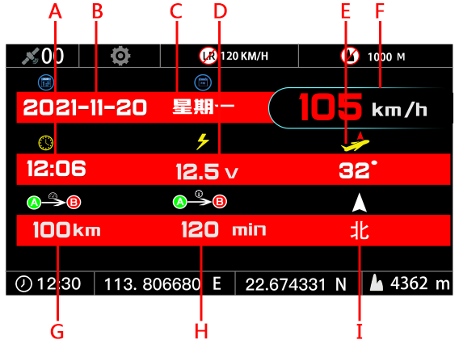A.时间 B.日期 C.星期 D.实时电压
E.航向角 F.GPS车速 G.行驶里程 H.行驶时间I.指南针
A.指南针 B.GPS车速D.海拔报警值 E.行驶里程
G.超速报警值 H.卫星信号强弱
C.航向角 F.行驶时间

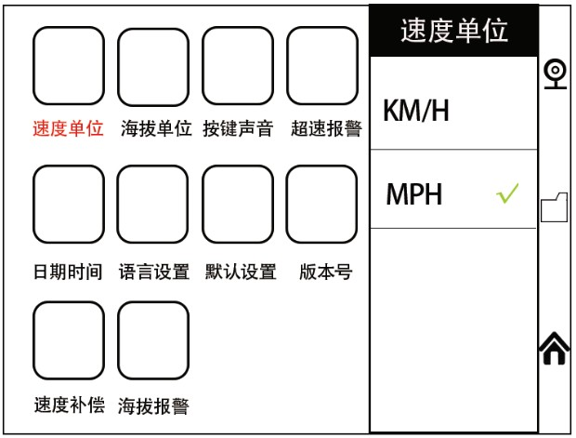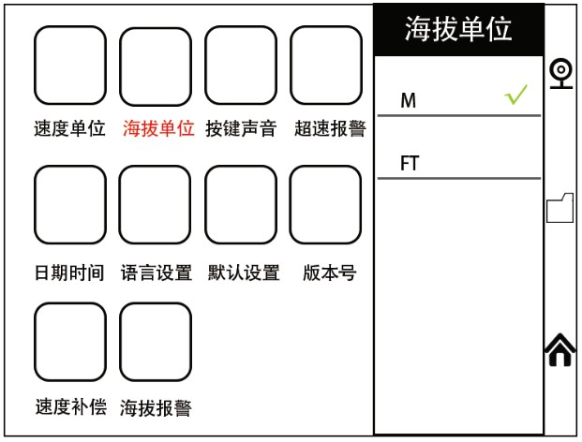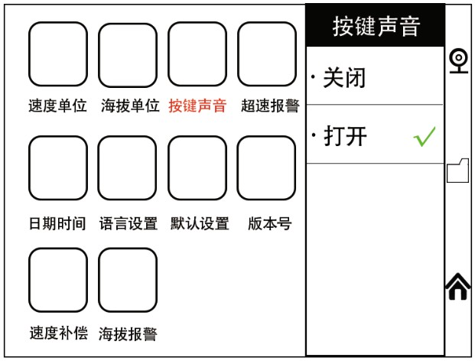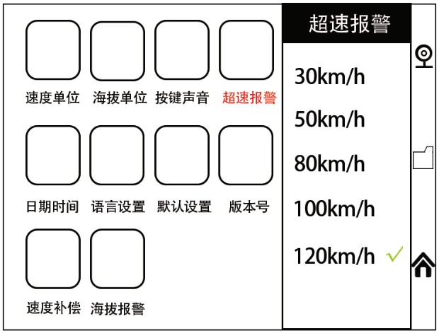功能设置介绍
显示界面点击功能设置进入设置界面
1-速度单位设置（KM/H-MPH）公里和英里切换

2-海拔单位（M-FT）米和英尺切换

3-按键声音开关

4-超速报警数值设置

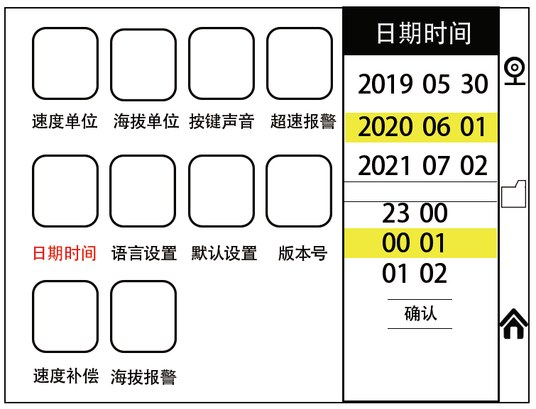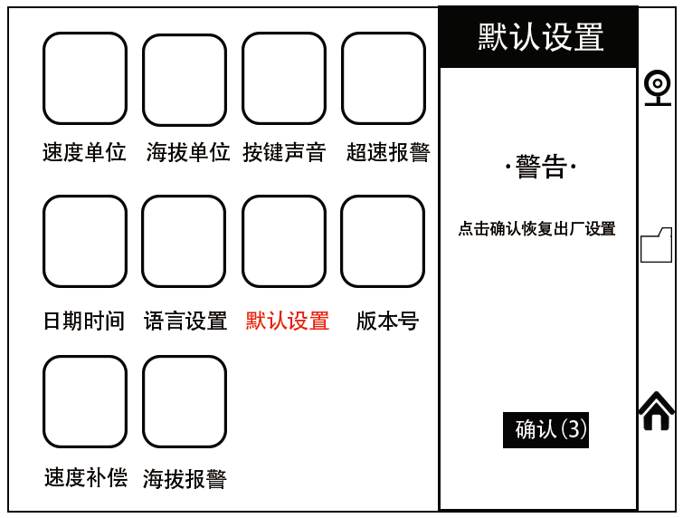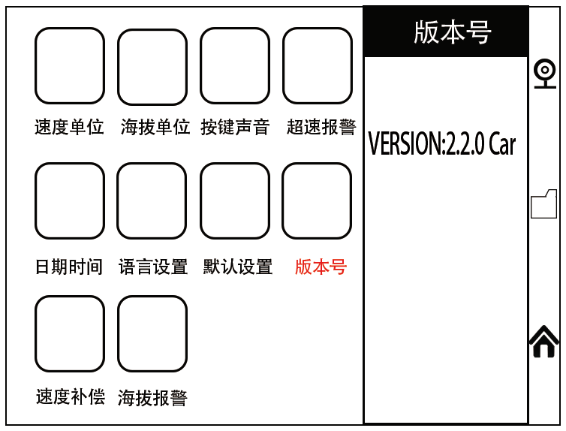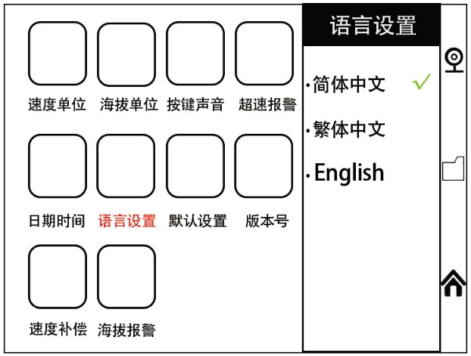5-日期时间设置

6-语言设置
7-默认设置（恢复出厂设置）

8-版本号（当前系统版本）

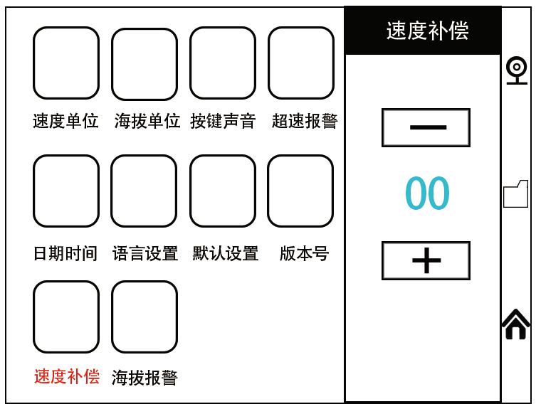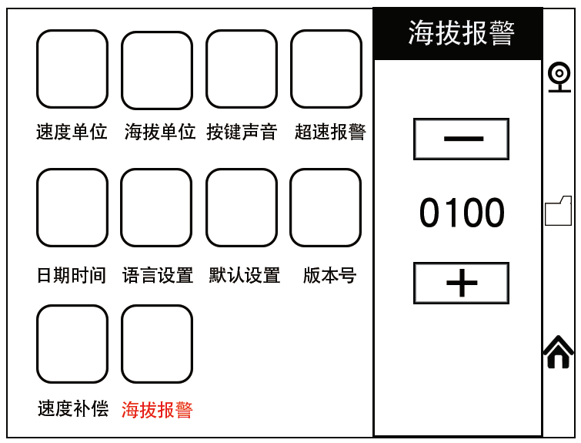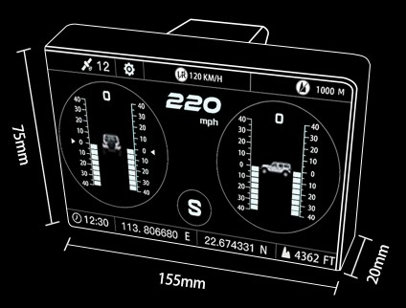
- 速度补偿（车速误差补偿设置） 产品尺寸

10-海拔报警（海拔报警值设置）

长155mm 高75mm 宽20mm

安装步骤

1.把汽车停放在水平路面上，将吸盘安装在主机上，固定于汽车内部方便观察的任何地方。

2.连接电源，将坡度手工调校至水平，等待接收卫星GPS信号，直到各项数据显示正常，即可驾车行驶。
以下情况不再免费保修范围
·非正规渠道购买的产品；
·未按产品说明书要求使用和维护造成的损坏；
声明：
公司保留更改产品设计与规格的权利，届时恕不另行通知。实物外观与颜色可能与说明书中显示的有差别，请以实物为准。 我们已尽最大努力力求使书中所有描述准确，但仍难免有不妥之处，如有疑问，请联系经销商或售后服务中心， 本公司对产品拥有最终解释权，不承担任何因误解而产生的后果。

售后服务售后保修
整机自客户签收日起享有1年保修期，附件1年保修期。保修方式
·根据具体的故障情况对设备进行修理或更换；
·我方保证所有更换的部件、 附件或设备都是全新；
·在客户收到产品90天内出现故障同时提供视频和图片， 我方承担运费并免费提供相应配件给客户更换。 收到产品超过90天，客户承担相应的费用，我方免费提供配件给客户更换；

copyright! No company or individual may reproduce or back up this manual in any form (electronic, mechanical, photocopying, recording or otherwise) without the written consent of the company. This manual is designed for the use of the company's products, and the company does not bear any responsibility for the consequences caused by the use of it to guide the operation of other equipment.

Due to the accident of the user or a third party, the company and its branches shall not be held responsible for the abuse or misuse of the equipment, unauthorized alteration or repair of the equipment, or failure to comply with the company's operation and maintenance requirements for damage or loss of the equipment.

Official statement: the other product names mentioned in this specification are intended to explain how the equipment is used and the ownership of the registered trademark still belongs to the original company.

Please save this manual
Product introduction.
Automobile intelligent escort multi-function display C20 is a multi-function display instrument with multi-data such as slope meter, HUD head-up display, compass and so on, which greatly improves the safety protection level of the product to the user and escorts the car owner.
Through the GPS/ Beidou dual-channel module to obtain data from the satellite, dual-signal stability and other advantages, commonly used in all models on the market, is a necessary artifact for self-driving enthusiasts.

Functions and characteristics Main function.
- Roll angle. ·Compass. ·Altitude.
- Pitch angle. ·GPS speed. ·Time date.
- Week. ·Real-time voltage. ·Heading angle.
·Travel time. ·Driving mileage. ·Number of satellites.
- Overspeed alarm. ·Altitude alarm
Main features.
- Suitable for all 12-30V vehicles.
- Equipped with high-precision dual-channel satellite GPS module.
- Automatically monitor the driving condition of the vehicle.
- The use of high-sensitive touch display screen, high display resolution.
·Adopt ABS high temperature resistant material design.
- Start with the car, stop the automatic dormancy function.
·Switch between Chinese, traditional Chinese and English.

Working environment and technical indicators. Power supply: DC10V~30V.
Operating temperature:-40 °C ~ + 80 °C. Pitch angle:-40 °~ + 40 °.
Roll angle:-40 °~ + 40 °. GPS data refresh rate: 1s.
Voltage measurement range: DC10V~30V. Voltage measurement accuracy: 0.5V. Speed accuracy: < 0.36Km/h.
GPS cold start time: 32s (average). GPS warm start time: ls (average).
Wireless transmission frequency: 2.4GHz. Weight: 0.23kg

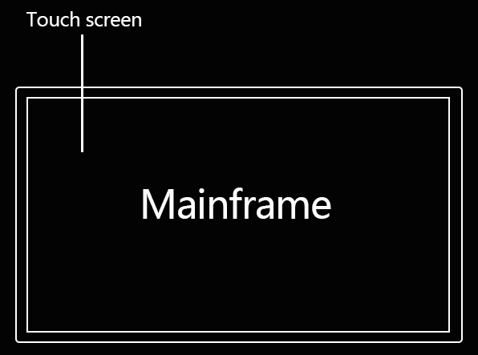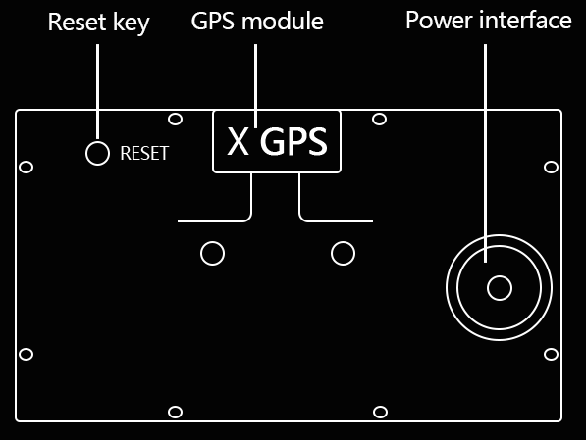Whole machine structure

Reset key:
Restore the factory settings, press short and hear the tone.
GPS receiver:
Built-in GPS module, boot automatically search connection GPS signal.

Introduction to display interface and function. Display interface-1
Display Interface-2.

a. Driving mileage. b. Travel time. c. Real-time voltage.
d. Compass. e. Heading angle. f. Overspeed alarm value.
g. Altitude alarm value
Display interface-3.

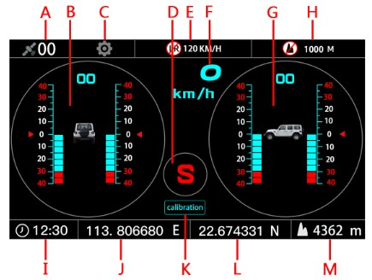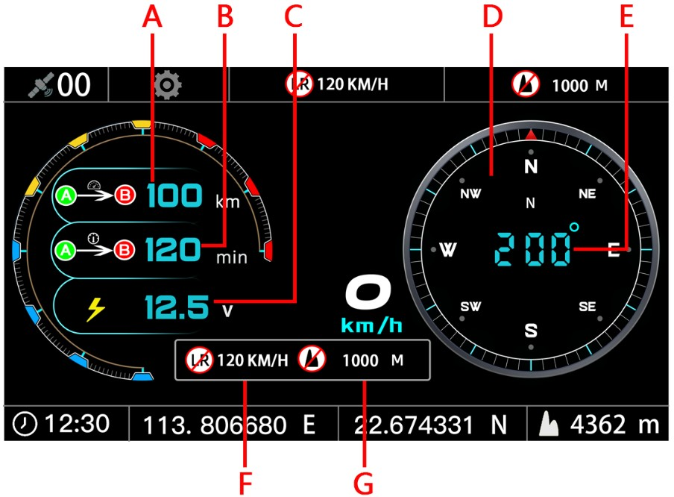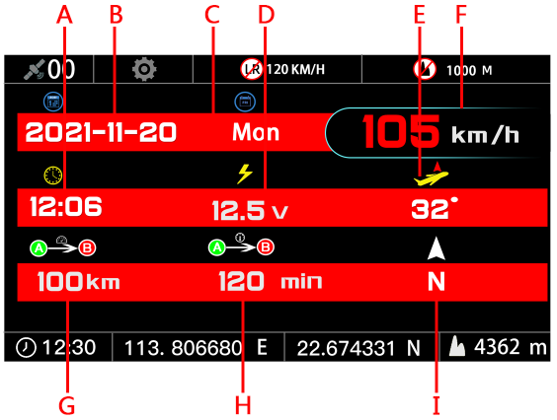a. Number of satellites. b. Roll angle.
c. Function setting. d. Compass.
e. Overspeed alarm. f.GPS speed.
g. Pitch angle. h. Altitude alarm.
i. time. j. Longitude.
k. Calibration (slope reset). l. Latitude.
m. Altitude

a. time. b. Date. c. Week. d. Real-time voltage.
e. Heading angle. f. GPS speed. g. .Driving mileage.
h. Travel time. i. Compass

Display interface-4.

Speed display interface. Display interface-5.
Introduction to function Settin.
Display interface click function settings to enter the settings interface.
- Speed Unit setting (KM/H-MPH) kilometer and mile switch.

- altitude unit (M-FT) meter and foot toggle.

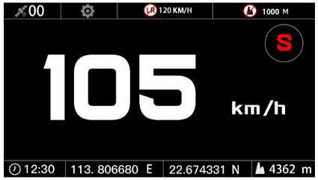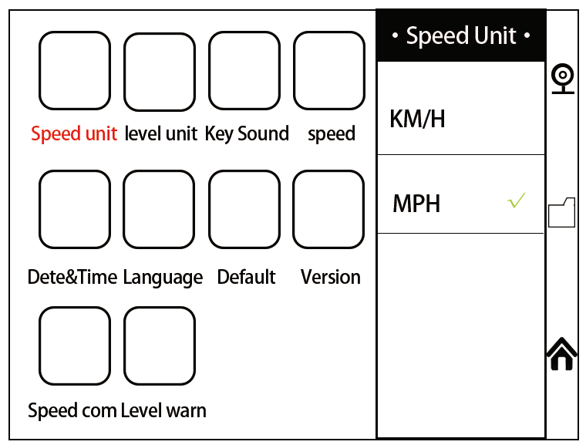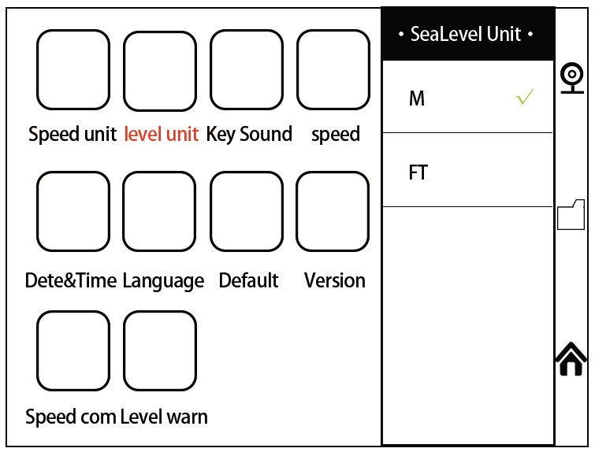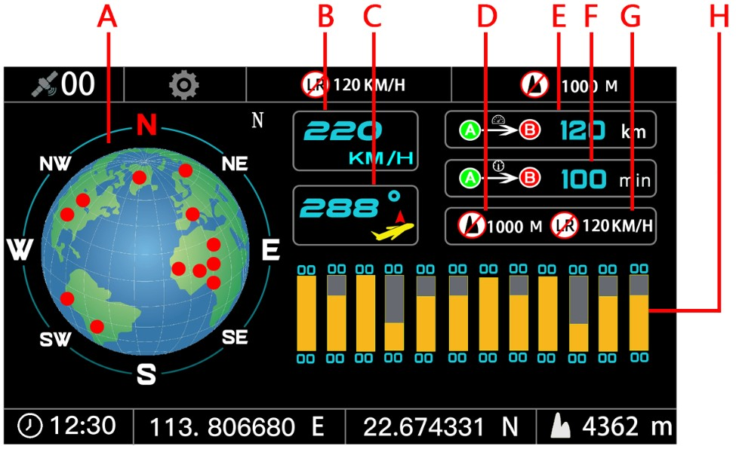

a. Compass. B.GPS speed. c. Heading angle.
d. Altitude alarm value. e. Driving mileage.
f. Travel time. g. Overspeed alarm value.
h. Satellite signal strength

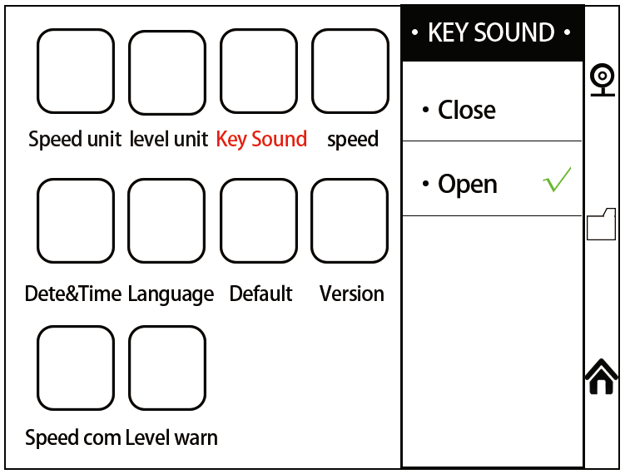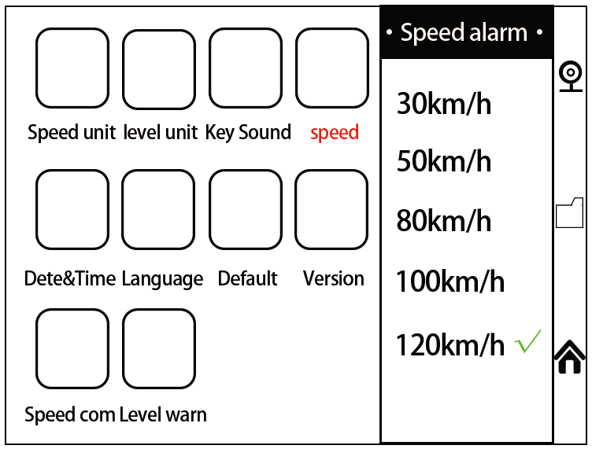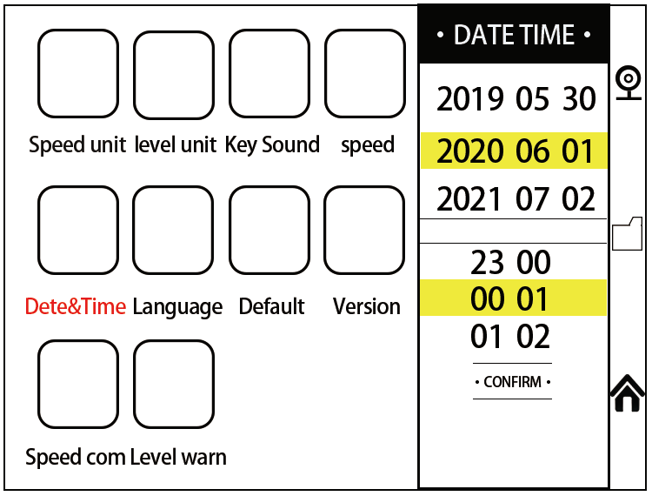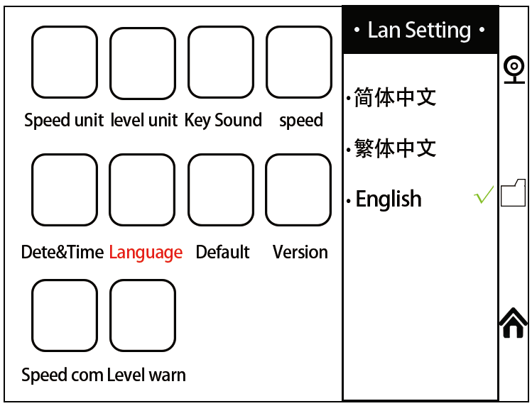
- Button Sound switch. 5-date and time settin.

- overspeed alarm value setting 6-language settin.

- 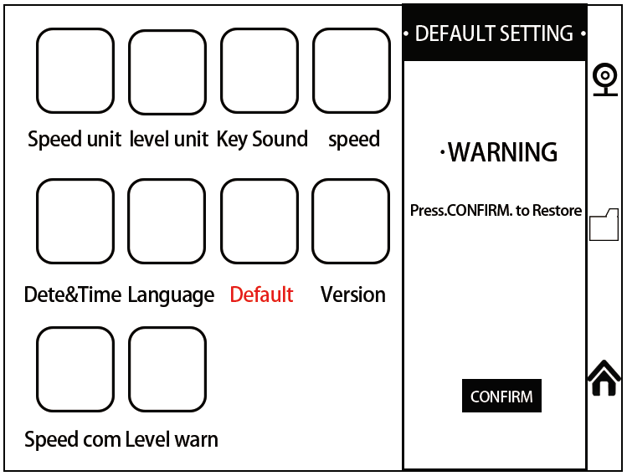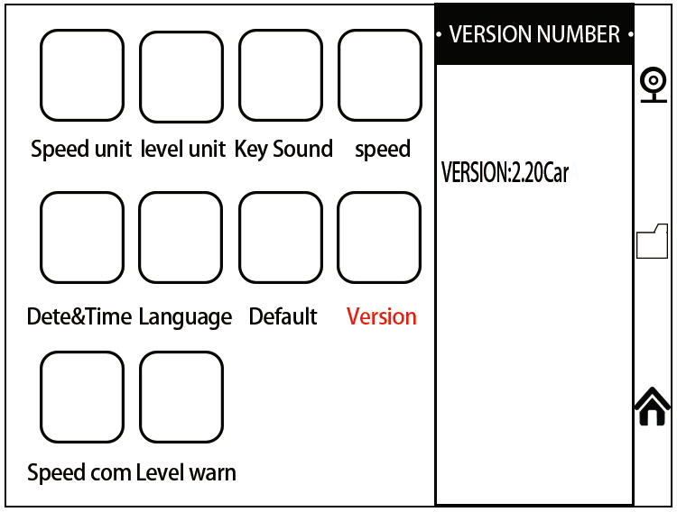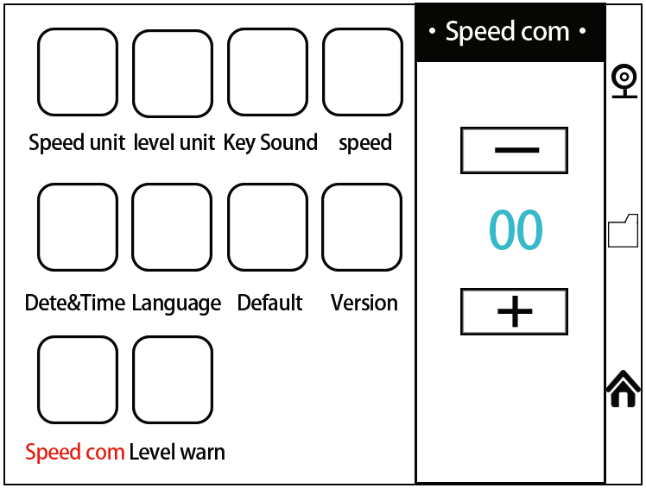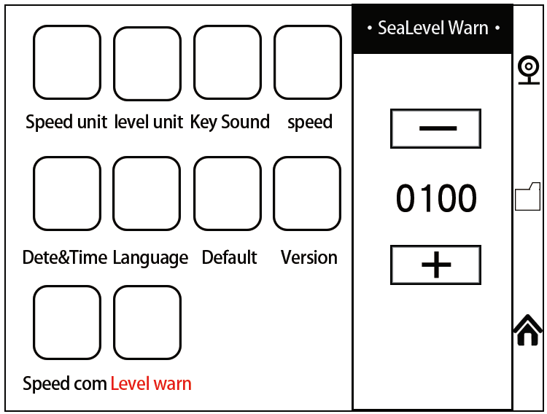default settings (restore factory settings).

- version number (current system version).
- Speed compensation (speed error compensation setting).

- altitude alarm (altitude alarm value setting).

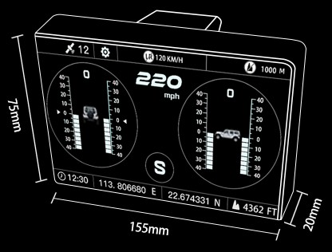Product size.

Long 155mm, high 75mm, wide 20mm Installation steps.
- Park the car on the horizontal road, install the sucker on the main engine, and fix it anywhere in the car where it is easy to observe.
- Connect the power supply, manually adjust the slope to the level, wait for the satellite GPS signal to be received, until the data show normal, you can drive.

after-sale service. After-sale warranty.
The whole machine has a 1-year warranty period from the customer signing date, and the attachment 1-year warranty period.
Warranty mode.
- Repair or replace the equipment according to the specific failure situation.
- We guarantee that all replacement parts, accessories or equipment are brand new.
- Provide video and pictures at the same time when the customer fails within 90 days of receiving the product.
We bear the freight and provide the corresponding spare parts to the customer for replacement free of charge. If the product is received for more than 90 days, the customer will bear the corresponding fee, and we will provide spare parts to the customer for replacement free of charge.

The following situations are no longer covered by free warranty.
- Products purchased through informal channels.
- Damage caused by failure to use and maintain in accordance with the product instructions

Declaration:
The company reserves the right to change the product design and specifications without prior notice. The appearance and color of the object may be different from those shown in the manual, please take the object as the standard. We have tried our best to make all the descriptions in the book accurate, but there are still some inadequacies. If in doubt, please contact the dealer or after- sales service center. Our company has the right of final interpretation of the products and will not bear any consequences arising from misunderstandings.

