4GGPS tracking Bracelet
Tracking App installation
Use the guardian’s mobile phone to scan below QR code and install the tracking App.
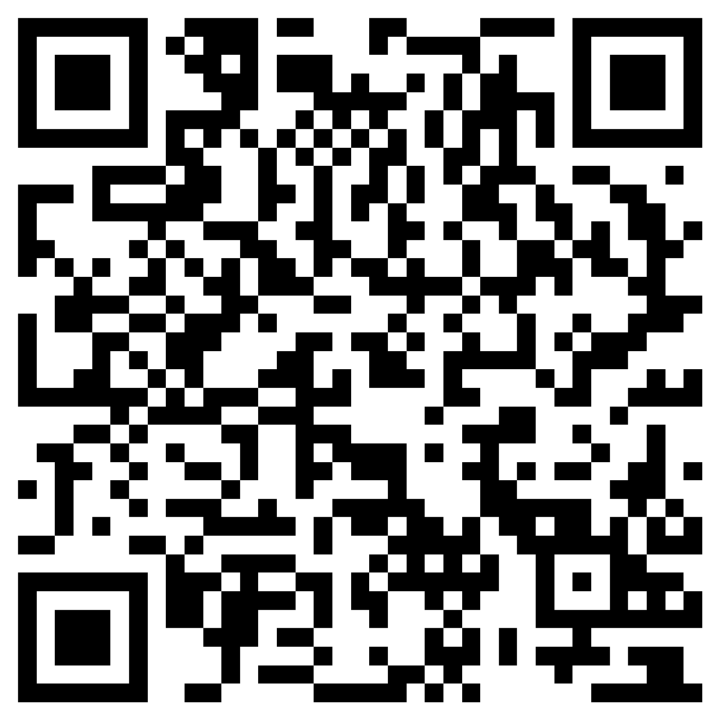

SIM card installation and power on device
Open the side SIM slot with screw driver in accessories. Insert the SIM card based on the direction as left picture shows till the SIM locked.
Long press the SOS key till the bracelet vibrates with ringtone and indicators on.

App login
Login the App via device 10 digits ID number on back label and default password 123456 from the access of “Device ID”as screenshot shows.
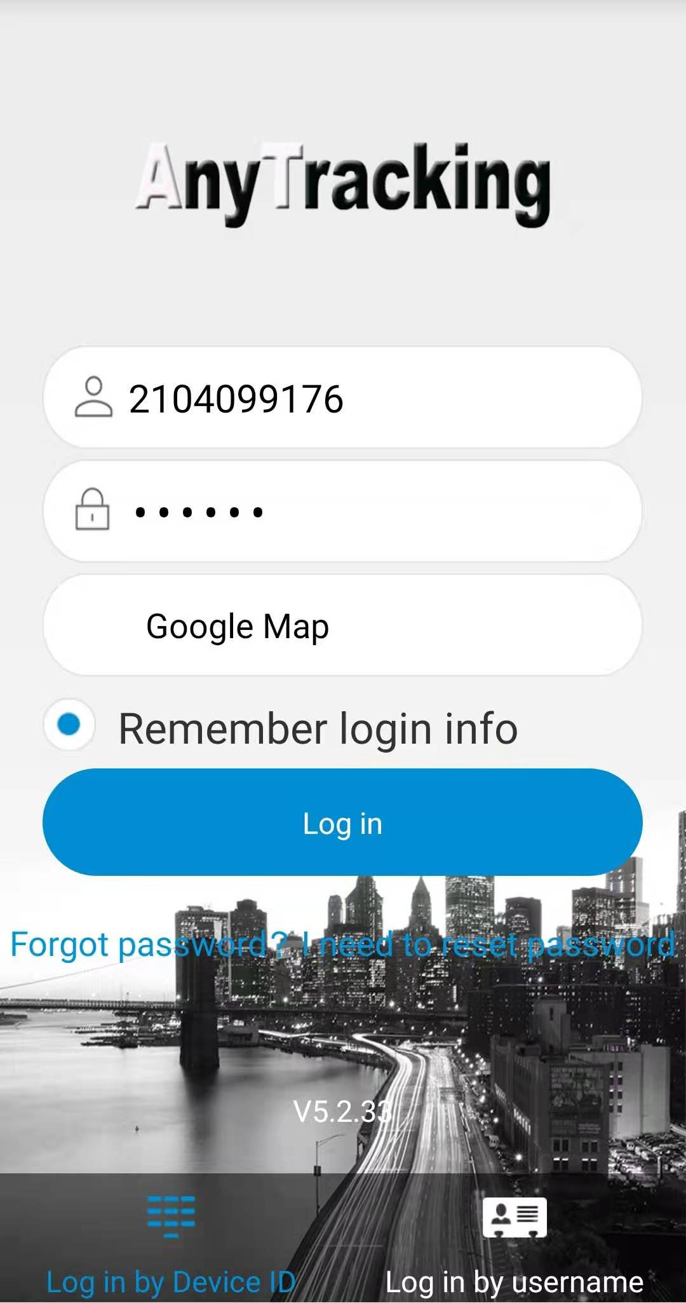
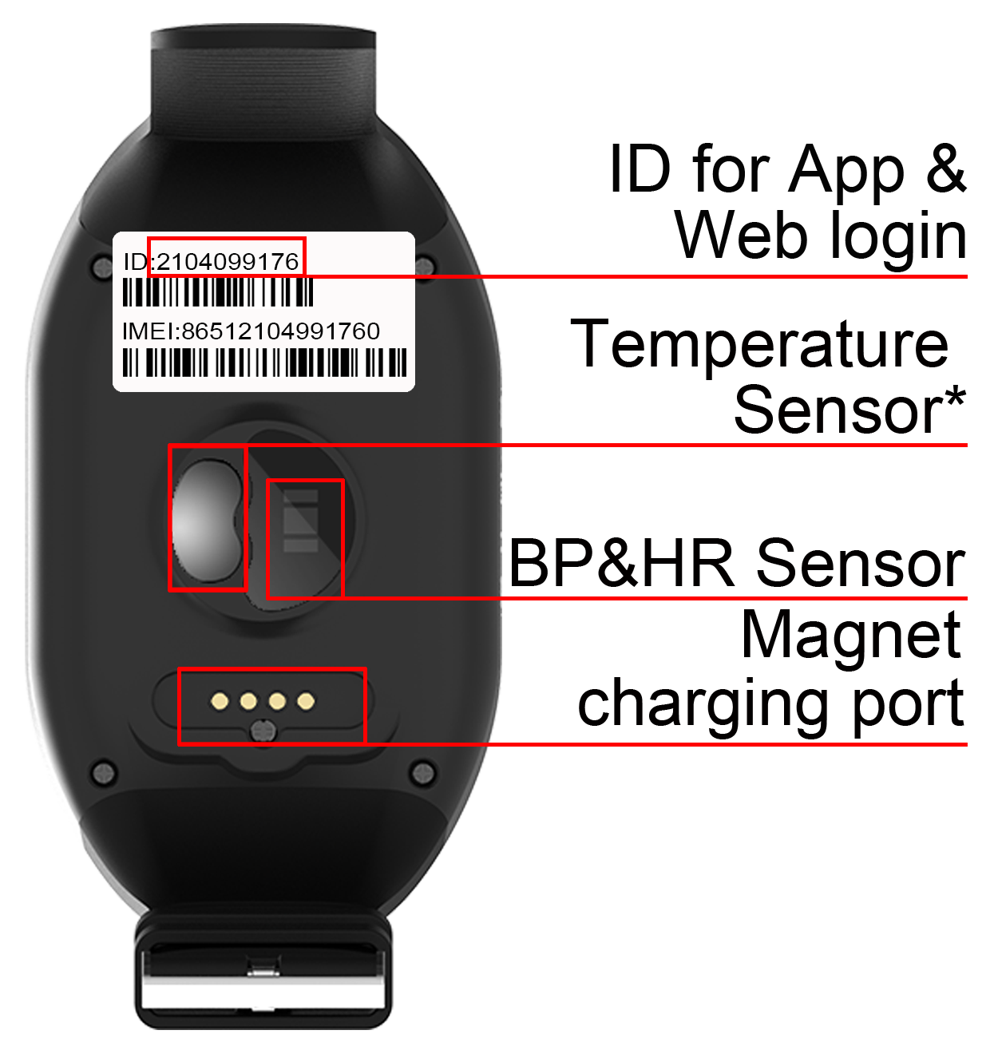
Real time tracking
App main page shows Stationary or Moving both means bracelet is online. Only when it is online can user make settings in App.
Click Real time tracking icon to check the latest bracelet location.
Click the upper right corner icon to set location uploading intervals. Usually, we suggest to set with “12 hours battery saving mode” to make sure bracelet has battery for urgent SOS help.
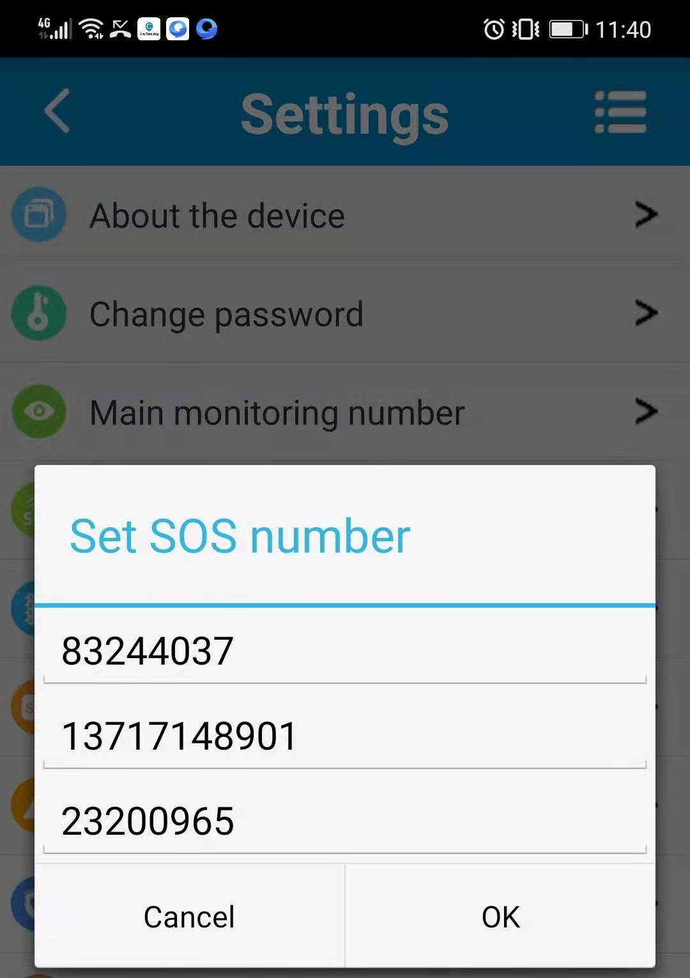
Bracelet settings
When App page shows bracelet online.
Click “Settings” Icon and set SOS numbers, then the bracelets basic calling and SOS help function work.
Set Main monitoring number：Set a number used for commands sending and SMS alerts receiving.
Set SOS numbers:3 SOS numbers for SOS call receiving.

Set phonebook
- First two numbers are for bracelet key 1 & 2.
- Whitelist:Only numbers in phone book can get through the calls to bracelet.
Voice message
- Press the bracelet microphone key and speak. Release the key to send out a voice message.
- Find “Voice talk” in App , click in and listen to the voice messages from bracelet.
Health monitor
- Click icon of Health and enter the health management page.
- Click Heart and enter measuring page. Click the button as picture shows here and OK to confirm. The bracelet will upload heart rate and blood pressure data in 3 to 5 minutes.
- Pill alarm & Sedentary: Set according to user’s needs.

Other functions
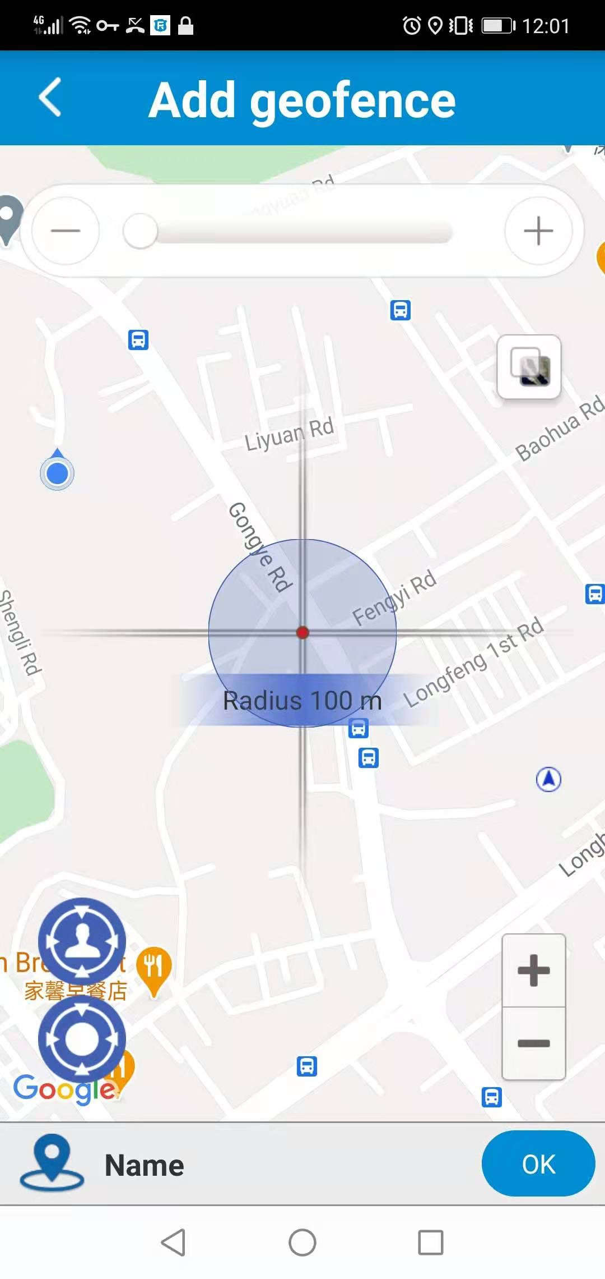
- Historical route: Display the historical route of any day in recent 90 days. You can choose whether to filter out LBS location data. (note: LBS means the location data indoors, the accuracy is not good.)
- Geo-fence: Add, check or cancel geo-fence. when the device gets into or out of the GPS-fence. The App will get alert. (note: we suggest the radius of GPS-fence over 300 meters to reduce false alerts.)
- WIFI-fence: You can set 2 WIFI safe zones, when device leaves safe WIFI zones, the App will give notification.
- Settings: Other functional settings
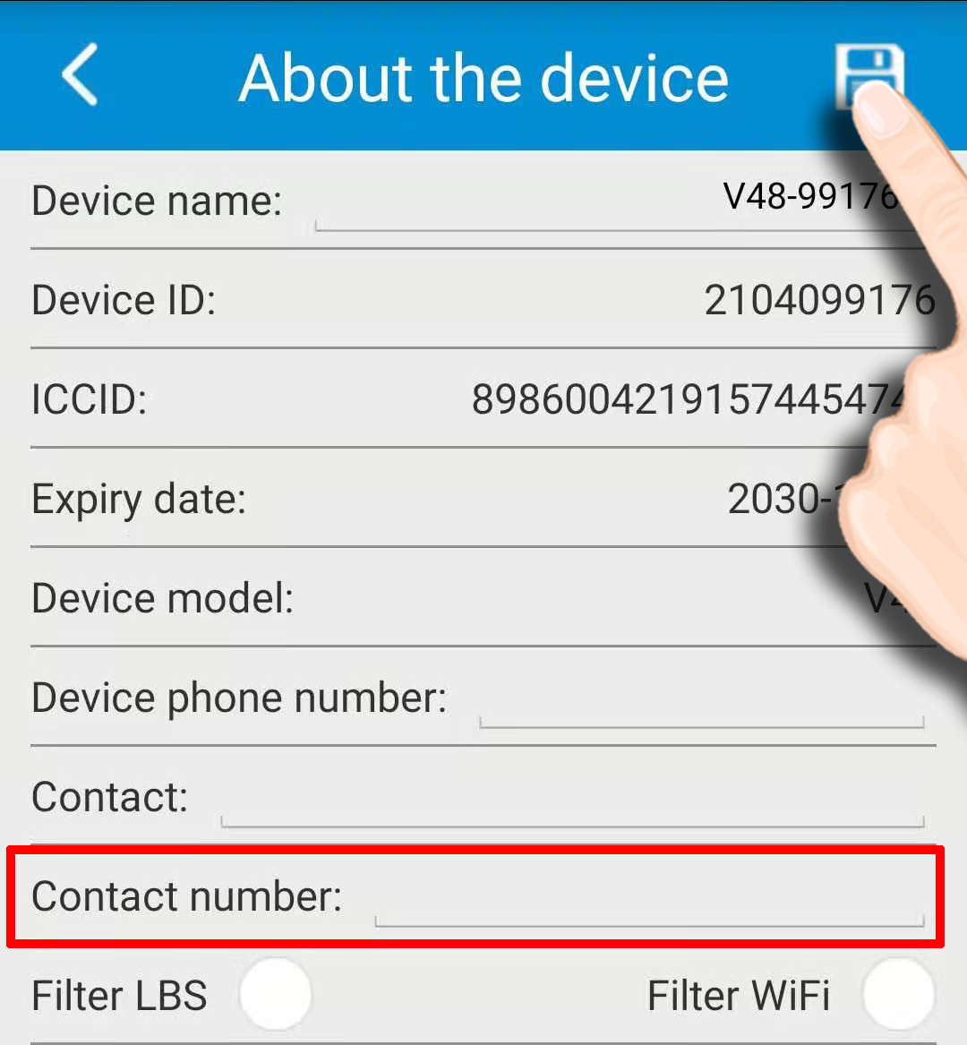
- About the device: Please make sure to fill in the contact number for App password find in later use.
Filter LBS and WIFI: As these two tracking ways’ accuracy is poorer, user can choose either of them in daily use. If the bracelet wearer stays indoors usually, it is not recommended to choose either option in case the location stops update. Click Save icon after information edit.
- SMS alert switch：Turn on this setting to enable the watch to send SMS alerts to main monitoring number or turn off it.
- Remove alarm: After turning on for more than 3 minutes, the watch will send alerts when it is taken off from wear’s wrist.
- Scene mode: Set the alarm ways of watch’s coming call, pill reminder, alarm clock, etc.
- Clock alarm: Set three different alarm modes accordingly.
- Find device: After the command sent, the watch will give out ringtone to guide the guardian to find watch and the wearer fast.
- Device Language and time zone: Set watch SMS alerts’ language and time zone. Options are Chinese and English.
- Remote reboot: To reboot the watch from this setting.
- Remote power-off: To power-off the watch remotely. (The watch can be only turned on by manually after this setting. Please use with caution)
- Factory-Reset: To default the device back to factory settings.
- Alarm list: To check all alarms the bracelet generated. Long press to delete an alarm.
- FAQ:You can find the solution with simple issues.

Main features：
- 4G LTE + 3G WCDMA + 2G GSM
- GPS + Beidou + WIFI +LBS position ways
- Heart rate, blood pressure and temperature detection
- Pill reminder, step counting and health management
- Waterproof level: IPX7
- Web platform/ Mobile App/ SMS commands check
- SOS button for help
- One clicks for a fast call
- Talking clock
- Low battery alarm
- Ringtone to find the bracelet
Accessories:
1* GPS bracelet 1* USB charging cable
1* Screw driver 1* User manual
2* Spare screws 1* Sim Card Ejector Pin

Product specification：
4G FDD：Band 1/2/3/5/7/8/20
4G TDD：Band 38/39/40/41
3G WCDMA：Band 1/2/5/8
2G GSM：Band 2/3/5/8
GPS locating time：30sec with cold boot (open sky)
29sec with warm boot (open sky)
5sec with hot boot (open sky)
GPS accuracy：5-15m (Open sky)
WIFI accuracy：15-100m（Under WIFI signal coverage）
Working temperature：-20℃ ~ +70℃
Working humidity：5% ~ 95% RH
Host size：65*42*20mm
Device net weight：73g
Battery capacity：1000mA
Appendix 1：
Indicator instructions
 | Color | Status | Meaning
Power on | Red  （Network） | Slow flash | Signal searching
 |  | Fast flash | Signal received
 | Blue  （GPS） | Slow flash | Positioning
 |  | Fast flash | Position uploaded
Charging | Red indicator | Slow flash | In charging
 |  | Always on | Fully charged
 | Blue indicator | Slow flash | In charging
 |  | Slow flash | Fully charged
Low battery : the red indicator slow flash only

Appendix 2:
Important! Please read below statements:
1. Due to external factors all GPS devices have position error, so the position provided by this device just for reference.
2. There may be delays caused by telecom operators at certain circumstance. Our company doesn’t assume to take responsibility of loss causes by this delay.

Q：After SIM card installed, App shows “Not enabled”.
Check whether the SIM card in bracelet activate GPRS data plan.
Make sure the bracelet is powered off when installing a SIM card.

Q：It says “Current device is offline” when save phone numbers in App.
Make sure the bracelet has inserted a SIM card and the bracelet indicators flash in a normal working way.

Q：The bracelet says it is busy now when call it.
Make sure your numbers have been set before. (To ensure the safety of wearer, only numbers saved via APP settings can call the bracelet.)
Make sure SIM card’s Caller ID display has been activated.

Q: In audio calls, sometimes I got noise, echo or even screech.
When calling phone is near the GPS bracelet, speaker gets cell phone signal disturbing, which causes noise or even screech.

Q:Sometimes, WIFI fence has no alarm？
The WIFI in this bracelet doesn’t support 5G WIFI. Android phones shall choose 2.4G WIFI as the hotspot of WIFI fence.
iPhones use the phone connecting WIFI as the fence hotspot automatically. If your iPhone is connecting a 5G WIFI, please don’t set WIFI fence to avoid the situation of no WIFI fence alarms.

2021-1

