OBD2+GPS Smart Gauge

A-pillar Installed

INTENDED USE
The OBD2+GPS Smart Gauge is intended for:
- Display vehicle data such as speed, engine RPM, battery voltage, fuel consumption, coolant temperature, turbo, oil temperature etc.
- Warnings related to exceeding the programmable speeds or RPM.
- Clear fault code

PLEASE NOTE
The default mode is OBD2 mode,If your car donnot have OBD2 protocol,please switch to GPS mode.

CONTENTS
Check the package contents immediately after unpacking.
- Smart Guage
- OBD connecting cable
- Operating instructions

PRODUCT OVERVIEW:
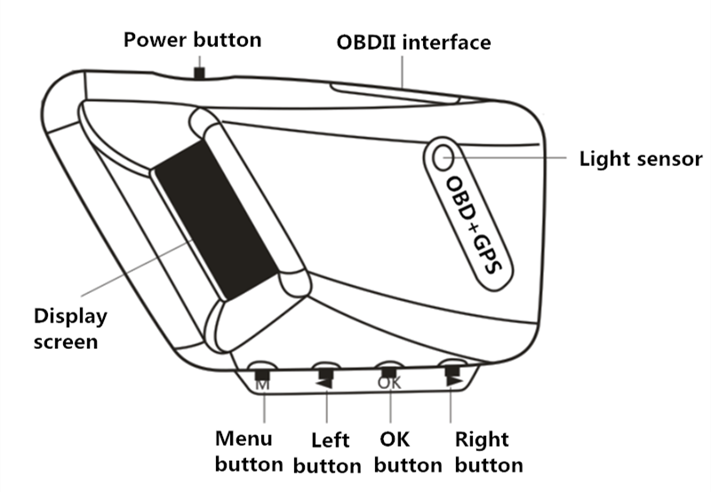
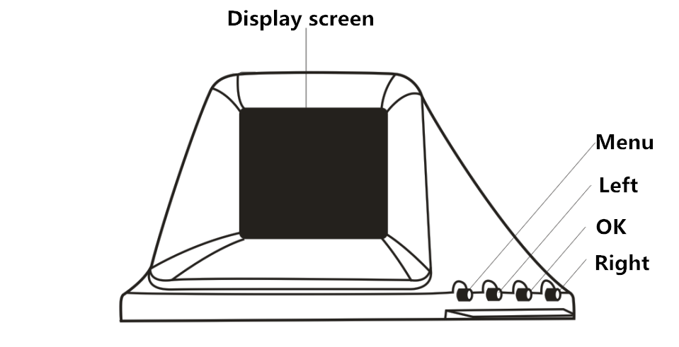
CONNECTING
The Smart Gauge connects to the vehicle via OBD cable, plug and play.
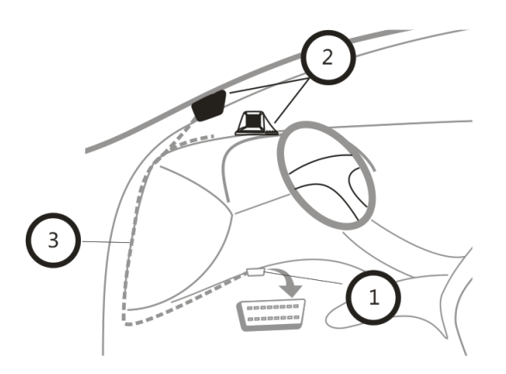
Usually the OBD2 interface is typically located on the driver's side, approx. 30 cm from the middle of the instrument panel.
- Turn the ignition off, connect the OBD cable to vehicle OBD2 interface
- Connect the OBD cable to the OBD interface on Smart Gauge
- Hide the OBD cable in A-pillar. Turn the ignition on, then it can work.

ASSEMBLY
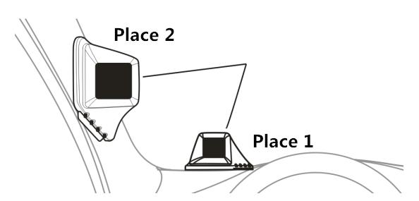
Select a mounting location [1-2]
Place 1 is on dashboard, Place 2 is on A-pillar

PRODUCT FUNCTION
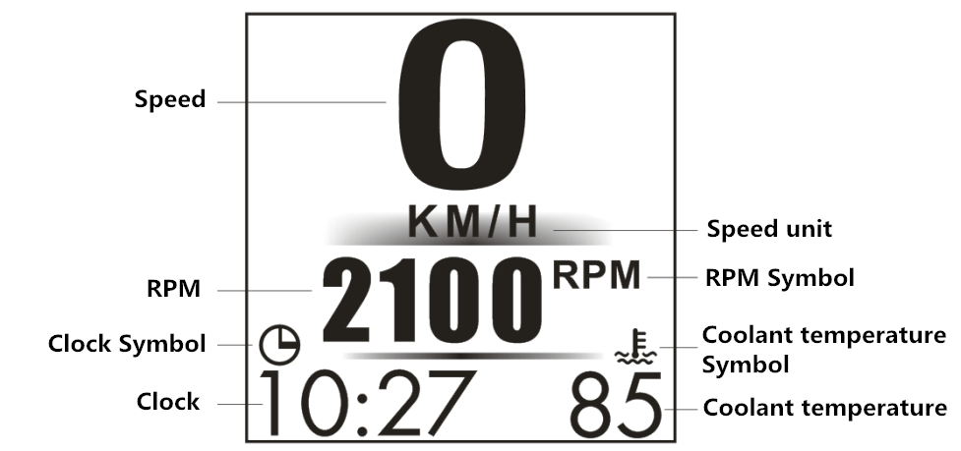 Picture 1
BUTTON FUNCTION
In Picture 1
The middle part can be swicthed by press [ OK ] button
The left part can be switched by press [ < ] button
The right part can be switched by press [ > ] button

In Picture 2, press [ < ] or [ > ] button can choose the display place.
Press [ OK ] button can switch the corresponding display information.
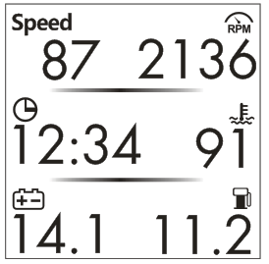
Picture 2

When Smart Gauge in normal display:

SHORT press [ M ] button can switch the display interface or back
LONG press [ M ] button for 5 seconds to enter into the setting menu
Press [ OK ] to enter or save.
Press [ < ] or [ > ] button: (1) switch to different interface in setting menu
(2) increase / decrease the parameter.

Problem | Solution
No display | - Start the engine. Verify the Smart Gauge is switched on. Verify the OBD connecting cable is correctly and firmly connected.  2) If the problem continues, test the Smart Gauge in a different vehicle.  3) If the car donnot have OBD2 protocol, long press [ M ] button for 5 seconds, find [System Set - OBD Switch], make OBD Switch [ OFF ], it means switch to GPS mode.
Display incorrect | Adjust the correction values.Restore the Factory Set of Smart Gauge from the System Set .
How to restore to  Factory set | When Smart Gauge in normal display, long press [ M ] button for 5 seconds,find [System Set - Factory set] ,it means restore to factory setting successful.
How to clear fault code | Long press [ M ] button for 5 seconds,find [ System Set - Clear DTC ]
Inaccurate speed | Long press [ M ] button for 5 seconds,find [Speed Set - Speed Adjust], if Smart Gauge show faster 2 km/h than dashboard, adjust the parameter to -2, if Smart Gauge show slower 2 km/h than dashboard, adjust the parameter to 2.
Inaccurate clock | Long press [ M ] button for 5 seconds, find [Clock Set - Clock Adjust ],then can adjust the hour and minutes

NOTICE:
- If set speed unit to KM/H, the water temperature unit will automatically be ℃, driving distance unit will automatically be KM, fuel conusmption unit will automatically be L/100 KM

- If set speed unit to MPH, the water temperature unit will automatically be ℉, driving distance unit will automatically be Mile, fuel conusmption unit will automatically be MPG.

