OBD2+GPS Smart Gauge

INTENDED USE
The OBD2+GPS Smart Gauge is intended for:
- Display vehicle data such as speed, engine RPM, battery voltage, fuel consumption, coolant temperature, turbo, oil temperature etc.
- Warnings related to exceeding the programmable speeds or RPM.
- Clear fault code

PLEASE NOTE
The default display OBD2+GPS mode at the same time,if your car donnot have OBD2 protocol,it will only show GPS function.

CONTENTS
Check the package contents immediately after unpacking.
- Smart Gauge
- OBD connecting cable
- Velcro sticker
- Operating instructions
PRODUCT OVERVIEW:
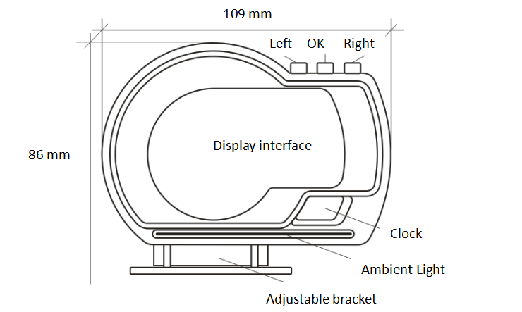
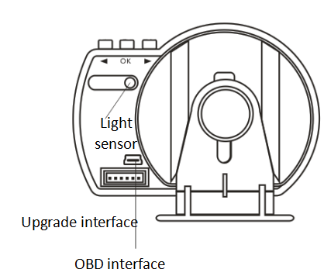
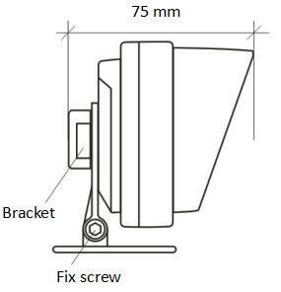

CONNECTING
The Smart Gauge connects to the vehicle via OBD cable, plug and play.
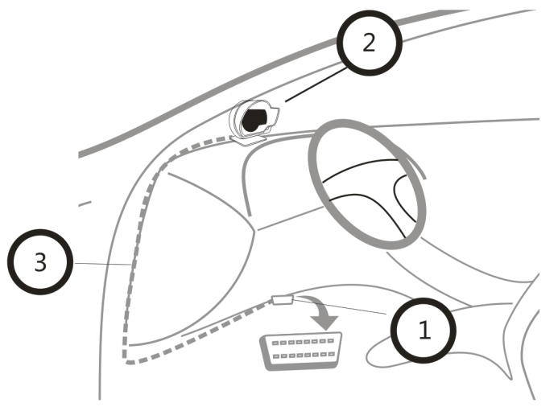
Usually the OBD2 interface is typically located on the driver's side, approx. 30 cm from the middle of the instrument panel.
- Turn the ignition off, connect the OBD cable to vehicle OBD2 interface
- Connect the OBD cable to the OBD interface on Smart Gauge
- Hide the OBD cable in A-pillar. Turn the ignition on, then it can work.

The bracket can be rotated in all directions to adjust the visual angle and height. There are 2 installation methods, 1) put on dashboard, 2) stick to windshield
AMBIENT LIGHT
- Turn on after power on, the color is blue (changing with the environment)
- When there is an alarm,change to red and flashing (remains the brightest)
- The ambient light can be turned off or adjusted brightness by manual (after turn off, it will still be red and flashing in case of alarm)

SYMBOLS

RPM Driving distance Coolant temperature
Turbo Fuel consumption Oil temperature
Voltage Driving time Satellite number
Altitude Compass Clock

BUTTON FUNCTION

Left button :
- Choose left, up or decrease parameter.
- Press left button to switch display place

OK button:
- SHORT press [ OK ] button can switch the display interface, enter or save.
- LONG press [ OK ] button for 3 seconds to enter into the setting menu,or back to upper menu.
Right button:
- Choose right, down or increase parameter.
- Press right button to switch display information.
- When in normal display, press and hold the right button to turn off.
- When power off, short press right button to turn on

Quick Turn on / off
When in normal display interface, press and hold the right button to turn off
When power off, short press right button to turn on

Switch interface
Press [ OK ] button to switch the interface

Switch function
Press left button to switch display place, press right button to switch display information

System set
Long press the [ OK ] button for 3 seconds, short press right button can switch to [ Speed - RPM - Fuel - Turbo - Time - Set ], press [ OK ] can enter.
LONG press [ OK ] button for 3 seconds to return to upper menu.

- Speed (Speed Set)
Speed Adjust: if Speed is different from dashboard, can adjust -9 ~ +9
Speed Choice:the default is OBD2 speed, can change to GPS speed.
Speed Alarm: the default is 160, adjust range is 30~250
Speed Unit: the default is KMH, press left or right button can change to MPH
- RPM (RPM Set)
RPM Adjust: if RPM is different from dashboard, adjust range is -25% ~ 25%
RPM Alarm: the default is 6000, adjust range is 1000 ~ 8500

- Fuel (Fuel Set)
Fuel Calcu: default is Auto, can change to Air flow or Emission to calculate Fuel
Swept Volume : can set it to your car emission.
Fuel Adjust: If fuel is different from dashboard, can adjust -25% ~ +25%
Fuel unit: the default is L/100KM, can change the unit to KM/L
Fuel Set: the default is Average Fuel, can change it to instantaneous fuel.

- Turbo(Tubro Set)
Turbo Adjust: if the turbo value is different from dashboard,can adjust it to be the same.
Tubro unit: the default is bar, can change the unit to 100kpa/ PSI

- Time (Clock Set)
Time zone: right button adjust hours, left button adjust the minutes
Rest Alarm: the default is 4, means smart gauge will give alarm to remind rest every 4 hours, adjust range is 1-8 hours

- Set (System set)
- Alarm Switch: the default is on. If want to make it off, press [ OK ] button, the icon flash, then press left or right button can make it off

- Coolant Alarm:the default is 120, adjust range is 90-130

- Voltage Alarm: the default is 10.0V, adjust range is 9.0-16.0

- Voltage Set: when the smart gauge voltage is different as dashboard, you can set it the same as dashboard.

- Brightness: the default is AUTO, it means the brightness is automatic adjusted, 1-11 is brightness adjusted by manual (1 is darkest, 11 is the brightest)

- TFT Contrast: no need change it

- AMP Lamp Set: the default is AUTO, it means the Ambient Light brightness is automatic adjusted, 1-11 is brightness adjusted by manual (1 is darkest, 11 is the brightest), OFF means turn off the Ambient Light

- OBD Switch:the default is on (it means OBD2+GPS mode display at the same time), change to OFF means only display GPS mode information

- Comd Search: no need change it

- PID search: no need change it

- Speed PID: no need change it

- RPM PID: no need change it

- Turbo PID: no need change it

- Factory Set: press [ OK ] button, then smart gauge will re-start, it means finish the factory set.

- Clear DTC: press [ OK ] button can clear the fault code.

Pls note: Brake test and Acceleration test need the speed reach to 100KM/H first, then the 2 function can display in normal.

Brake Test: when speed reach to 100km/h,step the brake until car stops, show the brake time and distance
Acceleration: When speed reach to 100KM/H, show the acceleration time.

NOTICE:
- If set speed unit to KM/H, the water temperature unit will automatically be ℃, driving distance unit will automatically be KM, fuel conusmption unit will automatically be L/100 KM

- If set speed unit to MPH, the water temperature unit will automatically be ℉, driving distance unit will automatically be Mile, fuel conusmption unit will automatically be MPG.
Problem | Solution
No display | 1)Start the engine. Verify the Smart Gauge is switched on. Verify the OBD connecting cable is correctly and firmly connected.  2) If the car donnot have OBD2 protocol, it will only display GPS mode.
How to switch KM or Mile | LONG press [ OK ] button for 3 seconds [Speed], short press [ OK] button to enter, press right button [ Speed Unit], Press [ OK ], [Speed Unit] icon will flash. Press left or right button to change to Mile, press [ OK ] to save, long press [ OK ] to return to upper menu.
How to quick turn on/off | When in normal display interface, press and hold the right button to turn off  When power off, short press right button to turn on  Pls note: quick turn off only work for 9 kinds interface.
Display incorrect | 1)Adjust the correction values.  2)Restore the Factory Set of Smart Gauge from the System Set .
How to restore to  Factory set | LONG press [ OK ] button for 3 seconds [Speed], short press right button 5 times [Set], press [ OK ] button [ System Set ], press right button 13 times [Factory set ] . Press [OK ], smart gauge will re-start.
How to clear fault code | LONG press [ OK ] button for 3 seconds [Speed], short press right button 5 times [Set], press [ OK ] button [ System Set ], press right button 14 times [Clear DTC ] . Press [OK ] to clear the fault code
Inaccurate speed | LONG press [ OK ] button for 3 seconds [Speed], short press [ OK] button to enter, Press [ OK ], [Speed Adjust] icon will flash. Press left or right button to adjust the parameter, press [OK ] to save, long press [ OK ] to return to upper menu.  ( if Smart Gauge show faster 2 km/h than dashboard, adjust the parameter to -2, if Smart Gauge show slower 2 km/h than dashboard, adjust the parameter to +2)
Inaccurate clock | LONG press [ OK ] button for 3 seconds [Speed], short press right button 4 times [Time], press [ OK ] button [Clock Set], Press [ OK ], [Time zone] icon will flash. Press right button adjust hours, left button adjust the minutes, press [OK ] to save, long press [ OK ] to return to upper menu.
When the engine off, smart gauge cannot power off. | When speed is 0, LONG press [ OK ] button and right button at the same time for 5 seconds, press right button to choose Poweroff Mode, short press [ OK ] button, the icon flash, press right button to adjust 1,LONG press [ OK ] to re-start.
For the start-stop function car, smart gauge power off when driving. | When speed is 0, LONG press [ OK ] button and right button at the same time for 5 seconds, press right button to choose Poweroff Mode, short press [ OK ] button, the icon flash, press right button to adjust 2, LONG press [ OK ] to re-start.

