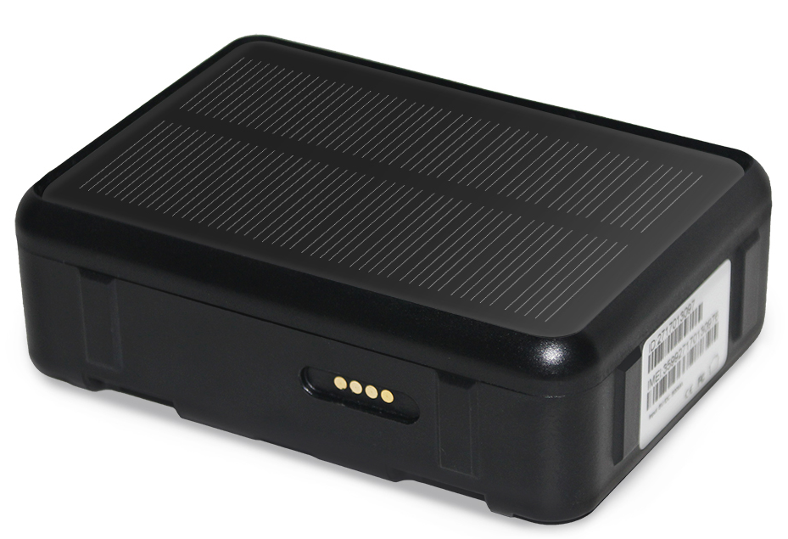
4GSolar Powered GPS Tracker
Important! Please read below statements:
1. Due to external factors all GPS devices have position
error, so the position provided by this device just for
reference.
2. There may be delays caused by telecom operators at
certain circumstance. Our company doesn’t assume to take responsibility of loss causes by this delay.

Main features:
- 4G LTE+3G WCDMA+2G GSM networks
- Waterproof IP67
- Remove alarm
- SOS alarm
- High frequency alarm with loudspeaker
- GPS positioning, with accuracy of 5m outdoor
- WIFI positioning, with accuracy of 30m indoors
- Web platform/ Phone App/ SMS for positions check
- Historical route, GPS fence & WIFI fence double care
- Solar charging automatically when sunlight exists
- Heath care with step counting and temperature measurement
- Low battery/SIMcard changing alarm
- High power LED prompt light
Product specification：
Version A bands combination:
4G-FDD：Band 1/2/3/5/7/8
4G-TDD：Band 38/39/40/41
3G-WCDMA：Band 1/2/5/8
2G-GSM：Band 2/3/5/8
Version B bands combination:
4G-FDD：Band 1/2/3/4/5/7/8/12/20/28A
3G-WCDMA：Band 1/2/5/8
2G-GSM：Band 2/3/5/8
GPS locating time：30sec with cold boot (open sky)
29sec with warm boot (open sky)
5sec with hot boot (open sky)
GPS positioning accuracy：5-15m (open sky)
WIFI positioning accuracy：15-100m(Under WIFI range）
Working temperature：-20℃ ~ +60℃
Working humidity：5% ~ 95% RH
Host size:97(L)*69(W)*31(H)mm
Host Net weight: 255g
Battery capacity: 9000mAh
Accessories:
1* Solar GPS tracker host | 1* USB magnet charging cable
1* User manual | 1*Collar holder (optional)
1* Magnetic holder (optional) | 1*Screw holder (optional)
1* Screw driver
Step 1: Get a new SIM card：
1). Choose aNano SIM card as below instruction.
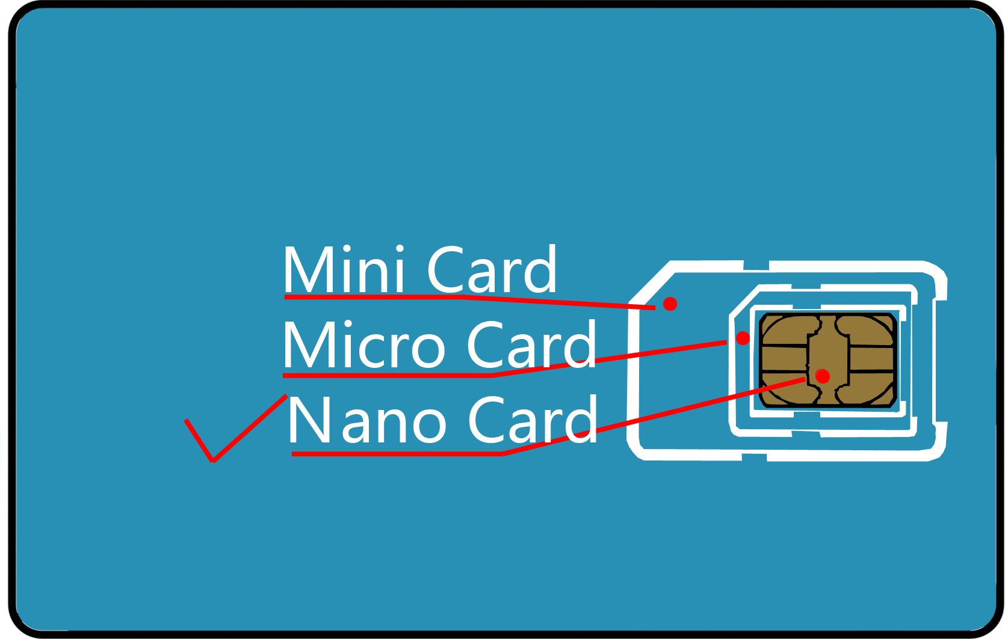

2). Activate the SIM card’s Cellular data plan and Caller ID display function. (Tracking needs consume data, making phone calls also needs charges.)

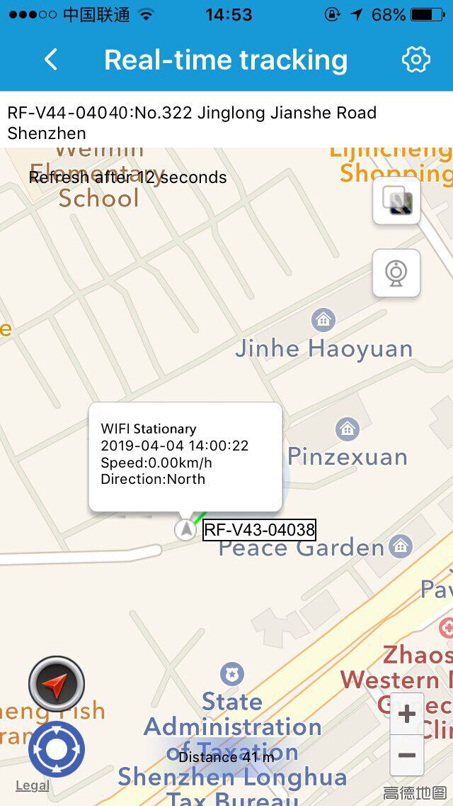
Step 2: Learn your Tracker device details:
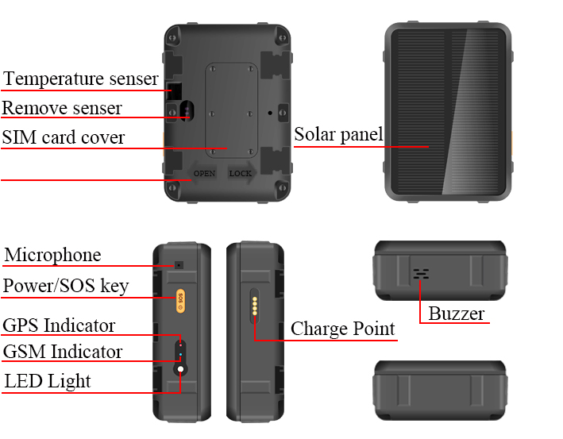
Step 3: SIM card installation and power on
1). Please make sure the tracker is powered off before inserting SIM card;
2). Open the SIMcard cover with screw driver and insert a SIM card into the slot accordingly.
3). To ensure waterproof, please install the SIM slot cover with screws.
4). Press 5 to 7 seconds of the power button to turn on it, the buzzer will sound. (The front blue and red indicators on for 2 seconds and release the button.)
5). When the tracker is in use, it can be powered off only via App.
Indicators instructions：
GPS and GSM indicator details：
Color | Function | Slow flash | Fast flash | Off
Blue | GPS signal | Searching | Searched | Sleep
Red | GSM signal | Searching | Searched | Sleep
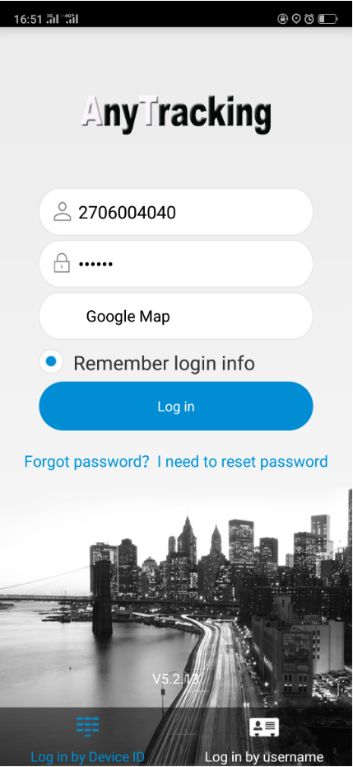
Step 4：Install APP by tracker Guardian
Guardian needs to scan the QR code in last page of this manual withsmart phone,download and install the tracking App.
Step 5: Login App
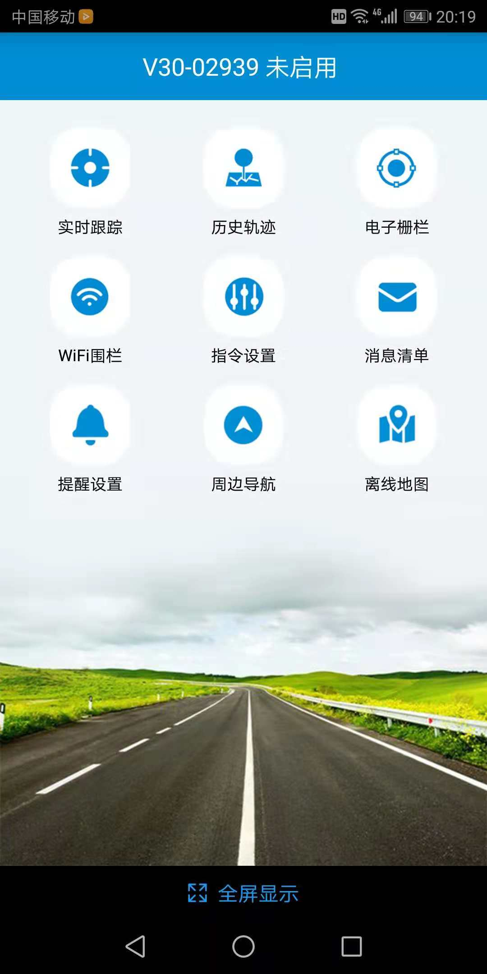
Login the App with the 10 digits ID No. on device back label, default passwordis 123456.
Step 6: Location check
- Real time tracking and interval for uploading：Display the last location of GPS tracker. For the latest location, press the “Single-refresh” button on map right top.Press the “interval for uploading” and choose different interval times. Default interval is 10 minutes. For emergency, change it to 1 minute. Interval affects the battery standby time, please choose accordingly.
- Historical route: Display the historical route of any day in latest 90 days. You can choose whether to filter out LBS location data. (note: LBS means the location data indoors, error can be large)
- Geo-fence: Add, check or cancel
- GPS-fence: when the device gets into or out of the GPS-fence. The App will get alert. (note: we suggest the radius of GPS-fence over 300 meters to reduce false alerts.)
- WIFI-fence：You can set 2 WIFI safe zones, when device leaves safe WIFI zones, the App will give notification.
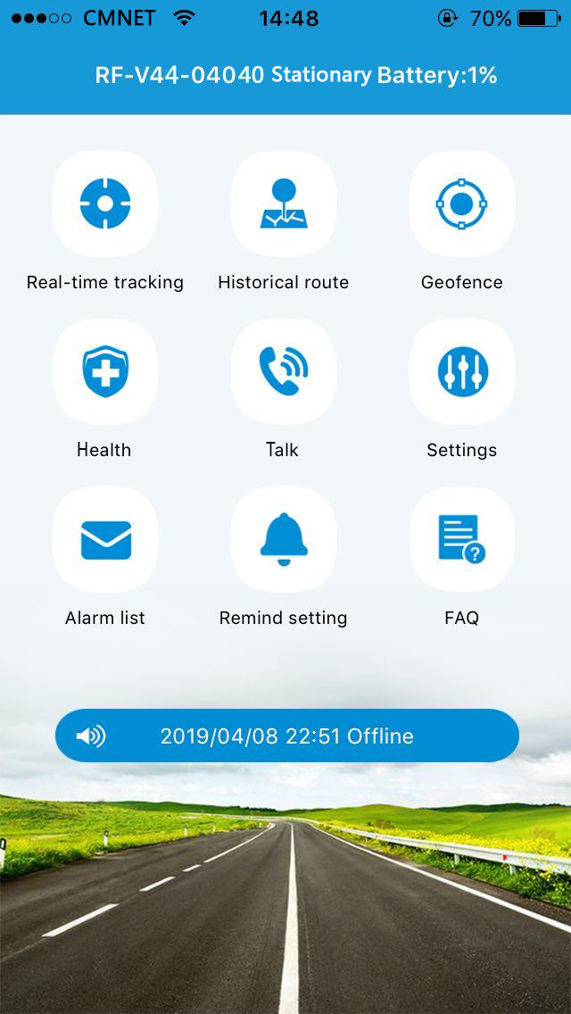
- Health：You can learn about the health status of animals through the App.
- Health Steps:In APP, turn on the Health Steps function to learn about the health of the animals through the step data.
- Measuring temperature: The body surface temperature of an animal can be measured.
- Talk:
- Call the tracker: To make a call to the tracker when click it;
- Voice monitoring: To request a one-way call from tracker to the number you type and hear the sound around tracker.
- Settings：All settings need to work when App shows device online with the SIM card’s data plan.
- About the device：Check and edit tracker’s information.
- Change password：Change APP and Web platform’s password.
- Main monitoring number：The number used for commands sending and SMS alerts receiving.
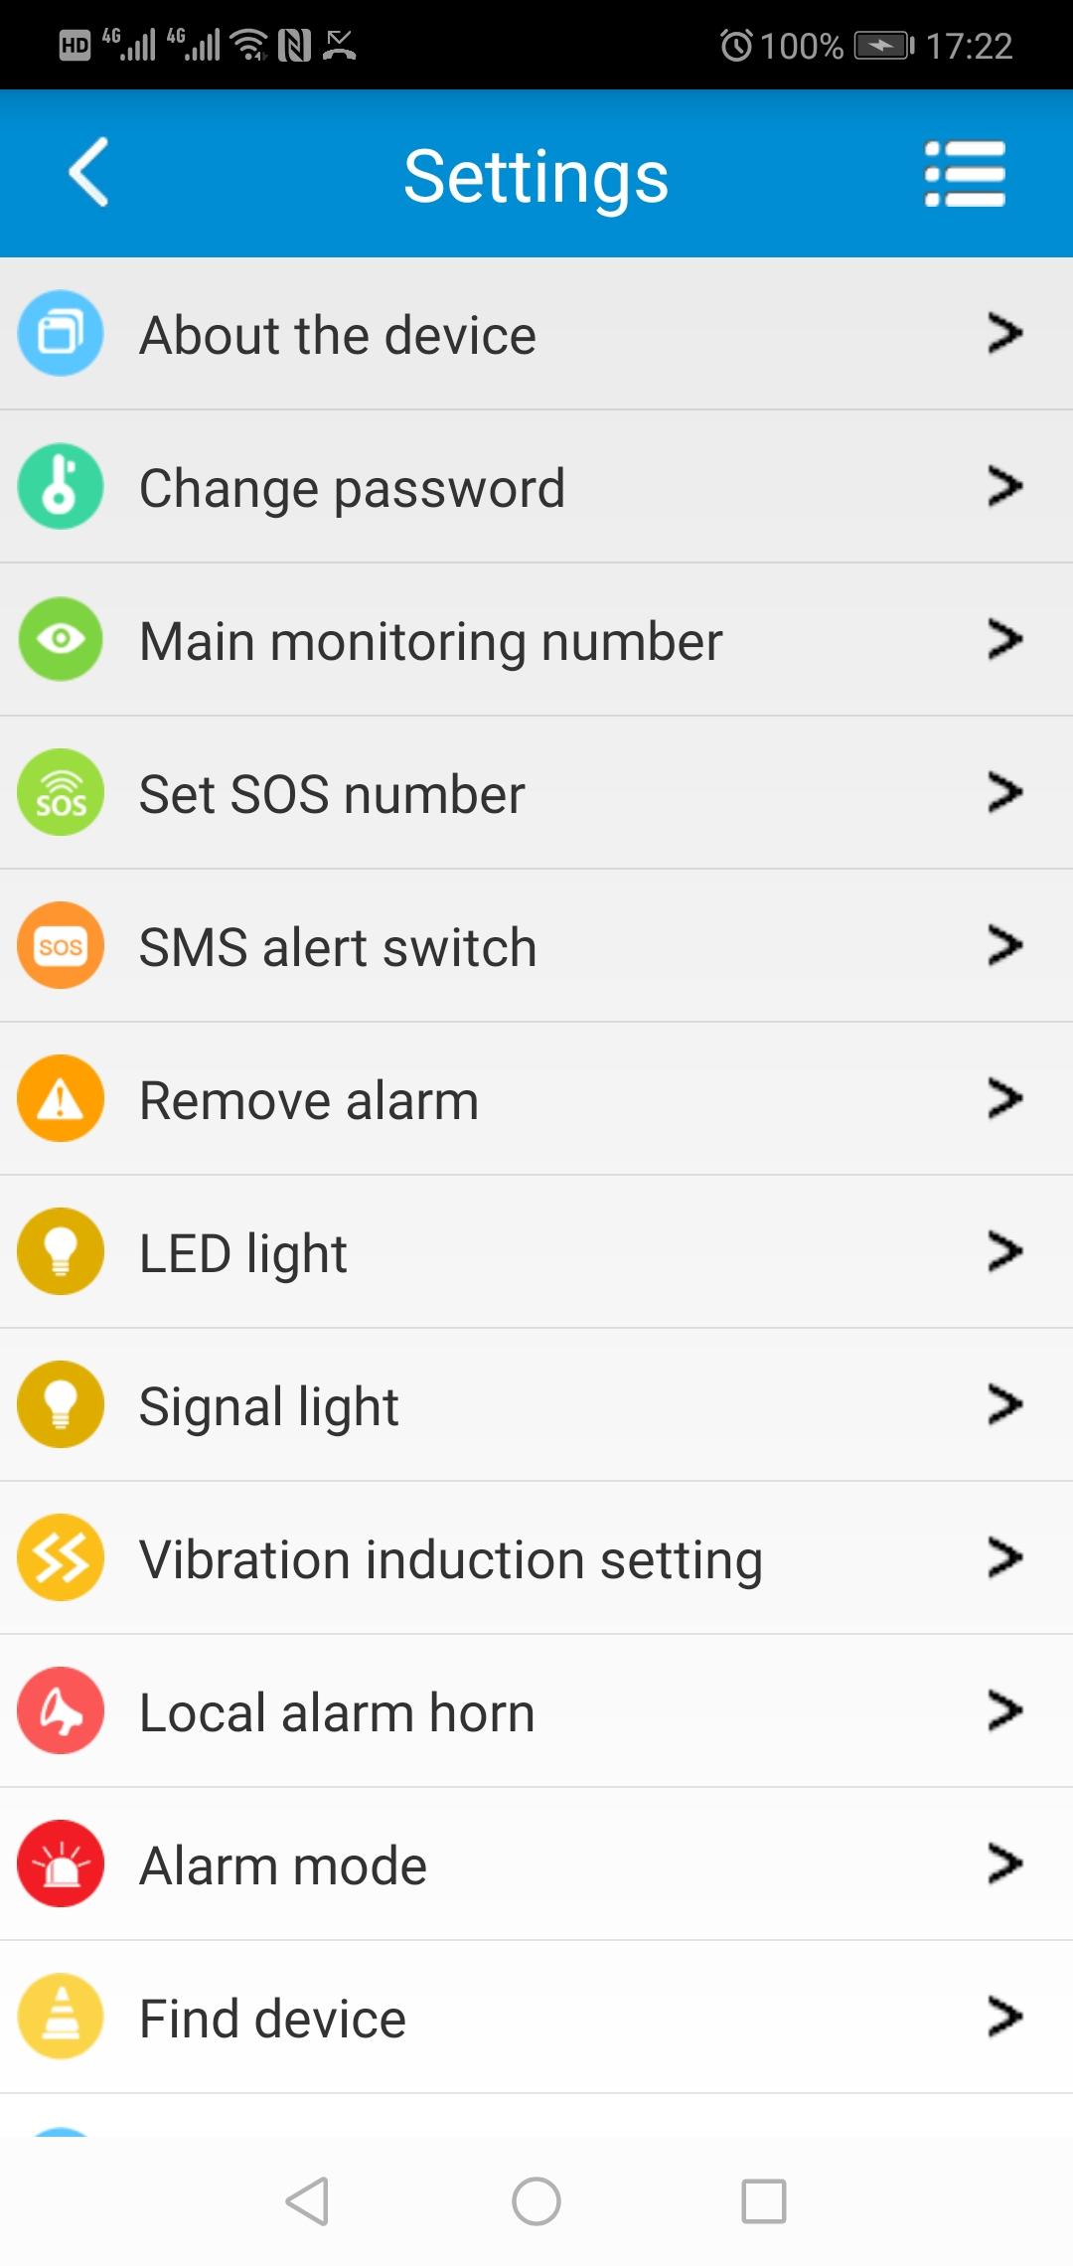
- Set SOS number: Preset SOS numbers to monitor the sound around tracker. (Note: For privacy of tracker user, non-SOS numbers couldn’t call the tracker.)
- SMS alert switch：Turn on this setting to enable the tracker to send SMS alerts to main monitoring number.
- Remove alarm: After turning on for more than 3 minutes, the tracker will send alerts when it is taken off from the wearer.
- LED light: Turn on or off the light then easy to find the animals, there are 2 lighting modes: mode 1 is flash mode; mode 2 is always light on.
- Signal light: Turn on or off the signal indicator lights in tracker;
- Vibration sensitiveness setting: on /off by App, there are 4 levels for vibration sensitiveness, level 1 is the most sensitive, level 4 is the most insensitive.
- Local alarm horn: Activate the device local alarm horn with 4 options:
Mode 1: The every-2-sec beep alarm sound lasts for 2 minutes after being activated, press power key to stop it;
Mode 2: The continuously beep alarm sound lasts for 2 minutes after being activated, press the power key to stop it;
Mode 3: Start the loudspeaker alarm actively to find the tracker nearby;
Turn off: The loudspeaker keeps silent even when alarm istriggered
- Alarm mode: Before the Remove alarm starts, there are four alarm modes to choose:
1. Alarm only to App;
2. Alarm notification to App and a call to main monitor number;
3. Alarm notification to App and send SMS to main monitor number;
4. Alarm notification to App, make a call and send SMS to main monitor number.
- Find device: When activate this function, the tracker will send out ringtone for being found easily.
- Device Language and time zone: Set tracker SMS alerts’ language and time zone. Options are Chinese and English.
- Remote reboot: To reboot the tracker from this setting.
- Remote power-off: To power-off the tracker remotely. After this setting, device can be turned on only manually.
- Factory-Reset: To default the device back to factory settings.
- Alarm list: To list all alerts sent by tracker.
- Remind setting：To turn on or off App notifications and modes of them.
- Logout: Log out from the App, and no more notification will be received from the tracking App.
For more functions of the App and web platform, please login our PC tracking platform:www.gps123.org.

Step 7: Power off the tracker
- When no SIM card in the tracker, press the power button for 5 to 7 seconds till a ringtone to power off it.
- When a SIM card installed, to avoid wrong operation, tracker can be powered off only via App setting.
Matters need attention：
- Please use this tracker in the area of good network signal.
- For a better performance, please charge the new device for 18 hours.
- Standby time: When location uploading time is every 10 minutes, the standby time is 38 days. Note: Above test data is under the status of strong network and without solar charge.
- To extend battery life, please charge and discharge the tracker fully at least one time in 3 months.
- The tracker is waterproof IP67, but we don’t suggest to dip it into water for too long time.
- Please don’t open the tracker case by yourself, as it may affect the waterproof and lose the warranty right.
- The tracker uses Cell tower signal (LBS) or WIFI when indoors, the locating accuracy depends on tracker distance to signal tower and other facts, like metal and surroundings. Due to the restrictions and influences of the use environment, the civil equipment has deviations in positioning which is not a quality problem, and is not subject to quality problems for after-sales processing.

FAQ：
Q: After inserting a SIM card, it can get SMS reply, but it displays “Not enabled” on the platform and APP.
A: Please check the tracker SIM Card has data plan.
Q: Device is online, but it shows “wait for the device responses” when you make settings with APP.
A: a. Device SIM signal is not good with poor datatransfer;
b. Device is busy in other process. Please wait a minute and try again.
Q: The SIM card has data plan, but the device still shows “Not enabled “or “offline”.
A:It needs to configure APN data, since we have pre-programmed most SIM cards’ APN, but some SIM hasn’t. Please set main monitoring number first by sending below command from your own phone to the tracker sim number.
pw,123456,center,your own phone number#
After a reply, send below command to set APN into the tracker.
The command is: apn,apndata,user,password,MCC MNC code#
(Note: The blue parts are different according to different SIM providers. If user and password are blank, delete them from the command. There is no space between them and all letters shall be in lowercase style.)

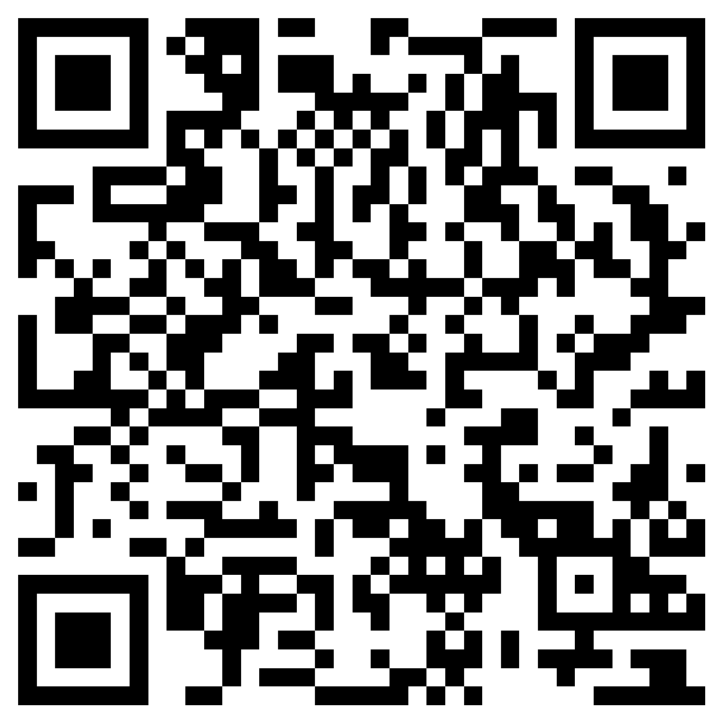
Scan QR code for install App
search Anytracking
in Google &iOS App store

