T-830G 4G GPS Tracker Using Guide--202004
Welcome to use this OBD 2G/3G/4G GPS tracker T-830G 4G, This product is with GPS & 2G GSM / 3G WCDMA / 4G LTE module and OBD II interface (Support Can Protocol: ISO15765-4, KWP2000:ISO14230-4, ISO9141-2, J1850VPW, J1850PWM), it can upload current location to website, display history tracking on website, it has Google map link locate function without platform, it is very easy to install and using, just insert the tracker to car OBD socket is OK, also it built in shock sensor to control power & internet data saving.
With GPS and 2G GSM / 3G WCDMA / 4G LTE network, the tracker sends the present location information through internet to server, so that user visit the website www.999gps.net with the applied user’s name and password (Given by us) through any computer with available internet, current location checking, history tracking playing back, alarm & running report etc can be operated, it is used for alarm, fleet management, anti-hijack etc.
User can download Android or iPhone iOS app software to android or iPhone mobile phone, click the app, logon with user name and password, you can locate current location & display history tracking, the user name and password is same with the website login. Basically using mobile phone send SMS to the tracker can get the current location Google map link.
Also this tracker can diagnostic car status by SMS (Reply DTC information & car status read from OBDII interface), this can help user or maintenance worker to know the car status and how to fix it.
This GPS tracker can be used as car alarm, fleet management, driver management etc, it can be used for tracking cars, company vehicles, buses, taxis, trucks, etc.
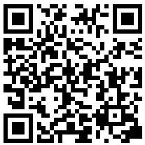
iPhone App Download Android App Download

Packing list
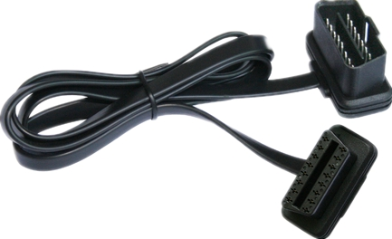
T-830G-4G GPS Tracker
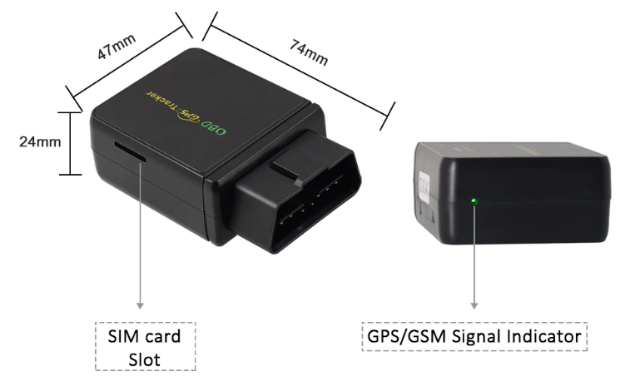
OBD External Wire(Optional)

Specification
- 2G/3G/4G global network;
- 2 channel Can Bus interface;
- OBD interface, DIY no installation;
- Diagnostic Car Status(reply by SMS);
- Auto download APN & GPRS setting;
- App (Android & iPhone) / Web / SMS locate;
- Built in battery for power down alarm & remove alarm;
- Built in Shock Sensor for Car Move and Shock Alarm;
- Shock sensor control uploading to save car battery power;
- Open protocol for 3rd client platform;
- Function can be customized by client request;
- Protocol can be changed by client request;
- Wide working voltage: 9-40V DC;
LED indicator
GREEN LED Flash once : 2G/3G/4G & GPS working well
GREEN LED Flash twice : 2G/3G/4G working well and no GPS signal
GREEN LED Flash three times : 2G/3G/4G & GPS working well but battery low
GREEN LED Flash four times : 2G/3G/4G working well, battery low and no GPS signal
GREEN LED ON continuously : 2G/3G/4G searching network
GREEN LED OFF continuously : Power off
GREEN LED Flash fast : incoming a call or sending SMS
RED LED Flash once : uploading current tracking
RED LED Flash twice : can not upload tracking now

Before Using
- Power ON / OFF
    - Insert the tracker to OBD socket, the tracker will power on automatically.
    - When power is ON, pull the tracker from the OBD socket, then the tracker will power off automatically.
- Install SIM card
Push the SIM card in, the SIM card will come out a little, pull the SIM card out is OK. Just push the SIM card into the tracker by the following direction, the SIM card will lock in the SIM card holder, please pay attention the SIM card direction & metal pin face down.
.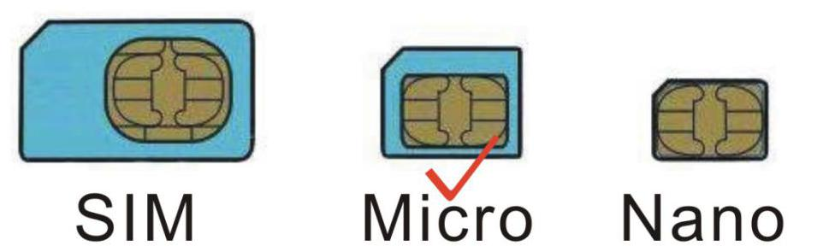

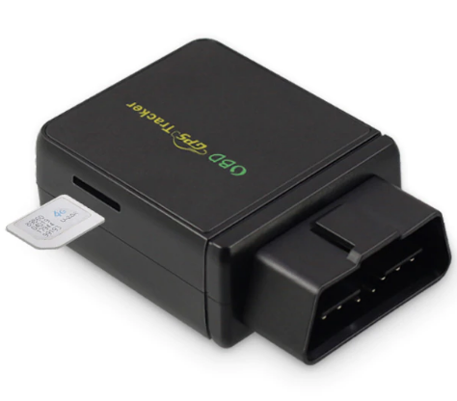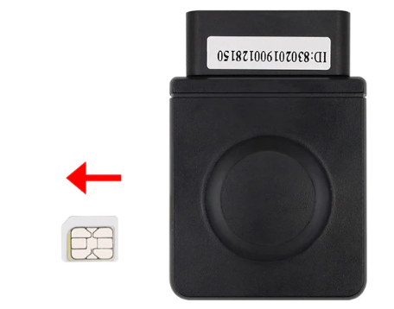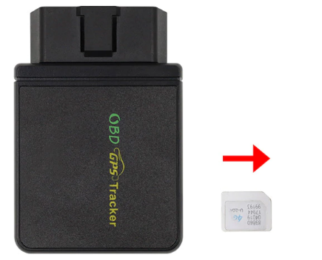

Note: 1. This tracker use 2G GSM 3G WCDMA & 4G LTE network, and it upload information by internet, it can not work in CDMA network or CDMA2000 network.
2. Before installing or uninstalling the SIM card, please power off the tracker.
3.APN and user name & password for internet visiting need to be set, the SMS command please refer the following.
- ANTENNA
- The Antenna of 2G/3G/4G and GPS are built in the tracker.
- Big metal and car panel will reduce the GSM and GPS signal. the GPS antenna need faced to heaven, otherwise the GPS signal will be weak and maybe can not located, if can not locate insert to OBD interface, you need connect a external OBD wire to install the tracker to other place .
- Using Condition
The working temperature is -20 ⁰C to 60 ⁰C, over this range the specification maybe can not reach the standard level, the storage temperature can reach to -40 ⁰C to 80 ⁰C.
- Back to factory setting (Default configuration)
Sending SMS (factory*12345678) to the tracker will delete all user setting and back to factory configuration and repower on.
Notes: After back to default set, all IP / APN / GPRS / Language / Timezone / Alarm Setting etc are deleted and back to factory setting, just like a new product, all authorized phone number are deleted and password change to 123456, all the alarm setting is canceled, if the IP/APN/GPRS name & password/TIMEZONE are changed, and you need set these again by sending SMS.

Simply Using Step
- First to buy a 2G GSM or 3G WCDMA or 4G LTE mobile phone SIM card, which needs SMS service and incoming caller ID display and internet function, this SIM card phone number is the tracker number and all the operations to the tracker is this number (M2M card that has no voice & SMS also can be used, this kind of SIM card can not send SMS command or receive SMS alarm information).
- Insert the tracker to the OBD socket is OK, it is not necessary to do any other installation, the OBD socket normally is under the car panel, if you can not find the OBD socket, check your car manual to find or call your car manufacturer hot line to confirm the OBD location.
- After inert the tracker to the OBD socket, the tracker will power on, Check LED flash, If Green LED flash once means mobile phone and GPS signal are well. And Red LED flash once means the location has been uploaded to the server. the tracker uploading is controlled by shock sensor, if the tracker begin to move, the tracker begin upload the tracking, the tracker status on the platform will change to online immediately. if the tracker stop moving, the tracker will stop upload the tracking and turn off GPS & GPRS to go to sleep, a few minutes later the tracker status on the platform also will change to offline.
- This tracker can auto configure APN & GPRS user name & password, if the auto configuration is not right, the tracker can not visit internet, so the tracker location can not update on the app & website, and the red LED will flash twice, then you need send SMS to tracker to change the APN & GPRS manually, please send SMS “CHECK*12345678” to tracker to check the APN auto configuration, call the tracker SIM card supplier to confirm the APN & GPRS is right. Send “APN*12345678*apnname” and “USERNAME*12345678*username*password” to tracker can change the APN & GPRS setting, please refer the following Tracker Setting Command 8 for detail.
- Visit & login the tracking platform www.999gps.net, click  can select different language, check current location, playback history tracking etc can be operated, platform user name and password is the last 7 digital numbers of the tracker’s ID (for example ID is : 803201712345678, the user name is : 2345678, password is :2345678 or 123456, user can change the password, send SMS “ID*12345678” to tracker can check tracker ID).
- iPhone Android App also use the same user name and password with website login, visit www.999gps.net with mobile phone, click the app icon on the login page, or scan the QR code on login page, the iPhone & Android app can be download & installed, please refer the platform operation guide.
- Fleet user can be created for easy fleet management, call your distributor to create a fleet.

Locate Operation Instruction
- Sending SMS trigger locating by Google map link
Send SMS “URL*12345678” to the tracker, “URL” is a command, “12345678” is password. If the operation is success, the tracker will send back the location information with Google map link to the sender. User click the link, the location in google map will display, the SMS example is as follow:
https://maps.google.com/maps?q=22.67680N,114.15188E
Battery:88%
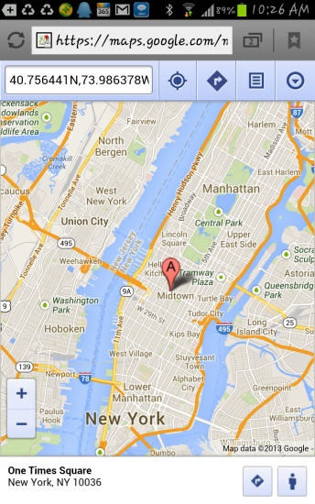
- Arm (Shock Alarm) by sending SMS
Send SMS “ARM*12345678” to tracker, “ARM” is a command, “12345678” is password, the tracker will send back the information “Set Shock Alarm ON” to indicate the operation is success and go to arm state, if the password is not right, the operation is fault, the tracker will send back information “Wrong Password”.
After go to shock alarm state, the system will check shock sensor, if the shock sensor is trigger (only continuously shock can trigger the shock alarm to avoid trigger by mistake), the tracker will send alarm and location information by SMS to the authorized phone number, and send the alarm information to the website server, also the tracker will call the authorized number A first, if no answered then B and C, if 3 authorized all no answered, then stop calling, If the tracker is triggered continually, every authorized phone will receive max 3 alarm SMS per hour.
If the authorized number have been set, use the authorized phone number to send SMS “ARM#” to the tracker also can trigger the tracker to enter arm state.
The shock alarm SMS is as follow:
Shock Alarm
https://maps.google.com/maps?q=22.67680N,114.15188E
Battery:88%
- Disarm (Shock Alarm) by sending SMS
Send SMS “DISARM*12345678” to tracker, “DISARM” is a command, “12345678” is password, the tracker will send back the information “Set Shock Alarm OFF” to indicate the operation is success and disable the shock alarm, if the password is not right, the operation is fault, the tracker will send back information “Wrong Password”.
- Check Car OBD Information
Send SMS “OBD*12345678” to tracker, “OBD” is a command, “12345678” is password, the tracker will send back OBD & car status information”, if the password is not right, the operation is fault, the tracker will send back information “Wrong Password”.
OBD information example: (The information maybe different with car model)
Number of DTCs:1,P0340,Car voltage:13V
The detail information of the DTC please see the car owner book, the different model car has different DTC, the 4S or fixing factory can diagnostic your car by mobile phone.

Tracker Setting Command
- Check Tracker ID:
The tracker ID is print on the label of the tracker, the S/N number on the label is the ID, Also if the label is missing, send SMS “ID*12345678” to tracker, in which, “ID” is the fixed command and “12345678”is the password. Having successfully been made, there will be a SMS “ID: 830201512345678”, in which, “830201512345678” is the ID and every tracker corresponds to the only number. This number is used to differ the tracking uploaded to the website from others. the last 7 digital number of the tracker ID is the user name and password of the tracker on the platform, for example the tracker ID is : 830201512345678, and then the user name on the platform of this tracker is : 2345678, and the platform password for this user name also is :2345678,user can login the platform to change the password.
- Set Server IP
Send SMS “IP*12345678*58.64.155.133,8011” to the tracker, in which, “IP” is the fixed command, “12345678” is the password and “58.64.155.133,8011” is the IP address of the server computer of our website. Having successfully been set, there will be a SMS “IP: 58.64.155.133,8011”. However, the IP address may be changed with the upgrade of our server, so please see to the notices on our website.
Notice: The tracker IP address has been set to default : 58.64.155.133,8011 in factory, it is not necessary to set again, unless our IP address has been changed or user need upload the location to other server, If our server IP is changed, we will notice on the website.
- Set APN
This tracker can download & config APN & GPRS username password automatically after power on, if the APN & GPRS user name password are not right, then you need sending SMS to tracker to change them, if the tracker can not upload location to platform (Red LED flash twice), please confirm the auto configuration of APN & GPRS user name password is right, the APN name and GPRS user name & password please call your tracker SIM card mobile phone company to confirm, the auto configuration APN & GPRS of the tracker please sending SMS “CHECK*12345678” to tracker to check. if the APN & GPRS are not right, please set by the following description.
Send SMS “APN*12345678*apnname” to the tracker, in which, “APN” is the fixed command, “12345678” is the password and “apnname” is the APN name of a mobile phone company. Having successfully been made, there will be a SMS “APN: apnname”.
Send SMS “USERNAME*12345678*username*password” to the tracker, “USERNAME” is a command, “12345678” is the password of the tracker; “username” is the mobile company GPRS user name, “password” is the mobile company GPRS password, if the operation is success, the tracker will send back the information “Username:username, Password:password”, if the password is not right, the operation is fault, the tracker will send back information “Wrong Password”.
- Add / Delete / Check Authorized Number:
The authorized phone number is used to send alarm information by SMS, or use mobile phone to locate the tracker without platform, if the authorized phone number is not set, then the alarm information can not send to user by SMS (alarm information, SOS, etc).
4.1. Add authorized phone number by SMS
Send SMS“ADDPHONE*12345678*A*number”(Not including the quotation marks “ ”, Number means the telephone number you want authorized, the following is same) to tracker is OK, “ADDPHONE” is a command; “12345678” is password; “A” is authorized number location, every tracker have 3 authorized phone number, A and B, and C, so you can set 3 phone numbers, if the add operation is success, the tracker will send back the information ”Add Authorized Phone OK”, if the password is not right, the operation is fault, the tracker will send back information “Wrong Password”.
4.2. Delete authorized phone number by SMS
Send SMS “DELETEPHONE*12345678*A” to the tracker, “DELETEPHONE” is a command; “12345678” is password; “A” is authorized phone number location, there are 3 locations “A” and “B” and “C”; if the delete operation is success, the tracker will send back the information ”Delete Authorized Phone OK”, if the password is not right, the operation is fault, the tracker will send back information “Wrong Password”.
4.3. Check authorized phone number by SMS
Send SMS “CHECKPHONE*12345678” to tracker, “CHECKPHONE” is a command; “12345678” is password; if the operation is success, the tracker will send back the information “Authorized Phone A: 13987654321； B：13876543210；C：13765432101 , the phone number is just an example. if the password is not right, the operation is fault, the tracker will send back information or “Wrong Password”.
- Change / Check Password
5.1. Change tracker password
Send SMS “CHANGEPASSWORD*12345678*888888” to tracker, “CHANGEPASSWORD” is a command; “12345678” is old password; “888888” is new password; if the operation is success, the tracker will send the information “ New Password：888888” to every authorized phone number, if the password is not right, the operation is fault, the tracker will send back information “Wrong Password”.
Note: Only authorized phone can change the password.
5.2. Check tracker password
Send SMS “CHECKPASSWORD” to the tracker, “CHECKPASSWORD” is a command, if the operation is success, the tracker will send back the information “Password：888888”; “888888”is an example.
Note: Only authorized phone can check or change the password.
- Set Alarm by Calling: ON/OFF
Send SMS “CALLON*12345678” (Call to authorized number) or “CALLOFF*12345678” (No calling) to the tracker, “CALLON” or “CALLOFF” is a command, “12345678” is the tracker password, if the operation is success, the tracker will send back the information “Alarm by calling : ON” or “Alarm by calling :OFF”, if the password is not right, the operation is fault, the tracker will send back information “Wrong Password”. If the alarm by calling is ON, then when the alarm is triggered, the tracker will call the authorized number to notice the alarm, the default setting is ON.
- Set Alarm by SMS: ON/OFF
Send SMS “SMSON*12345678” (Sending SMS to authorized number) or “SMSOFF*12345678” (No SMS) to the tracker, “SMSON” or “SMSOFF” is a command, “12345678” is the tracker password, if the operation is success, the tracker will send back the information “Alarm by SMS : ON” or “Alarm by SMS :OFF”, if the password is not right, the operation is fault, the tracker will send back information “Wrong Password”. If the alarm by SMS is ON, then when the alarm is triggered, the tracker will send SMS to the authorized number to notice the alarm.the default setting is ON.
- Set GPRS Mode: KEEPONLINE / SHOCKCONTROL
Send SMS “KEEPONLINE*12345678” (Keep online all the time even the tracker stop moving) or “SHOCKCONTROLGPRS*12345678” (Turn off GPRS after the tracker stop moving 2 minutes) to the tracker, “KEEPONLINE” or “SHOCKCONTROLGPRS” is a command, “12345678” is the tracker password, if the operation is success, the tracker will send back the information “GPRS: Keep Online” or “GPRS: Shock Control”, if the password is not right, the operation is fault, the tracker will send back information “Wrong Password”. the default setting is Shock Control, when the tracker begin to move, the tracker begin upload the tracking, the tracker status on the platform will change to online immediately. if the tracker stop moving, the tracker will stop upload the tracking and turn off GPS & GPRS to go to sleep mode , a few minutes later the tracker status on the platform also will change to offline.
If the tracker is always online, the tracker will send tracker status to platform all the time, but this will exhaust more data charge and car battery power, and if the car will park long time or the car battery is old, this maybe cause the car battery power low and can not start car engine, we do not recommend this working mode.
- Set Upload Time Interval
Send SMS “INTERVAL*12345678*xxx” to tracker, “INTERVAL” is a command, “12345678” is password, “xxx” is the interval time, which can be set from 30 to 999 seconds. The tracker will send back information “Set Interval xxx OK”, if the password is not right, the operation is fault, the tracker will send back information “Wrong Password”. 30 seconds is the default interval time. Longer upload interval time can save battery and GPRS data cost, but this will make the total mileage to more error.
- Check tracker setting
Send SMS “CHECK*12345678” to tracker, “CHECK” is the fixed command, “12345678” is password. The tracker will send back information including software version, ID S/N number, IP address, authorized phone number, GPS and GSM signal etc. if the password is not right, the operation is fault, the tracker will send back information “Wrong Password”. The following is an example :
V Mar 03 2014,CC888,CC0830C00820800,58.64.155.133,8011,30,A:13987654321, B:13876543210, GPS OK,+00,-95dBm,ShockControl,CMNET,User,Password,46000,e1d/24a0,93%

V Mar 03 2014, ;Software version date
CC888, ;TCP/IP Protocol name
CC0830C00820800, ;ID S/N number
58.64.155.133,8011, ;Server IP and Port
13987654321, ;Authorized number (A/B/C)
GPS OK , ;GPS status
+00, ;Time Zone (00 means GMT time)
-95dBm, ;GSM signal strength
ShockControl, ;GPRS is controlled by shock sensor
CMNET, ;APN name
User, ;GPRS user name
Password, ;GPRS password
46000, ;Sim Card MCC+MNC
e1d/24a0, ;Current Cell ID
Note: This command usually be used to check the tracker current status & configuration, if the tracker can not work well, this command can check what the problem is.
- Reset the tracker
Send SMS “RESET*12345678” to tracker can make the tracker power off and power on again, “RESET” is the fixed command, “12345678” is password. The tracker will send back information “Cancel all alarm setting and re-power on”, then the tracker will power off and power on automatically, if the password is not right, the operation is fault, the tracker will send back information “Wrong Password”. some time the tracker can not work properly, send the reset command, the tracker will re-power on a few minutes later.
- Restore to factory setting (Back to Default)
Send SMS “FACTORY*12345678” to tracker can make the tracker power off and power on again, “FACTORY” is the fixed command, “12345678” is password. The tracker will send back information “Setting back to factory default”, then the tracker will delete all user setting, and restore all setting to factory mode, just like a new tracker, then the tracker will re-power on after delete user setting. If the user have changed the setting, such as APN, IP, authorized number, etc, you need set this again after back to factory mode. if the password is not right, the operation is fault, the tracker will send back information “Wrong Password”.

Platform Operation Guide
The platform operation please refer the platform operation guide, scan the following QR code or click the website link to download the platform manual, visit website http://d.999gps.net and click the Platform Manual also can read online & download the platform manual.

Platform User Guide Pdf Version

Notes:
  - Please confirm that the SIM card PIN code has been disabled, it means if mobile phone use this SIM card, it is not necessary to input any password. Otherwise the tracker can not find GSM or CDMA network, the Green LED will keep ON .
  - This tracker use 2G GSM & 3G WCDMA network, and it upload tracking only through internet, it can not work in CDMA network CDMA2000 network, if the 4G SIM card can use in 2G GSM or 3G WCDMA network, then this kind of 4G SIM card can be used in this tracker.
  - The antenna of GSM and GPS is built in tracker, please note that the install location of the tracker must can receive the GPS signal, if the OBD socket place can not receive GPS, please add an external OBD wires to install the tracker to other place. please leave away the tracker from big metal, and keep away from the magnetic components.
  - The GPS need 10-200 seconds to locate the position, when the GSM signal is weak or the network is very busy, the SMS maybe delay to send by the GSM network, this is normal.
  - The tracking data on our server will keep 6-12 months, the old data will be deleted.

Trouble Shooting
      - The tracker auto power off: please confirm the tracker power supply is connect properly .
      - After power on the tracker, the tracker RED LED keep on, and it has not any repose, and no ring, please confirm the SIM card has been installed properly, the SIM card PIN code is disable, and the SIM card has enough charge, and the mobile phone can work well in that place. If the tracker work well the Green LED will flash once every 4 seconds.
      - If the tracker can not upload location to website, please confirm the SIM card GPRS function is enabled, and the APN or GPRS username & password have been set properly (call the mobile phone to confirm the APN & GPRS username and password). if the tracker do not move, the tracker will not upload tracking, try to move the tracker.
      - If the tracker can not send back information by SMS, please confirm the SIM card has ID caller display function and SMS service function, and you have set the center or slave center number (only center or slave center number can send SMS), and please read the SMS information of the tracker sending back, and check the instruction & password is right or not.
      - Can not login the platform: use SMS to check the ID of the tracker, and try it again, if not success please contact distributor.
      - After go out the under ground park, some tracking maybe lost, the GSM and GPS module will take a few minutes to receive signal and re-locate, some tracking maybe lost, this is normal.
      - Some time some location point is lost, this is normal, in the transmit process, some point maybe is lost, but this will not happen very often.

T-830G-4G Specification:
Working Voltage | 9-40V DC | Communicate Network | 2G GSM / 3G WCDMA / 4G LTE
2/3/4G Module (Can be Customized) | EC25-EC (Quectel) | 2G GSM Band | B3(1800 MHz)/B8(900 MHz)
3G WCDMA Band | B1(2100 MHz)/B8(900 MHz) | 4G LTE-FDD Band | B1/B3/B7/B8/B20/B28A
2/3/4G & GPS Antenna | Internal & Internal | GNSS Module | GPS
Locate precision | 5-10 Meters | GPS Hot Start Time | 1 second average
GPS Cold Start Time | 36 seconds average | Moving Tracking Current | <100mA /12V
Stop Standby Online Current | < 15 mA /12V | Stop Standby Current | < 5 mA /12V
CAN BUS Channel | 2 Channels | Backup Battery Capacity | 100mAh (Polymer)
Battery Recharging Current | <100mA 5V | Working Temperature | -20 ⁰C to +55 ⁰C
Absolute Working Temperature | -40 ⁰C to +80 ⁰C | Storage Temperature | -40 ⁰C to +80 ⁰C

Warranty
This system has been tested before sold. We strongly recommend you to get this system installed by professional. There is a one-year warranty except the following condition:
1. Installed, fixed, or changed by personally or unprofessional.
2. Warranty will eliminate if the ownership of the tracker has been changed.
3. Parts damaged by man-made.
4. Battery, adapter, wires, etc.
Warning: this device is just a auxiliary product that applying the location of current object, we have not any responsibility if you have damage or lost in using this tracker.
Customer
User Mobile Phone |  | Tracker SIM card
Date | Year month day
Model | T-830G 4G | Serial Number
Distributor
Notes: The explanation of this manual is belonged to our company, some small changes may not notice customer, if you have any problem please contact us, thanks !

