Car Head Up Display Q10
(This product Design Patent and Display Images Copyright had been registered with customs record)

HUD short for Head Up Display. It displays driving dates on the front windshield such as speed, RPM, water temperature, voltage，single driving distance etc on the car front window glass; avoiding drivers unsafely because of watching the instrument while driving. Drivers can read the driving information instantly, and can always keep the best state on the way with HUD.

Kindly Attention
This product is dual system: when the OBD system cannot be used, please switch to GPS system to use.
Working voltage: 5V - 18vdc (12VDC / 200mA)

Product functions

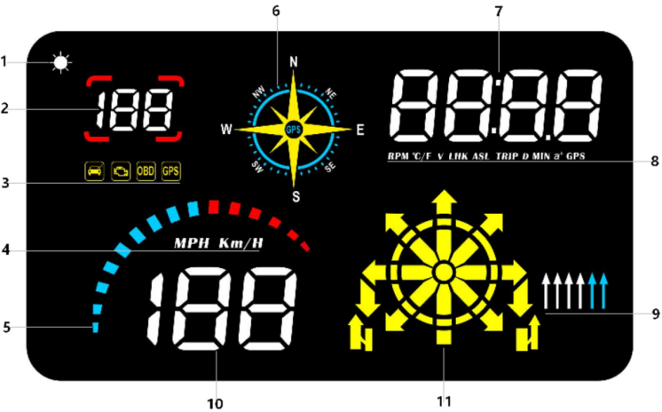

1.Light sensor: Automatically adjust the brightness according to the environment

2.Speed camera display area: cooperate with the navigation function of mobile app to display the speed limit of this road section

3.Multi icons, from left to right are: fatigue driving icon ,engine fault icon, OBD system icon, GPS system Icon
4.Speed unit: MPH=Mile/hour ,KM/H=kilometer/hour

5.Decoration icon, can switch to display the RPM or GPS speed in menu 3.

6.Driving direction(compass): it will flash when GPS signal is loading, and stop flashing once the signal is ready.It will display the direction when the speed exceeds 5.
N=North, S=South, W=West, E=East, NW= Northwest, SW=Southwest ,SE=southeast, NE=northeast
7.Multi function display area: speed, water temperature, voltage, fuel consumption, altitude, mileage, navigation distance, driving time ,Power test, number of satellites, clock

8.RPM=engine speed, C/F=water temperature, V=voltage, LHK=fuel consumption,
TRIP=driving mileage, D= navigation speed limit distance, Min=driving time, ASL=altitude,
a⁺ = Speed up test, GPS= satellites

9.Navigation Lane: use with the navigation function of mobile app, display the lane of the vehicle

10.Driving Speed

11.Navigation arrow direction : display vehicle navigation direction,need to use with the App.

Button functions:
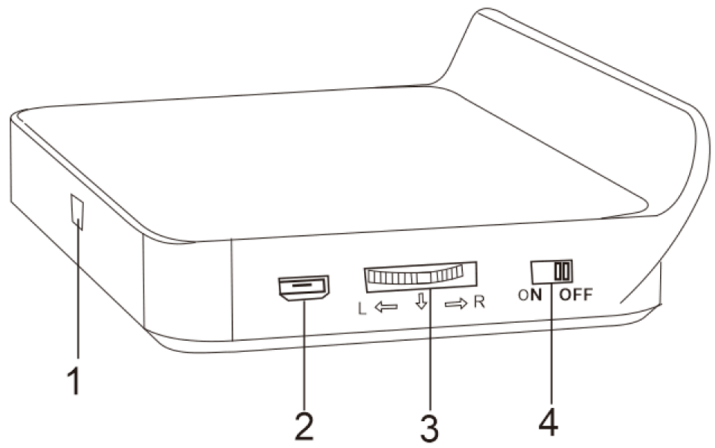

1.OBD port 2. Standby port 3. Setting scroll button
4.System selection key (on for OBD system , off for GPS system)

Scroll button function (when the scroll is on the left)
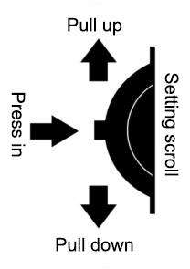
Press inward 1 second: (1)switch 32 display modes
(2)enter the setting menu and confirm the options

Press inward 2 second :(1)enter menu settings
(2) to save and exit once finished the menu setting
Pull up: (1)Switch the white 888 display
- change the menu option after entering in the menu setting

Pull down: (1)Switch the yellow 8888 display
(2)change the menu option after entering in the menu setting

System choice:
System selection: pull up the system key to enter the OBD system mode, and pull down to enter the GPS system mode
OBD System：（available for cars with OBD2 interface）
Display: speed, RPM, fuel consumption, water temperature, voltage, clock, driving mileage,driving time, driving direction, altitude, number of satellites, RPM diagram
GPS System:（universal for all cars,buses,trucks..）
Display: speed, clock, voltage, driving time, driving distance, driving direction, altitude, number of satellites, speed diagram
When the OBD system is not compatible, push the system key to off to enter the GPS system

Use of GPS system
The GPS flashing means satellites signal loading. Please driving the vehicle to an open road. When signal is ready, the GPS light will stop flash, and keeps light on.

Quick factory reset
Unplug the power, press in the scroll button and do not release it. Plug in the power, after the screen all lights on and then release it to finish restore the factory settings.

Clear the fault code
When the OBD2 system working normally, pull up the setting scroll button for 2 seconds, all lights on, pull up again to finish.

Navigation system use
HUD can support the smart mobile phone Navigation, need to work with the Application, and synchronous display the navigation info.
The Application only support Android ≥4.0 or IOS≥ 5

Please search WiiYii in App store to download . or scan the below QR code to download and install.

Steps as below.
- Confirm the APP installed successfully, and HUD is working.
Open the mobile Bluetooth,GPS,internet.
Click the WiiYii App,the mobile phone will auto connect with the HUD via Bluetooth.

2.If the mobile phone cannot connect to the Bluetooth device correctly, please follow the instructions below:
HUD host needs to display normally. If the OBD system is unable to connect, please switch to the GPS system,and display normally.
Check the mobile Bluetooth whether connected to other devices or not, if yes, please delete the paired Bluetooth device, and connect to WYHUD

3. Turn off the Bluetooth and then turn it on, or restart the phone
(for more questions, please refer to the troubleshooting)

Enter menu setting mode:
Press in and hold the setting scroll for 2 seconds to enter the menu setting mode. Pull down the scroll to change the menu option, short press in to confirm the menu option. After setting, press in 2 seconds after to exit.
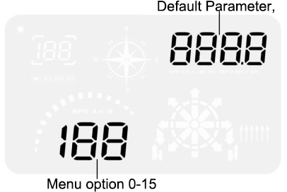
Menu option | Functions | Adjust Range | Explanation | Default parameter value | Setting status
0 | speed | 50-150 | If there is an error between the speed and the instrument panel, adjust the parameter value. If the instrument displays 100 km / h, the equipment displays 105km / h, and adjust the parameter value to 102 | 107 | 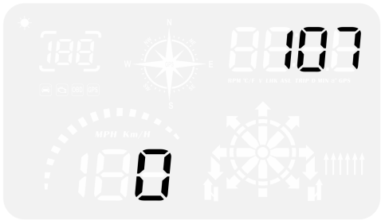
1 | adjustment of fuel consumption | 50-150 | Adjust the parameter value in case of oil consumption error | 100 | 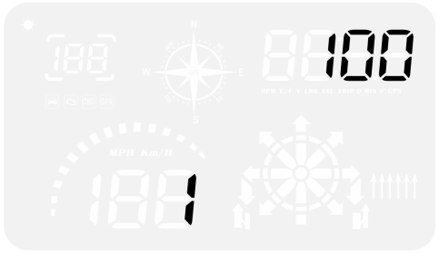
2 | RPM alarm | 100-7500 | Alarm after the speed reaches the set default value of 7500 rpm | 7500 | 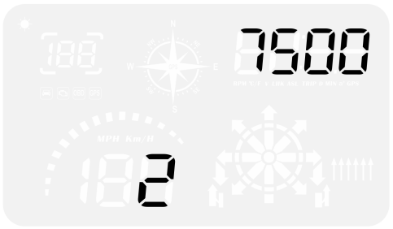
3 | Decoration icon display mode | 0-1 | 0=always lights on  1=RPM(if in OBD2 system)  1=Driving Speed(if in gps system) | 0 | 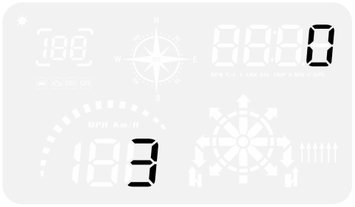
4 | Alarm mode | 0-1 | 0= user setting  1= 4-segment alarm | 0 | 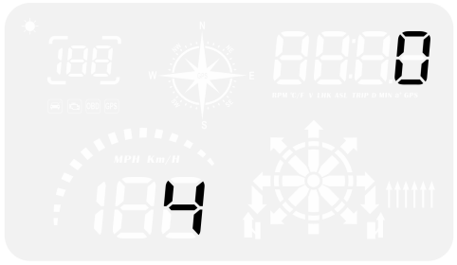
5 | Over speed alarm setting | 30-250 | Alarming when the vehicle speed reaches the default value of 150km / h | 150 | 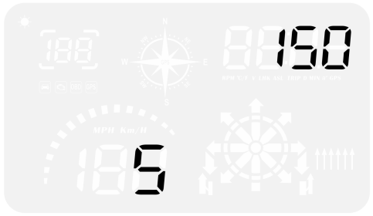
6 | Brightness adjustment | 0-5 | 0=automatic brightness 1-5=manual adjustment | 0 | 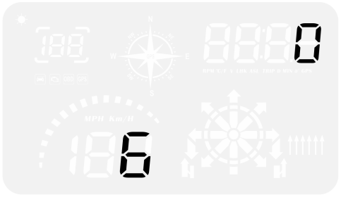
7 | Water temperature alarm setting | 50-150 | Alarming when the water temperature is over than 120 | 120 | 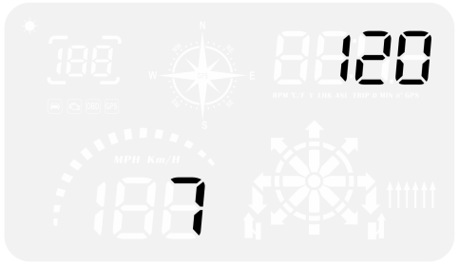
8 | Voltage alarm setting | 0-15.0 | Alarm when the voltage is lower than the default value of 10.0v | 10.0 | 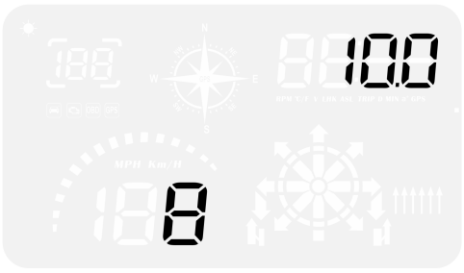
9 | Fatigue driving reminder | 1.0-8.0 | Alert after continuous driving for more than 4.0 hours | 4.0 | 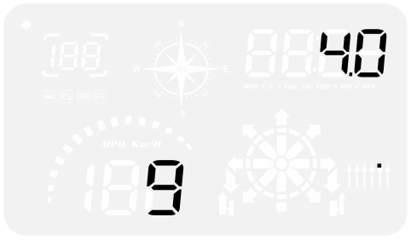
10 | Speed unit | 1-2 | 1=KM  2=MPH | 1 | 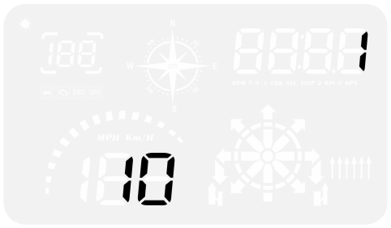
11 | Water Temperature unit | 1-2 | 1=℃  2=℉ | 1 | 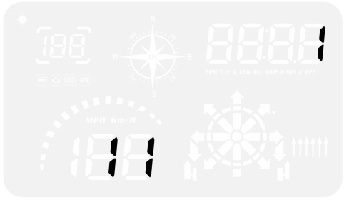
12 | Shutdown voltage | 0-15.0 | Adjust the voltage to 13.2v if can’t auto power off please make the value being 1 if your car is auto start-stop or Hybrid system | 0 | 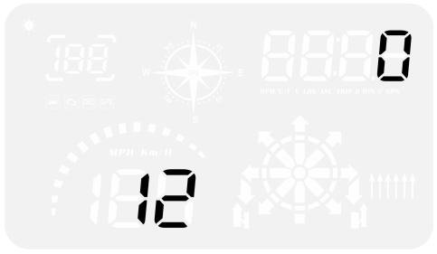
13 | Shutdown time | 5-300 | The default shutdown time is 20s,if your car is gas-electric hybrid or start-stop system,please delay the shutdown time(e.g. 180s),then the HUD will auto power off | 20 | 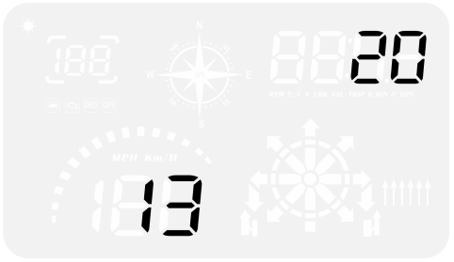
14 | Time calibration | 00:00-23；00 | Adjust the clock to be consistent with the local time. Dial up to increase the time zone and dial down to decrease the time zone | HUD will display the default time zone of 8 before the signal is ready,once the signal ready,it will show the digital clock of East 8. | 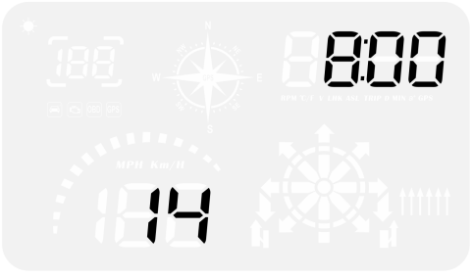
15 | Restore setting | 0-1 | Default is 0.  Please set the parameter to 1,then press in the scroll for 2 seconds to exit. | 0 | 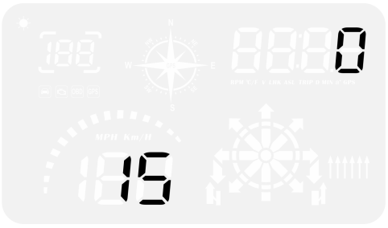

Please note:
Please unplug the HUD,when you won’t drive your car for more than a week.Due to the OBD equipment for long power, standby current is 20ma around,in theory, the use time of a common battery is 1 month,surely,situation of each car is different,it is recommended to unplug the OBD device if your car doesn’t been used for a long time.

OBD Troubleshooting:
1.The screen without any display, and no power
Please do these operations:①Check if OBD cable is tight enough,pull the OBD cable down several times②Try another car to test③Please maintain the OBD interface if it is damaged.

2.When HUD power on, HUD only shows the car voltage and be automatic power off after 30 seconds driving.
HUD just available for cars with OBD2 and EU-OBD agreement(European:manufactured after 2003, Other region: after 2007)
HUD Products don’t support JOBD and OBDI,if your car is these agreement,please switch to GPS system.

3.Wrong operation lead to crashes
If your car equip with other OBD devices (parking sensor, TPMS monitor,car window closer,ELM27)
If your car had been modified(central control navigation,electronic throttle controller,speed cruise,refresh the computer system,One-click start-up,keyless entry,remote startup)will cause a crash,unplug other OBD devices or Switch to GPS system for display (system key pushed to off)

4.Inaccurate Speed
Check the unit whether is correct, km / mph, (speed unit in menu 10)
When the car leaves the factory, the manufacturer shall increase the speed displayed on the instrument panel by 5-7%, and the international standard shall be subject to the driving computer data
Adjust the vehicle speed. If the instrument shows 100 km / h HUD shows 105 km / h, dial the wheel up and set the parameter value to 102

5 .Can't see clearly in the daytime, showing ghosting
There is a free highlight reflective film to wipe the glass clean, spray a little water to tear off 1 paste on the HUD display glass and then tear off 2

6.The car are with Automatic start/stop system
The engine stops running after the auto start and stop of the car is braked. The HUD will shut down after 20 seconds, and the shutdown delay can be adjusted to 180-300 seconds in item 13 of the setting item

7. Automatic start-up will auto off when step the brake and same situation on Hybrid car in the traffic.
1.Setting to COM mode(in the menu of shutdown voltage)
2.Setting shutdown delay to 300 seconds,so that it can turn off after 5 minutes
3. Please switch to the GPS system(up the button to choose in 5s when screen is sparking)

8.Shutdown restart
It means that the voltage is 13.2v higher than the starting voltage, and the parameter value of item 13 of the setting item is adjusted to 13.6-13.8v (the car can be started only when the car voltage is higher than the setting voltage)

GPS Troubleshooting
1.The screen without any display, and no power
Check whether the OBD cable is connected tightly. Pull it out and insert it repeatedly for several times. If it still doesn't display, it is recommended to replace the trolley for testing. Check whether the OBD diagnosis interface of the vehicle is broken. It is recommended to repair the OBD interface and connect the HUD again

2.No speed.
The GPS flashing means satellites signal loading. Please driving the vehicle to an open road. When signal is ready, the GPS light will stop flash, and keeps light on, it means GPS is working and will display the speed.

3.HUD cannot be automatically powered on or repeatedly extinguished while driving
OBD line connection: HUD will turn off when voltage lower than 13.2v.Vertically press the button in(5s)to enter into menu 12,adjust the default parameter 13.2 to 13.0 or 12.8.

4.Inaccurate Speed
Check whether the unit is correct, km / mph, (speed unit switch item 11)
When the car leaves the factory, the manufacturer will increase the speed displayed on the dashboard by 5-7%, and the international standard is subject to the satellite data
Fine adjust the vehicle speed. If the instrument shows 100 km / h HUD shows 105 km / h, dial the wheel up and set the parameter value to 102

5.Driving direction display error or random jump
The vehicle speed can not be displayed normally until it exceeds 5km / h

6.The speed is still displayed after the car stops
Under the underground parking lot, tunnel and overpass, if there are obstructions, the signal will be unstable and the satellite will drift. Please drive the vehicle to the open road. If more than 5 satellites are found, it will display normally.

7.View number of satellites
Scroll button allocation switch to GPS icon (normal display for more than 5 satellites)

8.The car will not auto power off when the engine is off
When the OBD line is connected, the HUD will automatically shut down after 3 minutes
If the power is not turned off within 5 minutes after shutdown and flame out, adjust the voltage setting parameter value of item 12 in the setting item to 13.5V

Navigation FAQ (navigation version only)
1.How to install app
Scan the QR code of the mobile phone (see the QR code in the manual), open it in the browser according to the prompts, click download and complete the installation
IOS Mobile, please search wiiyii in APP store.
Android mobile,please search wiiyii in Android Market.
After the App software is installed correctly, the turn off the mobile Bluetooth, gps,internet, and click the Wiyii. The system will automatically search for Bluetooth devices and connect.

2.If the mobile phone fails to connect to the Bluetooth device correctly
HUD host needs to display normally. If the OBD system is unable to connect, please switch to the GPS system, and works normally.
If the mobile phone cannot connect to the Bluetooth device correctly, please follow the instructions below:
HUD host needs to display normally. If the OBD system is unable to connect, please switch to the GPS system,and display normally.
Check the mobile Bluetooth whether connected to other devices or not, if yes, please delete the paired Bluetooth device, and connect to WYH2
Turn off the Bluetooth and then turn it on, or restart the phone

3.App Bluetooth connection failed
Check the mobile phone system version and whether it supports Bluetooth 4.0, IOS 5 and above, Android 4.4 and above
Mobile phone is required to enable Bluetooth search WYHUD, click to connect, and turn on mobile internet.
Turn on GPS navigation and positioning, and enter the navigation address after the positioning is successful

4.After the app Bluetooth connection is successful, the input address is not displayed
Please turn on the location service of the mobile phone, turn on the networking of the mobile phone, check the network signal, move to the place with strong signal, and enter the address you want to navigate again

5.HUD navigation stuck during navigation, vehicle speed display is normal
Turn off the power saving mode of the mobile phone, turn off the disable function of the information screen, or click to enter the navigation page of the mobile phone and stay on the navigation page.

6.The mobile phone switches the screen, or the navigation card does not move after the screen is off, and the speed display is normal
Turn off the power saving mode of the mobile phone, turn off the disable function of the information screen, or click to enter the navigation page of the mobile phone and stay on the navigation page of the mobile phone

7.Navigation is 10-20 meters away from the indication point
Because the GPS positioning error is about 5-10 meters, when the satellite signal is weak, the error of 10-20 meters is normal.

