Multi-function OBD+GPS Gauge
P19 Navigation
Thank you for purchasing our product,this product gets the vehicles driving data:speed, speed, fuel consumption,water temperature voltage..through the car ECU OBD2 interface,instantly read the driving data in the condition of view focus in the driving,to avoid the drivers unsafe caused by lowering head to watch the instrument in the course of driving,this product does not overwrite any data within the ECU.

Kindly attention:
Working voltage: 11V to 18Vdc (12Vdc/200mA),please use USB cable if your car volt > 24.

This product is dual system:you can freely choose your familiar language and system after powering up, ‘>’ button is for OBD or GPS system,device will be automatically enter into your last selected option with your operation after 5s.

Functions on button and interfaces
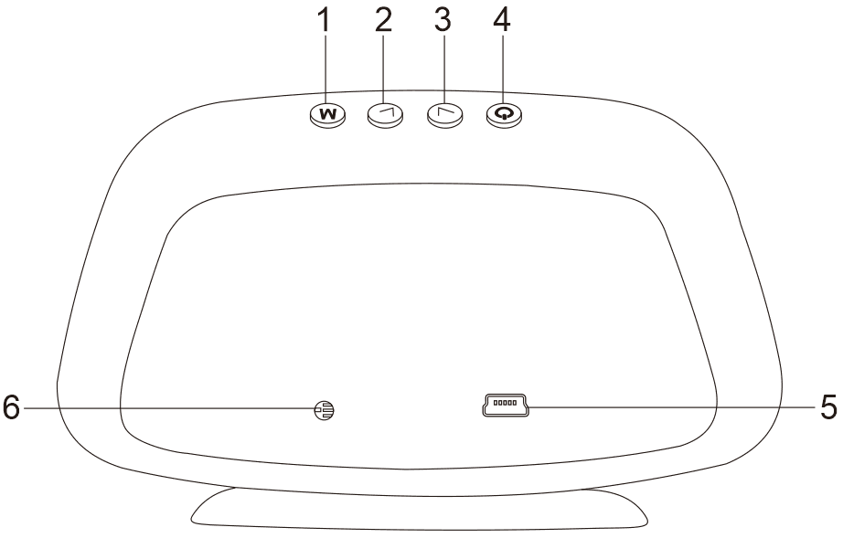

Short press:1s
Long press:2s hold and release after display appears

1.'M' Button
Short press:
- to switch functions
(2)to switch displays
Long press:
(1)to enter into settings
(2)to save and exit after adjustment

2.‘<’ Button(short press)
(1)to choose the language and system
(2)to switch the functions in the right area
(3)menu and parameter ‘-’

3.‘>’ Button(short press)
(1)to select the language and system
(2)to switch the functions in the left area
(3)menu and parameter ‘+’

- Power switch: long press to turn off,again to turn on
5.OBD cable and USB cable interface
6. Light sensitive components: sensing the intensity of external light,automatically adjust the brightness to adapt to the environment

Abbreviation:
ECT Engine water temperature | VLT Voltage | FUE Fuel consumption
RPM Engine Speed | TIM System Time | MIN Driving Time(time cost from Place A-B)
DIS Travel Distance | MAP Intake Pressure | OIT Oil Temperature
A/F Air-fuel ratio | TCP Turbo pressure | PSI Turbo pressure
RTC Satellite Time | ALS Altitude | GPS Satellite numbers
DIR Travel Direction

How to use Navigation
Please connect HUD with your smart-phone by Bluetooth,then APP can display a synchronized navigation information,compatible intelligent phones which meet the following requirement(Android 4.0 and IOS Iphone 5 or ↑)
Android Phones:Please search keyword ’WiiYii’ in the Android Market
Iphone:Please search keyword ’WiiYii’ in the APP Store
Scan below QR code to download
1. Firstly,please download this software,install HUD and actuate your car,manually turn on the Bluetooth and positioned,click the icon of WiiYii,system will automatically search the Bluetooth and connect
2.Please do the instructions below,if your phone cannot connect the Bluetooth HUD host needs to be bum steady,please switch to GPS system and delete the other Bluetooth devices matched before and binding WYHUD if the OBD system can not be connected.
Whether your phone's Bluetooth is connected to another device, delete the bluetooth device that has been paired, and then bind to WYHUD
3. Turn off Bluetooth and turn on again,or restart your phone
(For more questions, please refer to the FAQ on the back page)

Go into settings mode
Long press the 'M' button into the menu setting,''+'' is to increase the menu options,short press ‘M’ to enter into parameter value,short press ‘>’or‘<’ to adjust the parameter value,short press ‘M’ to return,and long press ‘M’ to save and exit.
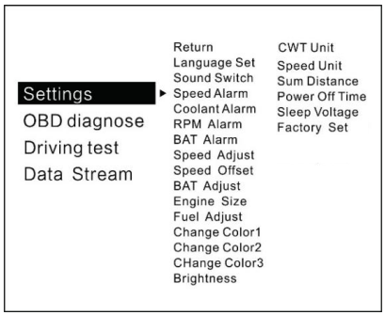
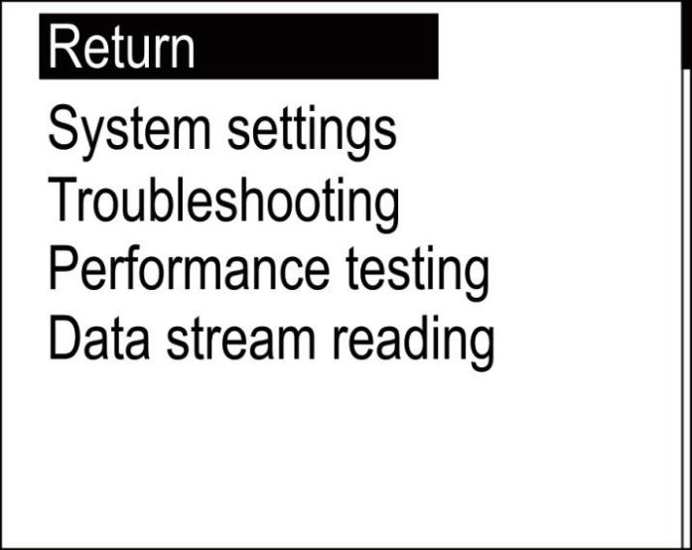
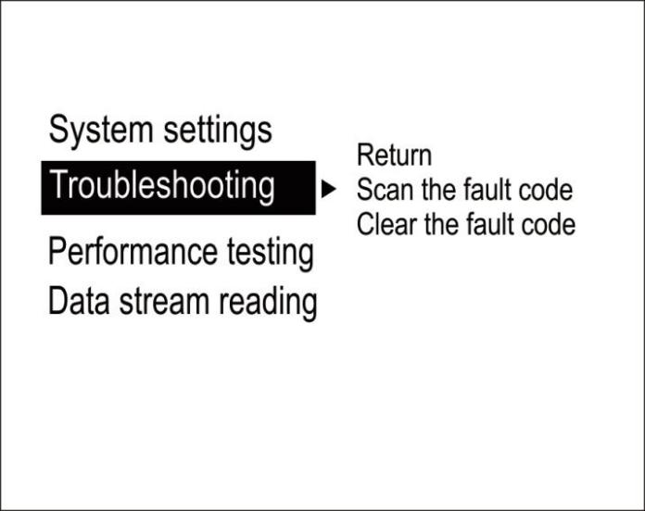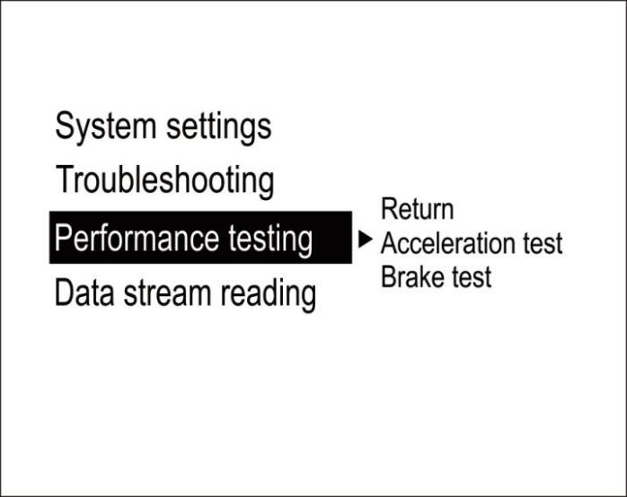

Select system language: CN Chinese Simplified/TW Chinese Traditional/EN English
System sound settings: ON buzzer on/ OFF buzzer off
Overspeed warning:alarm will turn on when the vehicle speed reaches the default value of 150KM/h,setting range from 5-200km/h
Engine temperature alarm:its default value 120 degrees C,range 50-200
Engine speed alarm:its default value of 6000r/min,range 1000-8000
Voltage alarm setting:its default value of 10.5v,range 10.0-15.0v
Speed adjustment:the operation is required only there is an error(e.g. instrument display 100 Km/h HUD shows 105Km/h,use default value 107-5=102)
Speed zero:the vehicle speed does not return to 0 after the car stops
(E.g. speed display 5Km/h,please adjust HUD to 6Km/h)
Voltage adjustment: Fine-tuning when voltage is wrong with instrument panel voltage
(If the device shows 0.2V above the meter voltage, the device is adjusted to 98%)
Engine displacement: please adjust if there is too much deviation on the fuel consumption
(E.g. make parameter value to 3.6L,if your car displacement is 3.6L)
Fuel consumption:making a fine-tuning if there is an error
(If the device shows 0.2L above the meter voltage, the device is adjusted to 98%)
First color: main display:speed color (8 colors optional)
Second color: left display color (8 colors optional)
Third color: the color displayed on the right (8 colors are optional)
Backlight brightness: Auto automatic light sensitive, 1 for the darkest, 8 for the brightest
Temperature unit: °C-Celsius °F-Fahrenheit
Speed unit: Km/hkm MPH miles
Count mileage: total mileage synchronization
(Keep it as same as dashboard,ex:odometer shows 30010km, adjust the parameter value to 30010km)
Shutdown delay setting: 10 seconds by default, adjustment range from 5-300 seconds
Shutdown voltage setting:please adjust to 13.2V or 13.6 or to COM mode if your car auto start-stop system when device can't turn off
System time adjustment: Can be adjusted to local time, the default time is Chinese time (GMT plus 8)
Factory reset: System restored to factory preset Select this operation, dial wheel vertical short press confirmation

Performance testing
Acceleration test: kilometers acceleration refers to the seconds 0 to 100km/h,is a test of car power
Brake test: the time and distance taken of a brake after the speed > 100, is a test of brake performance

Troubleshooting settings
Scan fault code: Scanning the car for fault codes
Clear fault code:Pressing 'M' to clear the fault code when the car has fault code
Read the data stream: Show all the data in the car engine

Reminder warning:
The standby current of OBD device is about 20 milliamps,then generally speaking its battery can storage for 1 month,surely different vehicles had different condition,we recommended to plug your device out when it not be used for a week
OBD2 FAQ
1.No function is displayed,no power
Check whether the OBD cable is tight connection,pull down repeatedly to confirm,please try it on another car if still not workable,analysis if it is an error from OBD diagnostic interface,if yes,please repair it and connect the device again.

2.Only the car voltage displays and be automatic power off after 30 second
This product is only available for OBDII and EOBD cars when it is in OBD2 mode
OBD2 is a car protocol(U.S.A Cars:2003Other regions:2007)
This product OBD2 mode does not support OBD I and JOBD
Switch to the GPS system using the USB cable to display, within 5 seconds of power short press the ''' key to select the GPS system.

3.The vehicle speed on P19 is not as same as speedometer’s
Please check that the unit is correct(KM/mile MPH) (speed unit switch please refer to the settings)
Vertical long press the 'M' button into the system settings, press ''>' to select the speed adjustment menu,and make a fine-tuning (e.g. meter displays 100 Km/h,device shows 105Km/h,use default value 107-5=102 ).

4. There is an error on fuel consumption
Checking your car displacement and make sure that the engine displacement of the device is as same as your car’s(e.g. car is 2.0L,please set parameter value to 2.0L)if the displacement is the same, you can also do a fine-tuning settings(e.g. equipment fuel is higher than 0.2L,please set the parameter to 98%) Recommended: fine-tuning is optional since it is a real data from car computer

5.This device cannot auto shut down
After the car engine stops,the RPM on the machine can not be turned off,please set voltage to 13.2V or 13.6V,so that the car can be turn off after 3 minutes.

6. Automatic start-up will auto off when step the brake and same situation on Hybrid car in the traffic.
1.Setting to COM mode(in the menu of shutdown voltage)
2.Setting shutdown delay to 300 seconds,so that it can turn off after 5 minutes
3. Please switch to the GPS system(up the button to choose in 5s when screen is sparking)

7.Wrong operation lead to crashes
(1)Are there other other OBD devices on OBD2 interface (parking sensor,TPMS,lock lift window,ELM27)
(2)Had your car been modified and brushed(central navigation,electronic throttle controller,fixed speed cruise)
(3)No matter engine start stop,keyless entry or remote start will cause a crash,unplug other OBD devices,and do a factory reset (see the menu settings)
Please long press 'M' to enter the settings,short press ''>'' to switch the menus,short press 'M' to enter the restore factory setting,short press 'M' to save the adjustment.
Please switch to GPS system(short press ”>” within 5s) which should be connected with a USB.

GPS FAQ:
1.The screen is not displayed, no power
Check the OBD cable or car charger is in tight connections,try it several times to make sure,or plug a USB cable into the cigarette lighter

2.No speed
GPS will take a short of time to search the satellites,please drive the car to the open road to get 5 and more satellites so that Gauge can be used normally

3.P19 cannot automatically power on or repeatedly extinguish during driving
Please use plug a USB cable in the cigarette lighter
Setting the shutdown voltage to 13.0V or 12.8v(in OBD mode)
Setting the shutdown voltage to OFF(in GPS mode)

4.Inaccurate clock
Enter into the settings(System time):press '>' to adjust and press 'M' to save exit

5.Speed is not correct
If the unit is correct,km KM/mile MPH, (speed unit switch reference settings item)
The car factory had increased speed(5-7%)than real for drivers’ safety,satellite data is strictly follow the international standards
Fine-tuning the vehicle speed, e.g. meter display 100 Km/h, machine display 105Km/h,default value 107-5=102

6.There is an error of travel direction
Satellite cannot recognize the driving direct without speed display,it will be normal until exceeds 5KM/H

7.Speed is still on display after the car stops
Satellite drift will be caused in underground parking,tunnel,overpass or blockers,please drive your car on open road,then this situation can be solved after the satellite numbers >5

8.P19 cannot be automatically shut down after car stopped
P19 can be shut down in 3 minutes(in OBD mode)
If not in 5 minutes,set item shutdown voltage to 13.5V or switch to GPS mode

Navigation FAQ (available on navigation version only)
1. How to install APP
Scan QR code to download this APP(see manual)
Iphone:Searchkeyword ‘WiiYi’ in APP Store
Android phones:Searchkeyword ‘WiiYi’ in Android Market
Firstly,please download this software,manually turn on the Bluetooth and location,click the icon of WiiYii,system will automatically search the Bluetooth and connect

2. If the phone can't connect to the Bluetooth device correctly
HuD host needs to display normally, if the OBD system cannot be connected, switch to GPS system normal display
Whether your phone's Bluetooth is connected to another device, delete the bluetooth device that has been paired, and then bind to WYHUD
Turn Bluetooth off again and then turn on your phone's Bluetooth, or restart your phone

3.APP Bluetooth connection is not successful
Check the phone system version and whether Bluetooth 4.0 is supported,Apple system should be IOS9 or ↑ , Android 4.4 or ↑
Turning on Bluetooth and connect with WYHUD
Turn on GPS navigation positioning,which can be entered after positioning gets

4.App Bluetooth connection is successful, no display of input address
Please turn on the location service,open your network,check the signal,please move to a place which has a strong signal,and enter the address again

5.P19 stuck during navigation or when you switch the display interface, speed display is normal
Turn off the power-saving mode of the phone, turn off the screen forbidden function, or click to enter the phone navigation page and stay on the phone navigation page

6.Navigation is 10-20 meters away from the designated location
6.Because the GPS positioning error is about 5-10 meters, the satellite signal will appear 10-20 meters when in weak signal

