GPS Head-Up Display
Model : G3

INTENDED USE
The head-up display is intended for:
- Display vehicle data such as speed,altitude, clock etc.
- Warnings related to speed and alertness assistant
- Support information related to monitoring driving time and distance

CONTENTS
Check the package contents immediately after unpacking. Check the device and all parts for damage. Do not use a defective device or parts.
- head-up display
- Non-slip mat
- USB connecting cable
- Operating instructions
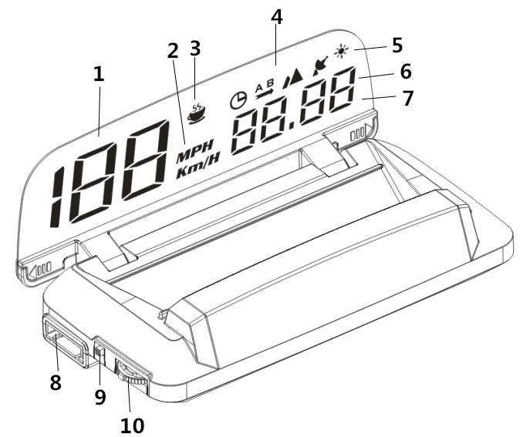

No. | Description
1 | Speed < 199
2 | Speed unit (km/h or MPH)
3 | Alertness assistant or driving time
4 | Symbols
5 | Brightness sensor
6 | Multifunction display, speed > 200
7 | Projection surface
8 | USB connecting interface
9 | On/Off switch
10 | Function wheel

Symbols
Altitude
Driving distance
Clock
Alertness assistant or driving time
Satellite number

CONNECTING
The head-up display connects to the vehicle via USB cable, plug and play.

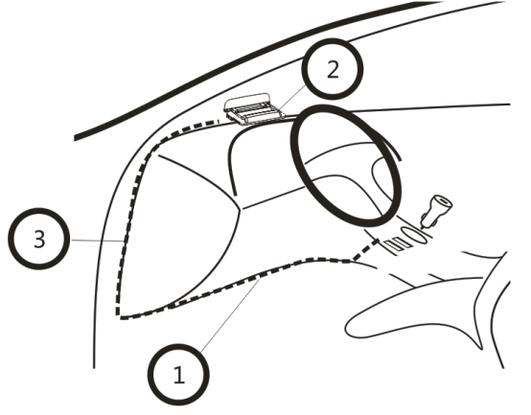
- Turn the ignition off, connect the USB cable to car charger
- Connect the USB cable to the interface [8] on the head-up display
- Hide the USB cable like above picture show. Turn the ignition on, flip open the projection surface [7], then it can work.

ASSEMBLY
Attention! when installing the head-up display, be sure it does not diminish your vision. The connecting cable must not interfere with your ability to drive and the head-up display must be firmly secured.
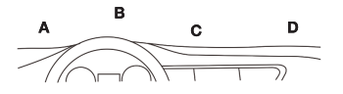
- Select a mounting location [A-D] on the dashboard.
- Place the non-slip pad in the desired location.
- Place the head-up display on the non-slip pad.

OPERATION
Warning: do not operate the head-up display whilst driving, as this will distract you from traffic. Maintain your focus on driving and traffic.

Switching on the head-up display
- Use the On/Off switch [9] to switch on the head-up display. Set the switch to the ON position.
- The display will search the satellite, and show the satellite number for approx. 3 seconds. It will then show the current speed (km/h).

Switching off the head-up display
- Use the On/Off switch [9] to switch off the head-up display. Set the switch to the OFF position.
- The display will turn off.

Switching the display interface

- When head-up display power on, the satellite Symbol will flash and search the satellite, when seach the satellite sucessfully, the satellite Symbol will keep light, and show the satellite number.
Satellite number

- The display on the projection surface [7] will change, the left part is speed, the right part can change to multi-function

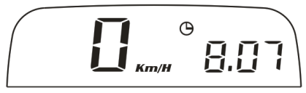
Clock - Driving distance - Altitude -
Satellite number - Driving time - Speed > 200

- Speed + Clock
- Speed + Driving distance
- Speed + Altitude
- Speed + Satellite number
- Speed + Driving time
- Speed

SETTINGS

The value on the head-up display should match the values on your vehicle’s dashboard. If this is not the same, you can change the settings of head-up display in the setting menu.
- Hold on the function wheel [10] for 5 seconds to open the setting menu.
- Push the function wheel [10] forward or backward to move to the next setting.
- Briefly press the middle of the function wheel [10] to change a value.
- Hold the function wheel [10] for 5 seconds again to exit the setting menu.

SETTING MENU

No. | Option | Display | Range | Description
 | Speed |  | -9~9 | Correction value if the speed in the head-up display does not match the vehicle's data.
 | 4 level speed alarm |  | 0-1 | 0-on ( alarm when speed reach 60 km/h, 80km/h,100km/h,120km/h) 1-off
 | 1 level speed alarm |  | 30-250 | Alarm when speed reach 180 km/h
 | Alarm sound on/off |  | 0-1 | 0-Off the alarm sound  1-On the alarm sound
 | Brightness by manual |  | 0-11 | 0 = auto brightness  1-11 = manual brightness
 | Lowest brightness in auto mode |  | 1-11 | 1-11 can adjust the auto brightness
 | Speed unit |  | 0-1 | - KM/H  - MPH
 | Clock |  |  | Push the function wheel [10] forward to set the hours, backward to set the minutes.
 | Restore to factory setting |  |  | Push the function wheel [10] forward or backward once,HUD will give a beep sound

Problem | Solution
No display | Start the engine. Verify the head-up display is switched on. Verify the USB connecting cable is correctly and firmly connected.
How to restore to factory setting | Find menu 8, Push the function wheel [10] forward or backward once, HUD will give a beep sound,it means restore to factory setting successful.
Inaccurate speed | In the setting menu, find menu 0, the adjust range is -9~9, if HUD show faster 2 km/h than dashboard, adjust the setting value to -2, if HUD show slower 2 km/h than dashboard, adjust the setting value to 2.
Inaccurate clock | - In the setting menu, find menu 7  - Tap the function wheel [10] forward to set the hours, briefly press the function wheel [10] can change the hours value  - Tap the function wheel [10] backward to set the minutes, briefly press the function wheel [10] can change the minutes value  - Hold on the function wheel [10] for 5 second to save and exit

