Car Smart Digital Meter

Model : P17
Introduction
Thanks for purchasing our car smart digital meter. This product connects car OBD2 interface by OBD cable, and display the driving dates, e.g. vehicle speed, engine RPM, water temperature, fuel consumption,voltage etc. It can keep the driver’s eyes always on road to avoid the dangerous of lowering down head to read the dashboard. This product won’t change any car ECU dates.

kindly attention
OBD mode working voltage: 11V~18VDC (12Vdc/200mA), when voltage is higher than 24v, please use a USB cable for GPS mode.
This product is a dual system (OBD2+GPS):the screen flickers after power on, press button to select OBD2 or GPS system, if without operation,it will automatically enter the last selected system after 5 seconds

Button functions:
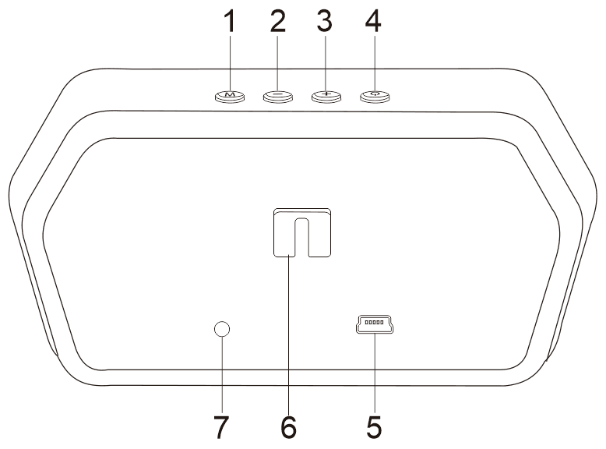

Short press means press for 1 second
long press means press for 2 seconds, donnot release the button until the display image changed
1, short press button: (1)Select function (2)switch screen image after normal display
Long press button: (1)to enter into the menu (2)after finishing the setting, to keep and exit.

2, short press ‘-’button: (1)Switch the language and system when first used. (2)Switch the right area functions in normal display. (3)Reduce menu option or parameter values after entering settings
3,short press ‘+’button: (1)Switch the language and system when first used. (2)Switch the left side area functions in normal display.(3) Increase menu or parameter values after entering settings
4,Power switch : long press to turn off, do it again, turn on.
5,OBD line interface
6, Suction cup bracket
7,Photosensitive component: sense external light intensity, automatically adjust brightness to adapt the environment

Display function abbreviation:
ECT - Engine Coolant Temperature | VLT - Voltage | FUE - Fuel Consumption
RPM - Revolutions Per Minute | TIM - Local time | MIN - Driving minutes
DIS - Driving Distance | MAP - Intake Pressure | OIT - Oil Temperature
A/F - Air-fuel Ratio | TCP - Turbine Pressure | PSI - Intake pressure
RTC - Real-Time Clock | ALS - Altitude | GPS - GPS satellite numbers
DIR - Driving Direction

Menu setting
After power on, long press the ‘M’ button to enter into the setting mode,press the ‘+’button to switch the menu option,short press the ‘+’to choose the menu,short press ‘+’or ‘-’to change the default value. Short press in the the ‘M’to back to the menu, long press ‘M’ to save and exit.

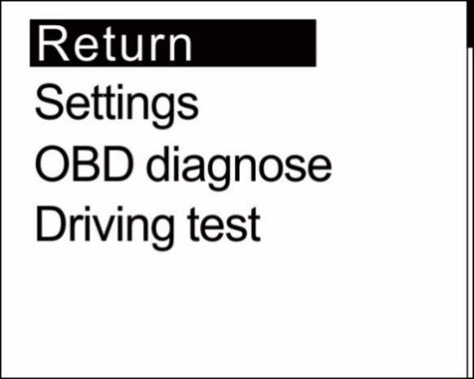
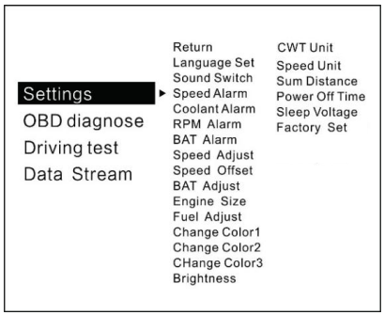

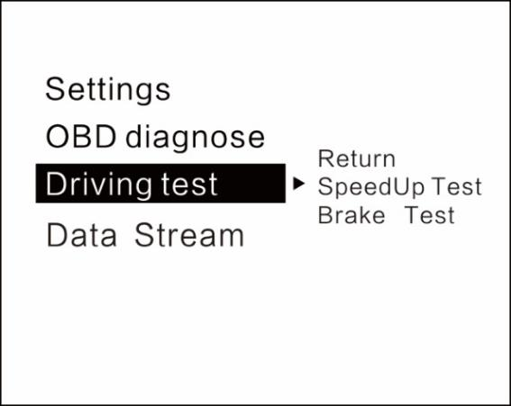
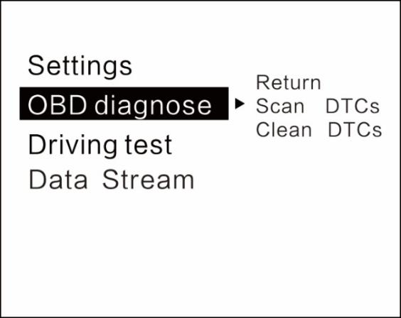

Language Set: Please choose your familiar language ( EN-English / CN-Simplified Chinese/ TW-Traditional Chinese)
Sound Switch: turn on/off the buzzer
Speed Alarm: the default value is 150 (the default value can be changed,pull down is to decrease,pull up is to increase, adjust range is 5-200km/h)
Coolant alarm: default value is 120°, it means this device will give alarm when Coolant temperature is over 120°(adjust range is 50-200)
RPM alarm: default value is 6000 r, it means this device will give alarm when RPM over 6000 r(adjust range is 1000-8000)
BAT Alarm: default value is 10.5V, it means this device will give alarm when battery voltage is lower than 10.5V(adjust range is 10.0-15.0V)
Speed Adjust: adjust the speed according to the dashboard,default value is 107%(if the speed is different with the dashboard,then can adjust the value. For example, if the dashboard speed is 100Km/h, and the device speed is 105KM/h, then please adjust the value to 102)
Speed Offset: When the vehicle turns off,but the device speed is not 0, then adjust the device Speed Offset value (if the device speed shows 5KM/H, then change the device Speed Offset default value at 5)
BAT Adjust:if the battery voltage is different with the vehicle,it can be adjusted.
(if the device voltage is 0.2V higher than the dashboard’s,please change the value to 98%)
Engine Size: if the fuel consumption is much different with the dashboard,please change it as the Displacement size(for example, if the vehicle displacement is 3.6L, please change the default value to 3.6L)
Fuel adjust: default value is 100%,it can be adjusted when the fuel consumption is different with the dashboard.
(for example, if the device fuel consumption is 0.2L higher than the dashboard, please adjust it to 98%)
Change Color 1: the speed color in the main display interface
Change Color 2:the left side functions color on the screen
Change Color 3:the right side functions color on the screen
Brightness: default 0(Automatic sensitivity),1-8(the brightness will be increased as the digital added)
CWT Unit : default coolant temperature is °C,also can be changed to ℉
Speed unit: KM/h or MPH can be changed
Sum distance: can make the total driving distance same as dashboard(if the dashboard shows the sum distance is 30000Km,the user can make the device value at 30000KM)
Power off time: default power off time is 10s,for Auto start and stop cars,please make the power off time to 180-240s
Sleep Voltage: default is off ,if the device can’t auto off,please adjust the voltage at 13.2V or higher
Factory set: short press in to do the factory set
Time adjust : default time is GMT+8(China time), can change the it to local time by pulling up/down.

Driving test
Speedup test: show the speed,distance,driving 400m takes time,driving 100m takes time
Brake Test: Brake when the speed is over 60 KM/H, then it show brake distance and time

Error code set
Scan DTCs:scan the ECU to check if there is the error code,and show the error details
Clean DTCs:switch to Clean the DTCs,short press in the button to finish the cleaning

Data Stream
Show all the vehicle data stream

Please note:
It is recommended to unplug the device if your car doesn’t been used for more than one week.

OBD2 System Troubleshooting
1.The screen without any display, and no power
Please do these operations: If OBD cable is tight enough,pull the OBD cable down several times. Try another car to test. Analyze whether the vehicle OBD diagnostic interface is broken. If the OBD diagnosis is bad, it is recommended to repair the OBD interface and connect the device again.

2.When the device powered on, it only shows the car voltage and be automatic power off after 30 seconds driving.
The device is available for cars with OBD2 and EU-BOD protocols(European:manufactured after 2003, Other region: after 2007)
The Product don’t support JOBD and OBDI
Please switch to the GPS system to display using the USB cable. When the device powered on,press the ‘-’ button within 5 seconds to select the GPS system.

3.Inaccurate Speed
First check the speed unit is correct or not, the speed unit including KM/H and MPH,please refer to the setting to switch the unit.
When the device is powered on, long press in‘M’ button for 2 seconds to enter the menu setting.
Short press the ’+’ button to switch to speed adjust option,and short press the ‘M’ button to choose this option,then short press ‘+’ button or ‘-’ button to change the value. Once finished,long press in ‘M’ to save and exit.
(If the dashboard speed is 100 Km/h, but the device displays 105Km/h,just need to adjust the value at 102)

4.Inaccurate Fuel consumption
Check your car displacement,and set the device same as your car(if your car is 2.0L,then change the device value at 2.0L).The fuel consumption can be adjusted,but we don’t suggest to change it ,because all the datas are read from the car ECU directly.

5.The device can not auto power off
Adjust the sleep voltage to 13.2V or 13.6V, then device will power off in 3 minutes.

6.Auto start and stop cars
Change the Power off time to 180s

7. The device crashes in driving,or Hybrid car
Change the power off time to 180 or 300. If still can’t solve,please switch to GPS system.

8.Wrong operation lead to crashes
- Please check the OBD interface if connected withe other device
- Modified and retrofitted cars will cause a crash
Please remove other OBD devices and do the factory reset.
If still not solved,please switch to GPS system.

GPS System Troubleshooting
1.The screen without any display,and no power
Start the car engine;check if the cable line is tight;or connect the USB to the computer to check

2.Without car Speed
After the device power-on, the GPS will try to find the satellite. Please driving the car to the road. It will work once gets more than 5 satellite signals.

3. Cannot be turned on automatically or repeatedly extinguished during driving
Please use the USB cable to insert the cigarette lighter
If you use the OBD cable, change the sleep voltage to 13.0V or 12.8V
If use the USB cable, make the sleep voltage off.

4.Inaccurate time
Entering into the setting menu, choose the time adjust, press ‘-’ to adjust the time zone time.
After setting,long press ‘M’ button to save and exit.

5.Inaccurate Speed
a.First check the speed unit is correct or not, the speed unit including KM/H and MPH,please refer to the setting to switch the unit.
b.The car manufacturers usually make the dashboard speed 5-7% higher than the ECU. The international standard is based on satellite data.
(if the dashboard shows 100,and the device shows the 105,change the default value at 102)

6.Driving direction is wrong
The satellite cannot distinguish your direction of travel without speed, after the vehicle speed exceeds 5KM/H, the direction can be displayed normally.

7. The speed is still displayed after the car stops.
When driving in the underground parking lot, tunnel,or under the crossover bridge, there will be unstable satellite drift when there is obstruction. Please drive the vehicle to the empty road. Once the satellites are more than 5,it will display normally.

8. The device cannot auto power off when the car is turned off
If connects by OBD cable, it will auto power off in 3 minutes.
If it still not powers off in 5 minutes,please change the sleep voltage to 13.5V, or use the USB cable.

