Car HUD Head Up Display M7
(This product Design Patent and Display Images Copyright had been registered with customs record)

Kindly attention:
Working voltage: 11V~18VDC (12vdc/200ma),please use a USB cable when voltage higher than 24v

This product is a dual system:users can freely choose OBD or GPS system after turning on(toggle left),HUD will enter into the previous selective system if users not give an option.

HUD short for Head Up Display.It displays driving data on the car windshield such as speed,RPM,water temperature,voltage,single mileage etc;avoiding drivers unsafely because of watching the instrument while driving.Drivers can read the driving information instantly, and always keep the best state on the way with HUD.

Product functions:
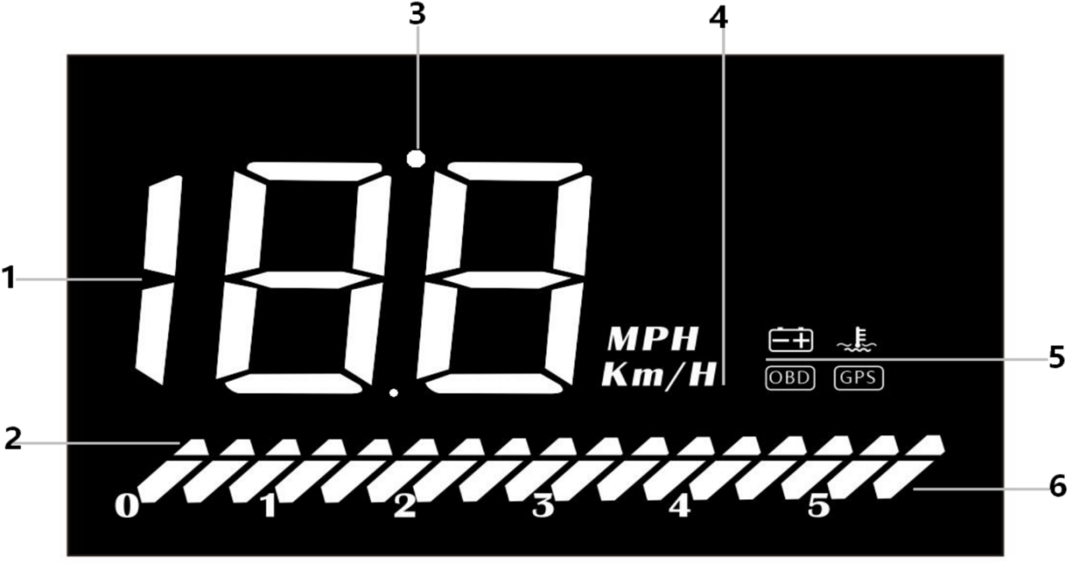
1.Multiple functions:Speed,water temperature,voltage,satellite numbers,driving distance
2.Decorative lights:all LED in,you can freely push right to turn off
3.Light sensor:HUD can automatically adjust the brightness according to the environment
4.Speed unit:KM/H=kilometer/hour, MPH=Mile/hour
5.Unit icons:V=battery voltage, C=Celsius,F=Fahrenheit,OBD system,GPS system
6.RPM icon:It is engine speed in OBD mode, and speed progress bar in GPS mode.

Button functions:
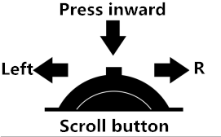

Button in front
1.Push left:switch between OBD and GPS system within 5 seconds after power up;parameter+.
2.Push right:After HUD displays:switch display mode (standard, athletic, concise);parameter-.
3.Press inward:switch voltage,water temperature,speed,satellite numbers;return to the main page after enter into menu setting.
4. Push left(5s):Alarm turn on and off,one more time to turn on the buzzer.
5.Push right(5s):All LED on;eliminate the fault code,do it again to return to the main page.
6.Press inward(5s):Enter into settings (1-11 settings,more details please refer to the menu table),vertically long press 5 seconds to save and exit your settings.

System choice:
Scroll left dial to choose OBD or GPS system within 5 seconds,HUD will automatic enter into the OBD system if you have no operation.
OBD System：（available for cars with OBD2 interface）
Vehicle speed,engine RPM,water temperature,driving distance after flame-out,battery voltage,engine RPM icon,decoration icon
GPS System：（universal for cars,buses,trucks..）
Vehicle speed,battery voltage,satellite numbers,speed icon,decoration icon

Please switch to GPS system when OBD doesn’t work(re-start the power)
Restore setting:
Vertical long press the scroll button in till all LED lights are on,release the button.(Under the condition of turning off)
Fault code clear:
When HUD is turning on,push the scroll right(5s) till all LED lights are on;do it again to back to the main page
Turn off/on the buzzer
Pull down the setting button for 5 seconds,listen to a “di”,to turn off the buzzer,do it again to turn on.

HUD setting
Please kindly watch the reflection on windshield to make your operation.Vertical long press in the setting button for 5s to enter the menu setting,menu is 1.Push right or left to do a menu choice(1-11);vertical press inward(1s) to enter into parameter,push right or left to do a parameter adjustment,press inward(1s) again to return to the main page;press inward(5s) to save your adjustment.
Menu | Functions | Range | Explanation | Default
 | Speed | 50-150 | When the Speed is not the same as dashboard:left or right the setting button to adjust | 107
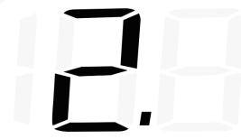 | RPM alarm | 10-75 | HUD will give the alarm when the RPM reach to 5000 r(50=5000r),the default alarm can be changed | 75
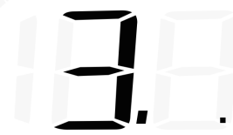 | 4-stages alarm | 0-1 | 0=alarm off  1=alarm on(alarm icon will light up when speed at 60,80,100,120KM/H) | 0
 | Over-speed alarm | 30-199 | alarm icon will light up when speed at 150KM/H) | 150
 | Display mode | 0-2 | 0=high-speed mode(when speed > 80km/h,HUD will show speed only) 1=displays all information 2=displays speed only | 1
 | Brightness | 0-11 | 0=automatic brightness 1=darkest 11=brightest | 0
 | Speed unit | 0-1 | 0=KM  1=MPH | 0
 | Temperature unit | 0-1 | 0=℃  1=℉ | 0
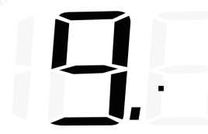 | Starting voltage | 0-15.0 | If HUD cannot auto turn off,change the voltage at 132(means 13.2V) | 0
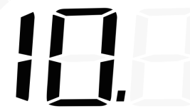 | Shutdown time | 20-199 | The default shutdown time is 20s,if your car is gas-electric hybrid or start-stop system,please delay the shutdown time(e.g. 180s),then the HUD will be turned off | 20
 | Restore setting | 0-1 | Please set the parameter to 1(push the button right to make an adjustment,then press inward 5s to save your setting). | 0

Please note:please manually turn off the HUD,when you don’t drive your car for more than a week.Due to the OBD equipment for long power, standby current is 20ma around,in theory, the use time of a common battery is 1 month,surely,situation of each car is different,it is recommended to unplug the OBD device if your car doesn’t been used for a long time.

OBD Troubleshooting:
- The screen without any display, and no power
Please do these operations:①If OBD cable is tight enough,pull the OBD cable down several times②Try another car to test③Please maintain the OBD interface if it is damaged.

2.When HUD power on, HUD only shows the car voltage and be automatic power off after 30 seconds driving.
HUD just available for cars with OBD2 and EU-OBD agreement(European:manufactured after 2003, Other region: after 2007)
HUD Products don’t support JOBD and OBDI,if your car is these agreement,please switch to GPS system.

3.Wrong operation lead to crashes
If your car equip with other OBD devices (parking sensor, TPMS monitor,car window closer,ELM27)
If your car had been modified(central control navigation,electronic throttle controller,speed cruise,refresh the computer system,One-click start-up,keyless entry,remote startup)will cause a crash,unplug other OBD devices and do the factory settings (more details please refer to the menu table)

4.Inaccurate Speed
a. First check the speed unit is correct or not, the speed unit including KM/H and MPH, set it at the correct one(refer to menu 9)
b. When HUD is power on, vertical press the setting button for 5 seconds to enter into the menu 1 and the parameter shows 107,up or down the setting button to increase or decrease the value according to the difference until it shows correct one. After adjustment, vertical press in 5 seconds to save it.

5. The car are with Automatic start/stop system
Once the start stop vehicle engine stopped,the HUD will shutdown. It can delay the shutdown time to 180s,please refer to the menu setting 10.

6.HUD can not auto power off(RPM or Speed not at O)
When HUD is power on,long press in the button for 5 seconds to enter into menu,set to menu 9. Change the voltage from 0 to 13.2V or 13.5V. Once the adjustment finished,long press in the setting button for 5 seconds to save and exit.
- HUD will automatically restart
Indicates that the voltage is higher than the starting voltage 13.2 volts, the setting item 9th parameter value is adjusted to 13.6-13.8

GPS Troubleshooting
1.The screen without any display, and no power
OBD line connection:Start the car engine,HUD start voltage is 13.2v in order to prevent power consumption,as long as the car reaches 13.2v,it will be automatically turn on.Check the OBD cable or car charger is connected to the elastic, pull down repeatedly plug several times, with a USB cable into the cigarette lighter device.

2.HUD cannot be automatically powered on or repeatedly extinguished while driving
Under OBD line connection: HUD will turn off when voltage lower than 13.2v.Vertically press the button in(5s)to enter into menu 11,adjust the default parameter 13.2 to 13.0 or 12.8.
If no effect still,please try to use the USB cable insert to cigarette lighter.

3. HUD doesn’t automatically turn off after flame-out
OBD line connection: the default turnoff voltage is 13.2v.HUD will auto on when voltage higher than 13.2,oppositely,it will auto off.Please enter into menu 11 and change the parameter to 13.5 when your HUD cannot automatically off. If no effect still,please try to use the USB cable insert to cigarette lighter.

4.Inaccurate speed
Under the condition of turning on,vertical long press the scroll button 5 seconds to enter into the menu options,menu display 1,parameter value 107,make an increase or decrease depending on how much difference between HUD and the instrument panel,increase and decrease of parameter. After adjusting,vertically press in 5 seconds to save.

Technical Parameters
1.Terms of Use:Environment temperature:-40C— +80C Barometric press: 86-106KPa
Relative humidity:10%-95% Environment voice:<=60dB
2.Work voltage:11V~18Vdc(12Vdc/200mA)
3.Standby current:<=20mA
4.Display way:Image reflective
5.Display channel :LED Display

