Car HUD Head Up Display
Model M10
(This product Design Patent and Display Images Copyright had been registered with customs record)

HUD short for Head Up Display.It displays driving datas on the front windshield such as
speed,RPM,water temperature,voltage,single mileage etc on the car front window glass;avoiding drivers unsafety because of watching the instrument while driving.Drivers can read the driving information instantly , and can always keep the best state on the way with HUD.

Product function
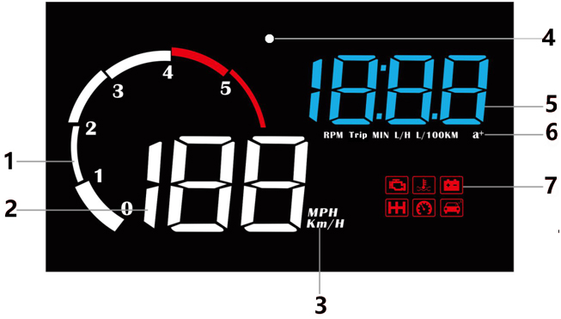

- decorative lighting and RPM light
- Speed
- Speed unit: KM/H , MPH
- Light sensor:HUD can automatically adjust the brightness according to the environment
5. Multi functions: Instantaneous fuel consumption, 100 km acceleration, water temperature, voltage, speed, trip distance, travel time, clock
6. Unit of functions: RPM= Rotational Speed,Trip=trip distance,L/H=Instantaneous fuel consumption, L/100KM=100 km instantaneous fuel consumption, a+=100 km acceleration time
7.Alarm icons: Engine failure icon,water temperature icon,Voltage icon, shift reminder icon, speed alarm icon,Fatigue driving icon
Wave button function:
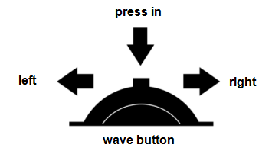
When the wave button/setting button is in the front:

Push left: (1)switch the RPM display mode
(2)after entering into the setting menu, to decrease the default value

Push right: (1)when HUD is working,to switch display mode(Standard/competitive/simple mode) (2)after entering into the setting menu, to add the default value

Short press in:(1) switch the multi functions:Instantaneous fuel consumption / 100 km acceleration time/ water temperature/ voltage/speed/trip distance/travel time/clock
(2) after entering into the setting menu, to add the menu

Long push left: turn off/on the buzzer

Long push right: all lights will be on, to eliminate the fault code, do it again to back to working

Long press in: (1) to enter into the setting menu
(2) when finish the adjustment, long press in the button to save and exit

Factory reset
When the HUD turns off, long press-in the wave button and at the same time turn on the HUD, all the lights will be on, and then release the button, the reset finished.

Clear the fault code
When HUD is power on, long pull right the button for 5 seconds, then all the lights will be on, it means finished, do it again to save and exit

Turn off/on the buzzer
Long push left the setting button for 5 seconds to turn off the buzzer,do it again to turn on the buzzer

Clock calibration:
The unit does not contain a battery, so it is required to set the clock after HUD power off
Long press in the button for 5s to enter into the menu, then short press in 15 times to menu 15, the clock is 12:00 and flicker,push left to switch the hour and minute,push right to adjust the number. Once finish the calibration,press in the button for 5 seconds to save and exit.

HUD setting:
Please kindly watch the reflection on windshield to make your operation
Long press in the wave button for 5s to enter the menu setting, it will display menu 1,short press in to increase the menu option, push left or right the wave button to increase or decrease the default value. After adjustment, long press in 5 seconds to save and exit.
Menu | Function | Adjustment range | Explanation | Default value
1 | Speed | 50-150 | When the Speed is not the same as dashboard:push left or right the wave button to adjust. Eg. When dashboard display speed at 100, HUD display speed at 103 (fast 3 than dashboard), then adjust HUD default value from 107 to 104 | 107
2 | Fuel consumption | 50-150 | When fuel consumption is not the same as dashboard:  Up or down the wave button to adjust | 100
3 | RPM Alarm | 10-75 | HUD will give the alarm when the RPM reach to 7500 r (75=7500r) | 75
4 | Shift reminder | 10-75 | HUD will give the Shift reminder when the RPM reach to 7500 r (75=7500r) | 75
5 | Four-stage alarms | 0-1 | 0=alarm off  1=open alarm(when speed at 60,80,100,120KM/H will give alarm) | 0
6 | Over speed alarm | 30-199 | When the vehicle speed reach to 150,HUD will give the alarm | 150
7 | Brightness adjustment | 0-11 | 0 =automatic brightness adjustment, 1=darkest, 11=brightest,1→11 is increasing | 0
8 | Water temperature Alarm | 50-150 | When the water temperature is higher than 120,it will give the alarm | 120
9 | Voltage alarm | 0-15.0 | Once the voltage is lower than the default value of 10.0 V,it will give the alarm | 10.0
10 | Fatigue driving reminder | 1.0-8.0 | Remind after 4.0 hours of continuous driving | 4.0
11 | Speed unit | 1-2 | 1=KM  2=MPH | 1
12 | Water temperature unit | 1-2 | 1=°C  2=°F | 1
13 | Voltage setting | 0-15.0 | If HUD cannot auto turn off,change the voltage at 13.2 | 0
14 | Turn off time | 20-300 | The default value for HUD turn off time is 20 seconds,when the car is gas-electric hybrid a, you can delay the shutdown time(e.g. 180s),then the HUD will shutdown in 180s | 20
15 | Clock calibration | 12-hour system | push left to switch the hour and minute,push right to adjust the number | 12：00
16 | Factory reset | 0-1 | Default is 0.  Set to 1,vertically press the setting button for 5s, then return to the display interface. | 0

Warning

If donnot use HUD for a long time(more than one week), please pull out the cable

Troubleshooting

1.The screen without any display, and no power
Start the car engine; check if the OBD cable line is tight; please pull out the OBD cable more times to ensure; check if HUD power switch turns on. If still no display, please change another car to test, analyze whether the car OBD diagnostic interface is good, if it is not good, please repair it and try again.

2.When HUD power on, HUD only shows the car voltage and be automatic power off after a few seconds driving.
OBD mode only available for cars with OBD2 and EU-OBD agreement(European region: after 2003 years, Other region: after 2007 years)
HUD Products don’t support JOBD and OBDI protocol.

3.The machine is stuck or stuck during driving
Check the OBD interface if connected with other OBD device,please remove other OBD devices and do the factory reset (find menu 16).

4.Inaccurate Speed
(1)First check speed unit is correct or not, the speed unit including KM/H or MPH (refer to menu 11)

- When HUD is power on, vertical press the setting button for 5 seconds to enter into the menu 1 and the parameter shows 107,push left or right the setting button to increase or decrease the value according to the difference until it shows correct one. After adjustment, vertical press in 5 seconds to save it.(Example:If the dashboard shows 100,and HUD shows 103,then change the HUD default value from 107 to 104)

5.Inaccurate fuel consumption

The unit for fuel consumption is L/100KM, HUD display is the single driving fuel consumption, while car display is Integrated average driving fuel consumption, so it is normal if there are difference.

HUD display three kinds of fuel consumption

a. Idle mode: HUD display Instantaneous fuel consumption per hour (L/H), it means HUD can figure out how much oil the car will consumed after start engine in one hour
b. Driving mode: HUD display Instantaneous fuel consumption of 100KM
c. Finish driving: HUD display is average fuel consumption of 100KM, when turn off the car, HUD will auto turn off in 10s

6.Stop-star cars,HUD shutdown after braking
Vertical press in 5 seconds to enter into menu setting, short press 14 times to menu 14, the default parameter is 20, push left or right to change to 180, then power off time will be 3 minutes,then vertical press in 5 seconds to save and exit,HUD will power off in 3 minutes.

7.HUD can not auto power off(RPM or Speed not at 0)
When HUD is power on,long press in the button for 5 seconds to enter into menu,set to menu 13. Change the voltage from 0 to 13.2V or 13.5V. Once the adjustment finished,long press in the setting button for 5 seconds to save and exit.

8.When HUD turn off, but restart
Find menu 13, adjust the default to 13.6-13.8 V

Technical Parameters
1.Environment temperature: - 40 °C— +120 °C
Barometric press: 86-106KPa
Relative humidity:10%-95%
Environment voice:<=60dB
2.Work voltage:11V~18Vdc(12Vdc/200mA)
3.Sleep current:<=30mA
4.Display way:Virtual image reflection
5.Display screen :LED Display

