Car Head Up Display C1
(This product Design Patent and Display Images Copyright had been registered with customs record)

Introduction
HUD short for Head Up Display,The main function is to display the car dashboard information (e.g.speed,RPM,water temperature,voltage,trip distance etc ),and keep the driver eyes always on road to avoid the dangerous of lowering down head to read the dashboard.

Kindly Attention
OBD2 mode working voltage: 11V~18VDC (12vdc/200mA), when voltage is higher than 24v, please use a USB cable for GPS mode.

System selection:When HUD is power on, Pull up the setting button to select the language and systems. Default system is OBD.

Key functions
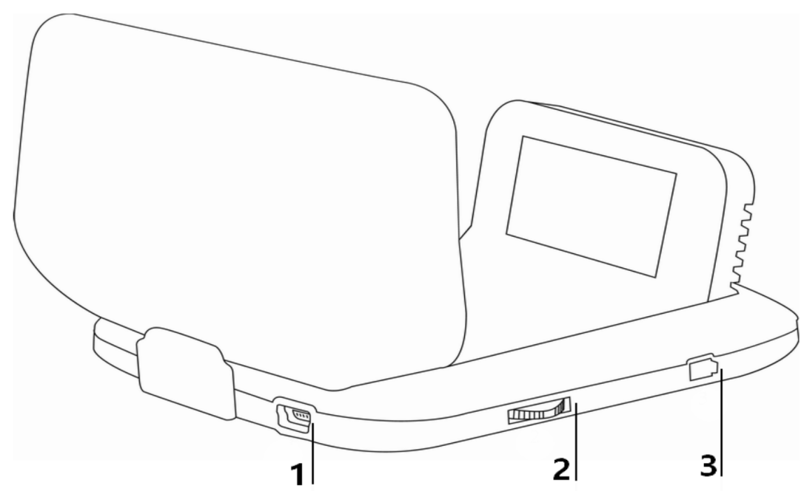

1.USB input
2.Setting button(can pull up,pull down,short press in,long press in)
3.power button

Setting button functions: When the setting button in the left

1 Short press in(quick press in the button and release within 1 second):
- to switch the display mode
- to choose menu after entering the setup menu

2 Long press in(press in the button more than 2 seconds and release):
- to enter the setting menu
- to save and exit after setting

3 Pull up:
- to switch the functions in the left area
- to change the setting options

4 Pull down:
- to switch the functions in the right area
- to change the setting options

Pull left/right to switch the multi functions area
Below are the functions abbreviations:

ECT - Engine Coolant Temperature | VLT - Voltage | FUE - Fuel Consumption
RPM - Revolutions Per Minute | ODO - Odometer | TIM - Driving Time
DIS - Driving Distance | MAP - Intake Pressure | OIT - Oil Temperature
A/F - Air-fuel Ratio | TCP - Turbine Pressure | PSI - Intake pressure
RTC - Real-Time Clock | ALS - Altitude | GPS - GPS satellite numbers
DIR - Driving Direction

Setting Mode(Menu mode)
Long press in to enter into the setting mode,pull up to choose the menu,and short press in to confirm.Once finishing the setting,long press in to exit.

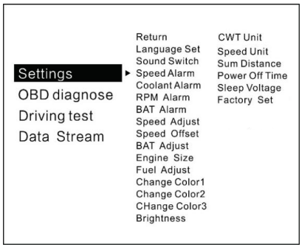
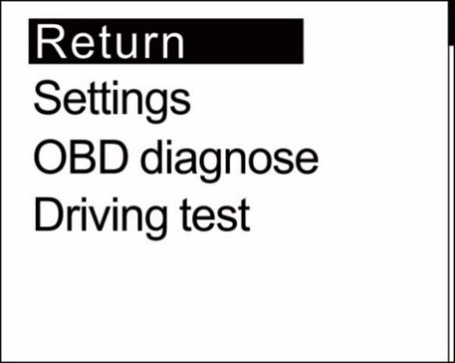

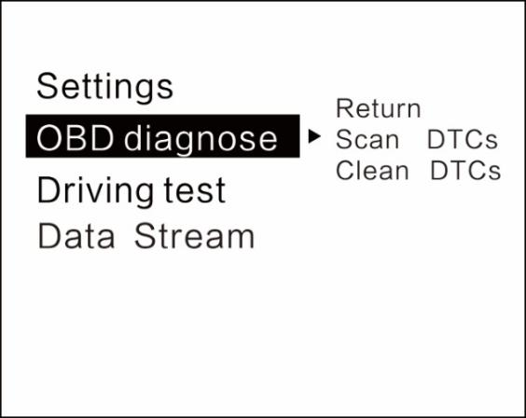
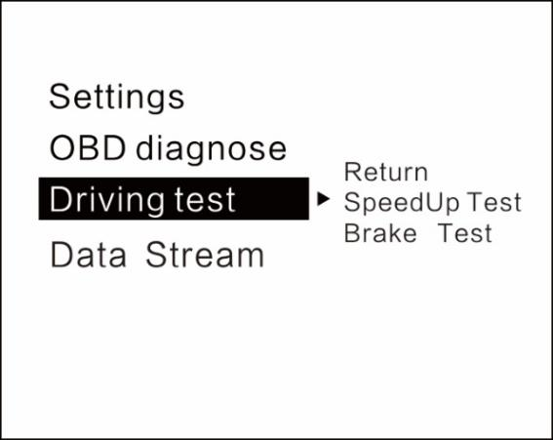

Language Set: Please choose your familiar language ( EN-English / CN-Simplified Chinese/ TW-Traditional Chinese)
Sound Switch: turn on/off the buzzer
Speed Alarm: the default value is 150 (the default value can be changed,pull down is to decrease,pull up is to increase, adjust range is 5-200km/h)
Coolant alarm: default value is 120°, it means this device will give alarm when Coolant temperature is over 120°(adjust range is 50-200)
RPM alarm: default value is 6000 r, it means this device will give alarm when RPM over 6000 r(adjust range is 1000-8000)
BAT Alarm: default value is 10.5V, it means this device will give alarm when battery voltage is lower than 10.5V(adjust range is 10.0-15.0V)
Speed Adjust: adjust the speed according to the dashboard,default value is 107%(if the speed is different with the dashboard,then can adjust the value. For example, if the dashboard speed is 100Km/h, and the device speed is 105KM/h, then please adjust the value to 102)
Speed Offset: When the vehicle turns off,but the device speed is not 0, then adjust the device Speed Offset value (if the device speed shows 5KM/H, then change the device Speed Offset default value at 5)
BAT Adjust:if the battery voltage is different with the vehicle,it can be adjusted.
(if the device voltage is 0.2V higher than the dashboard’s,please change the value to 98%)
Engine Size: if the fuel consumption is much different with the dashboard,please change it as the Displacement size(for example, if the vehicle displacement is 3.6L, please change the default value to 3.6L)
Fuel adjust: default value is 100%,it can be adjusted when the fuel consumption is different with the dashboard.
(for example, if the device fuel consumption is 0.2L higher than the dashboard, please adjust it to 98%)
Change Color 1: the speed color in the main display interface
Change Color 2:the left side functions color on the screen
Change Color 3:the right side functions color on the screen
Brightness: default 0(Automatic sensitivity),1-8(the brightness will be increased as the digital added)
CWT Unit : default coolant temperature is °C,also can be changed to ℉
Speed unit: KM/h or MPH can be changed
Sum distance: can make the total driving distance same as dashboard(if the dashboard shows the sum distance is 30000Km,the user can make the device value at 30000KM)
Power off time: default power off time is 10s,for Auto start and stop cars,please make the power off time to 180-240s
Sleep Voltage: default is off ,if the device can’t auto off,please adjust the voltage at 13.2V or higher
Factory set: short press in to do the factory set
Time adjust : default time is GMT+8(China time), can change the it to local time by pulling up/down.

Driving test
Speedup test: show the speed,distance,driving 400m takes time,driving 100m takes time
Brake Test: Brake when the speed is over 60 KM/H, then it show brake distance and time

Error code set
Scan DTCs:scan the ECU to check if there is the error code,and show the error details
Clean DTCs:switch to Clean the DTCs,short press in the button to finish the cleaning

Data Stream
Show all the vehicle data stream

Please note
It is recommended to unplug the device if your car doesn’t been used for more than one week.

OBD2 System Troubleshooting
1.The screen without any display,and no power
Start the car engine;check if the OBD cable line is tight;please pull down the OBD cables more times to ensure;check if product power switch turns on. If still no display ,please change another car to test, analyze whether the car OBD diagnostic interface is good, if it is not good,please repair it and try again.

2.Only shows the car voltage and be automatic power off after 30 second when the device is with power
This product just available for cars with OBD2 agreement and EU-OBD agreement(European region: after 03 years, Other region:after 07 years)
This Products do not support JOBD and OBDI and recommended test for another car.

3.Inaccurate Speed
a.First check the speed unit is correct or not, the speed unit including KM/H and MPH,please refer to the setting to switch the unit.
b.When the product is power on,long press in the button to enter into the menu option,pull down the button to choose the speed adjust,short press in the button to set the value,pull down or up to change the value.(if the dashboard shows 100,and the device shows the 101,change the default value at 106%)

4.Inaccurate Fuel consumption
Check your car displacement,and set the device same as your car(if your car is 2.0L,then change the device value at 2.0L).The fuel consumption can be adjusted,but we don’t suggest to change it ,because all the datas are read from the car ECU directly.

5.The device can not auto power off
Adjust the sleep voltage to 13.2V or 13.6V, then HUD will power off in 3 minutes.

6.Auto start and stop cars
Change the Power off time to 180s

7.HUD crashes in driving,or Hybrid car
Change the power off time to 180 or 300. If still can’t solve,please switch to GPS system.

- Wrong operation lead to crashes
- Please check the OBD interface if connected withe other device
- Modified and retrofitted cars will cause a crash
Please remove other OBD devices and do the factory reset.
If still not solved,please switch to GPS system.

GPS System Troubleshooting
1.The screen without any display,and no power
Start the car engine;check if the cable line is tight;or connect the USB to the computer to check

2.Without car Speed
After HUD power-on, the GPS will start to find the satellite. Please driving the car to the road. It will work once gets more than 5 satellite signals.

3. Cannot be turned on automatically or repeatedly extinguished during driving
Please use the USB cable to insert the cigarette lighter
If you use the OBD cable, change the sleep voltage to 13.0V or 12.8V
If use the USB cable, make the sleep voltage off.

4.Inaccurate time
Entering into the setting menu, choose the time adjust, pull up or down the button to change it.
After setting,long press in the button to save and exit.

5.Inaccurate Speed
a.First check the speed unit is correct or not, the speed unit including KM/H and MPH,please refer to the setting to switch the unit.
b.The car manufacturers usually make the dashboard speed 5-7% higher than the ECU. The international standard is based on satellite data.
(if the dashboard shows 100,and the device shows the 105,change the default value at 102)

6.Driving direction display error
After the vehicle speed exceeds 5KM / H, the direction can be displayed normally.

7. Speed is still displayed after the car stops
Under the underground parking lot, tunnel, under the overpass, there will be unstable satellite drift when there is obstruction. Please drive the vehicle to the empty road. The number of satellites found is more than 5 and it shows normal.

8 The device cannot auto power off when the car is turned off
If connects by OBD cable, it will auto power off in 3 minutes.
If it still not powers off in 5 minutes,please change the sleep voltage to 13.5V, or use the USB cable.

